Title: Ambulatory Cologuard Order
Application: EpicCare Ambulatory
Affected Role: RN, MA, Provider, Henry Ford – Cologuard Population Health Coder
Date: 9/30/2017 | Revision Number: 2

What is Cologuard? Cologuard is a Colorectal cancer-screening test that detects altered DNA and/or blood in the stool as a way to find cancer in its early stage. It is approved by the United States Preventive Services Task Force and HEDIS as one of the recommended methods for colon cancer screening and has an interval of every 3 years.

How it Works

- Provider places Cologuard order in Epic
- Cologuard order is automatically faxed to Exact Sciences
- An Exact Sciences representative will call the patient to confirm mailing address/insurance information
- A kit is shipped to the patient – which comes with a prepaid and preaddressed UPS return label
- Patient collects stool sample in the privacy of their own home
- Patient ships the kit from any UPS location or call 1-800-PICKUPS to schedule a pick-up
- Exact Sciences results the test and posts results to a Cologuard Portal
- Henry Ford Cologuard Population Health Coder(s) monitor the Exact Sciences portal for results. When results become available, they update the original Epic order with the results (positive or negative
- Results are issued to the provider’s InBasket
- Results are issued to MyChart if applicable
- A final Cologuard result of positive or negative will complete Health Maintenance for 3 years

Note: If, after multiple attempts, Exact Sciences could not get a final result the order will be canceled. The Population Health Coder(s) will then Cancel the Epic order which will issue a Canceled Ord message to the Authorizing provider’s InBasket indicating that the test could not be completed.

Try It Out – Cologuard Ambulatory Order

Step 1: Access the patient visit encounter by double-clicking the patient on the schedule.
Step 2: From Meds & Orders, search for and select the Cologuard (Exact Sciences) order. Click Accept.
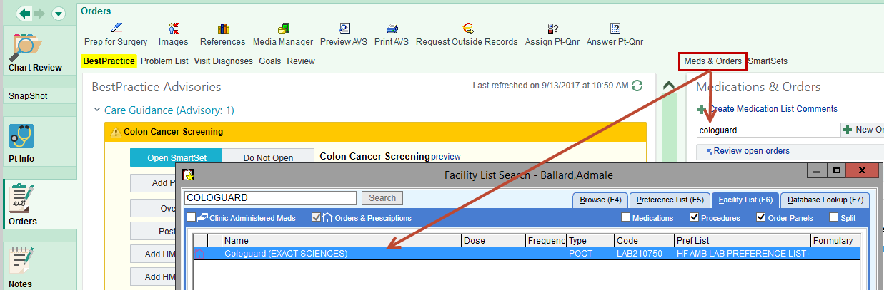
Step 3: Review, associate diagnosis, and sign the order.
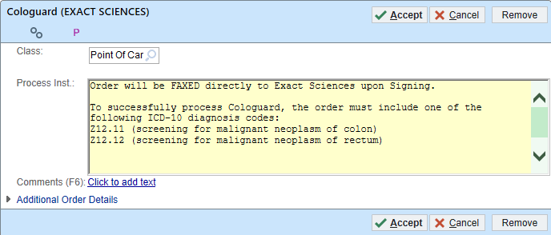

To successfully process Cologuard, the order must include one of the following ICD-10 diagnosis codes:
- Z12.11 (screening for malignant neoplasm of colon)
- Z12.12 (screening for malignant neoplasm of rectum)
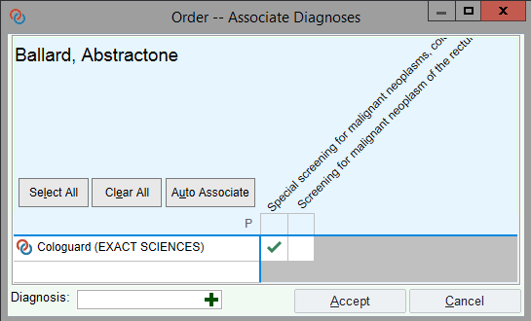

What happens when - Cologuard Order Signed

What happens when the Cologuard order is signed in Epic?
- An order requisition is faxed directly to Exact Sciences
- A copy of the faxed order requisition is printed in the clinic
- A Patient Instructions report is printed in the clinic

You Can Also...

You can include Cologuard Patient Instructions in the AVS using SmartPhrase . COLOGUARD
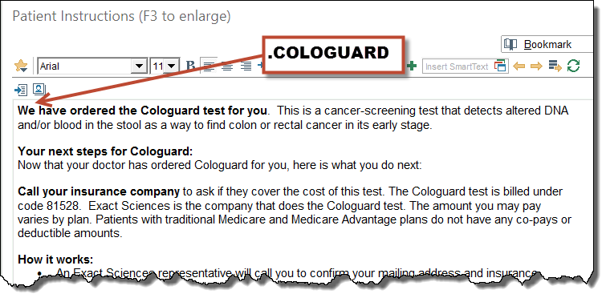

Cologuard Results in Epic

Henry Ford Population Health Coder(s) will monitor the Exact Sciences portal for results belonging to Henry Ford Health System.
When results become available, the Henry Ford Cologuard Population Health Coder(s) will:
- Access the Enter/Edit Results activity from the patient’s Chart
- Locate, and double-click on the Cologuard (Exact Sciences) order
- Update the results including: Collection Date and Time, Result Value – Negative or Positive, Resulting Lab, Result Date and Time, and Result Status (Preliminary Result or Final Result)
- Click Accept
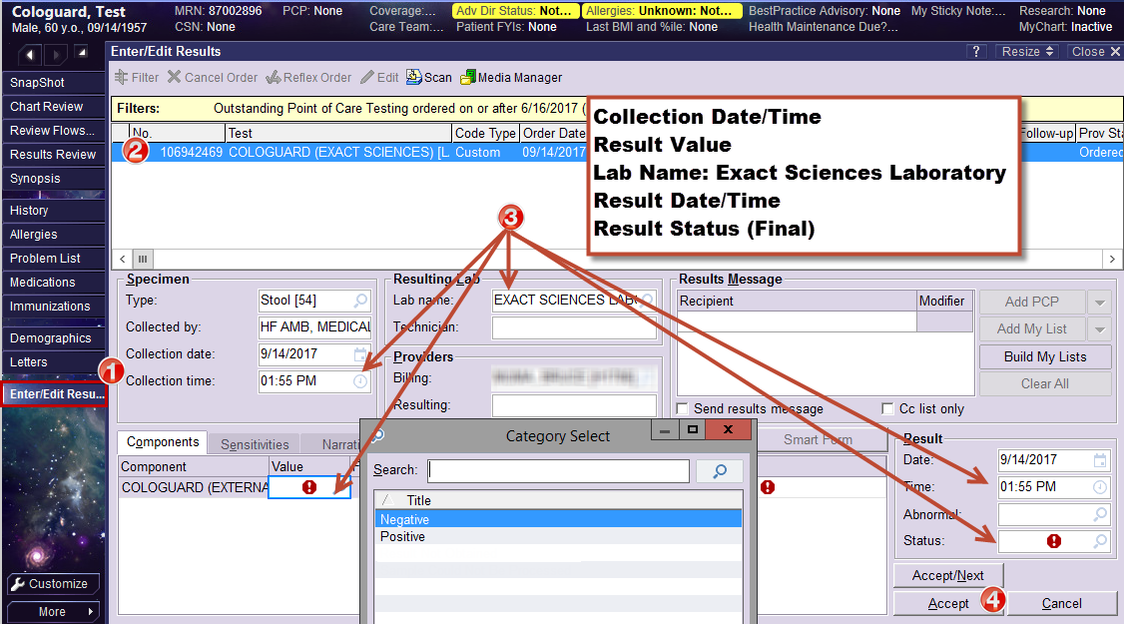

Cologuard Order Canceled in Epic

If, after multiple attempts, Exact Sciences could not get a final result the order will be canceled.
The Population Health Coder(s) will access Enter/Edit Results to Cancel the Epic order. Canceling the order in Epic will issue a Canceled Ord message to the Authorizing provider’s InBasket indicating that the test could not be completed. Provider will follow up as appropriate.

