

CREATING ACCORDIONS
SITECORE SXA | HENRY FORD HEALTH

Accordions: Adding through the Experience Editor

To add an Accordion:
- Select the Add component icon in the top left corner and select the +Add here button where you would like to add the Accordion.
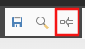
- In the select a Rendering window, select Accordion and Select.
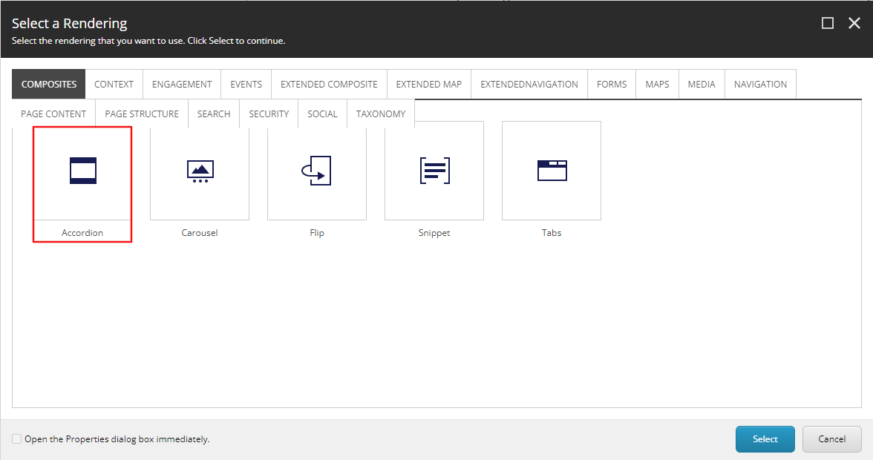
- A Select the Associated Content window will appear, from here select Create or the folder you wish to have this Accordion Component be stored under and then select Create.
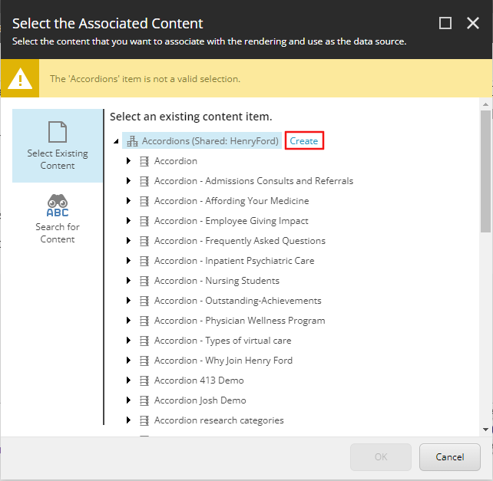
- In the Insert Item window, either create an Accordion folder or an Accordion, and assign a Name to it in the bottom field. Then select Okay.
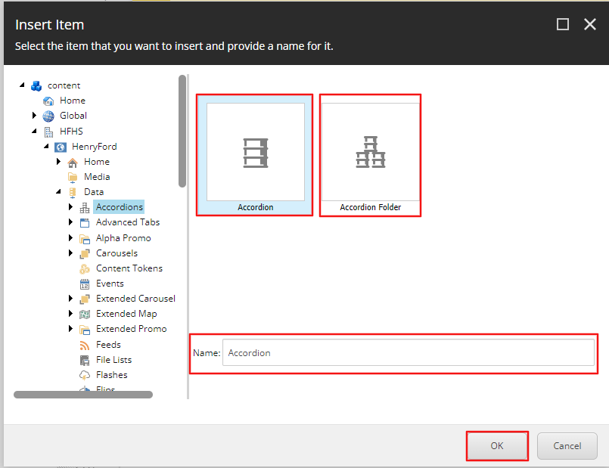
- The Accordion will load on the page after a few seconds. To edit the Accordion Headings, select the Accordion Item 1 or Accordion Item 2 text and type in the text you wish to display as the heading.
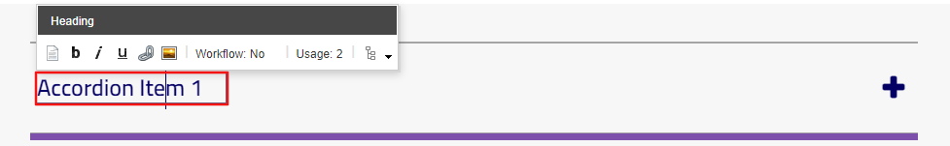
- To edit the content copy in the Accordion content area, select the plus icon on the righthand side of the component. This will expand the accordion that you selected. To edit the Content Copy, select the [No text in field] area and either enter the text you want displayed or select the RTE icon in the tool bar and enter the text into the RTE window and then select Okay.
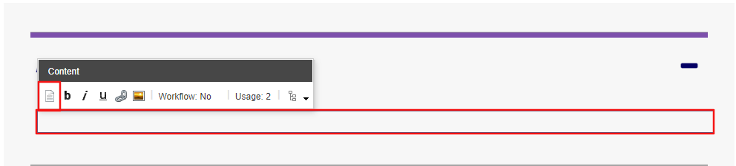
- To add/delete or move more accordion items to the accordion component select under the Content Copy area (blue).
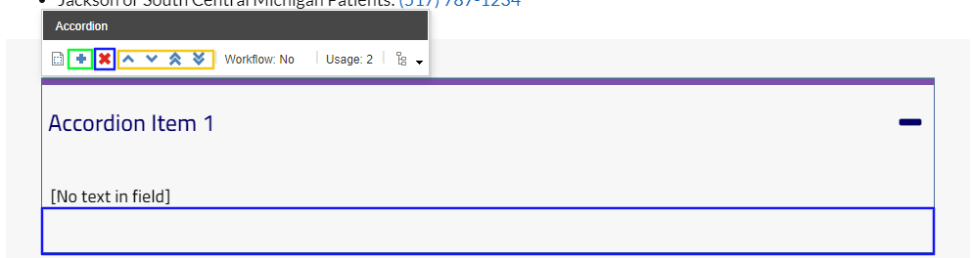
- Once you select in that area an Accordion Toolbar will appear. To add a new accordion Item, select the plus icon (green). An Insert Item window will appear. Select the Accordion Item, provide a name in the field below and then select Okay. An accordion Item will now appear below the other accordion items.
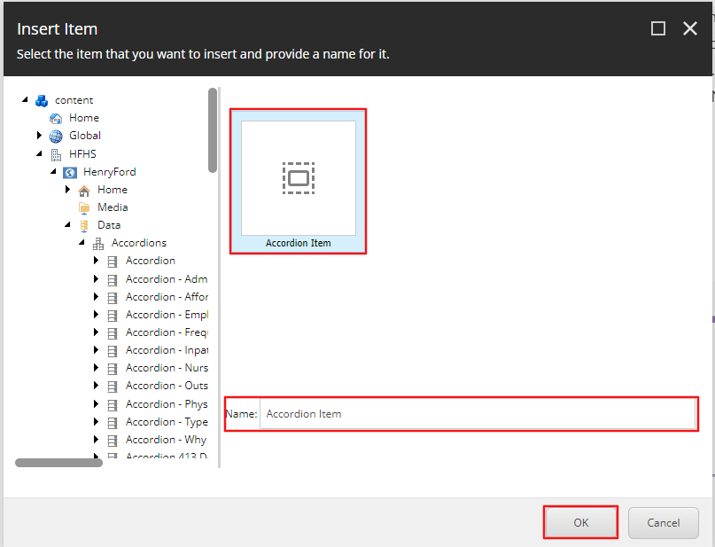
- To Delete an Accordion item, select the area that was mentioned in step 7. In the Accordion toolbar that appears, select the X icon (Blue). A dialogue box will appear asking you if you are sure you want to delete that accordion item. Select Okay.
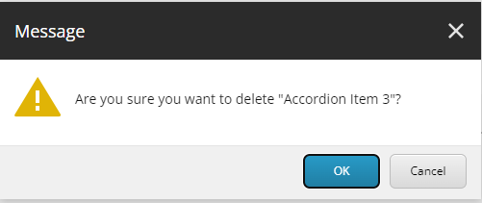
- To Reorder an accordion item, select the area that was mentioned in step 7. In the Accordion toolbar that appears, select the corresponding icon that meets your needs (Yellow).
  - Up caret = move accordion item up one spot.
  - Down caret = move accordion item down one spot.
  - Double Up caret = moves accordion item to the top of the accordion component.
  - Double Down caret = moves accordion item to the bottom of the accordion component.

