

HENRY FORD BLOG MODULE
SITECORE SXA | HENRY FORD HEALTH

Table of Contents
The Launchpad – The Experience Platform 3
Changing Your Password 4
Editing Content Using the Content Editor 6
How to Edit the Page Data through the Content Editor 7
Utilizing the Experience Editor Ribbon 9
Adding & Editing a Blog Post using the Experience Editor 11
Using the Rich Text Editor 16
Creating Links to Pages & PDF Documents 21
Link to a Sitecore Page 21
Link to a PDF Document 22
Using the Hyperlink Manager through the RTE 25
Editing Call to Action Components 27
Adding a CTA to the side rail 27
Submitting Your Page through the Blog Workflow 33
From the Content Editor 33
From the Experience Editor 34
How to Publish Your Page 35
From the Content Editor 35
From the Experience Editor 35

Logging into Sitecore
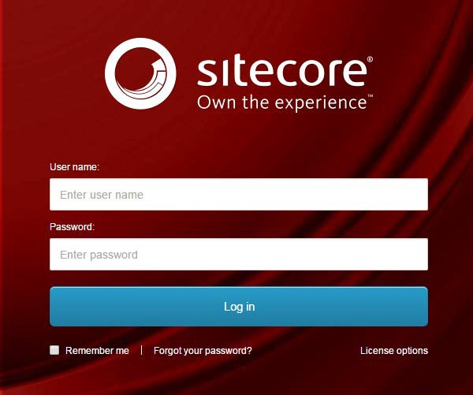
- Enter your User Name, Password, and then click Login to log into Sitecore

- Forgot Your Password – enter in your User Name to have Sitecore email you a newly generated password (this may go to your junk email folder – sender: donotreply@website.net)

- It is recommended that you use either Chrome, Mozilla or Edge.

The Launchpad – The Experience Platform

Note: Based on the access rights of your account and role, your launchpad may look different.

- The Sitecore Launchpad is well organized in the following categories:
  - Green – marketing and analytics tools
  - Red – content editing tools
  - Orange – tools to organize your digital assets and page workflows
  - Black – recycle bin to retrieve your deleted items
  - Blue – account configuration, system steup and app installations
  - Purple – user account settings

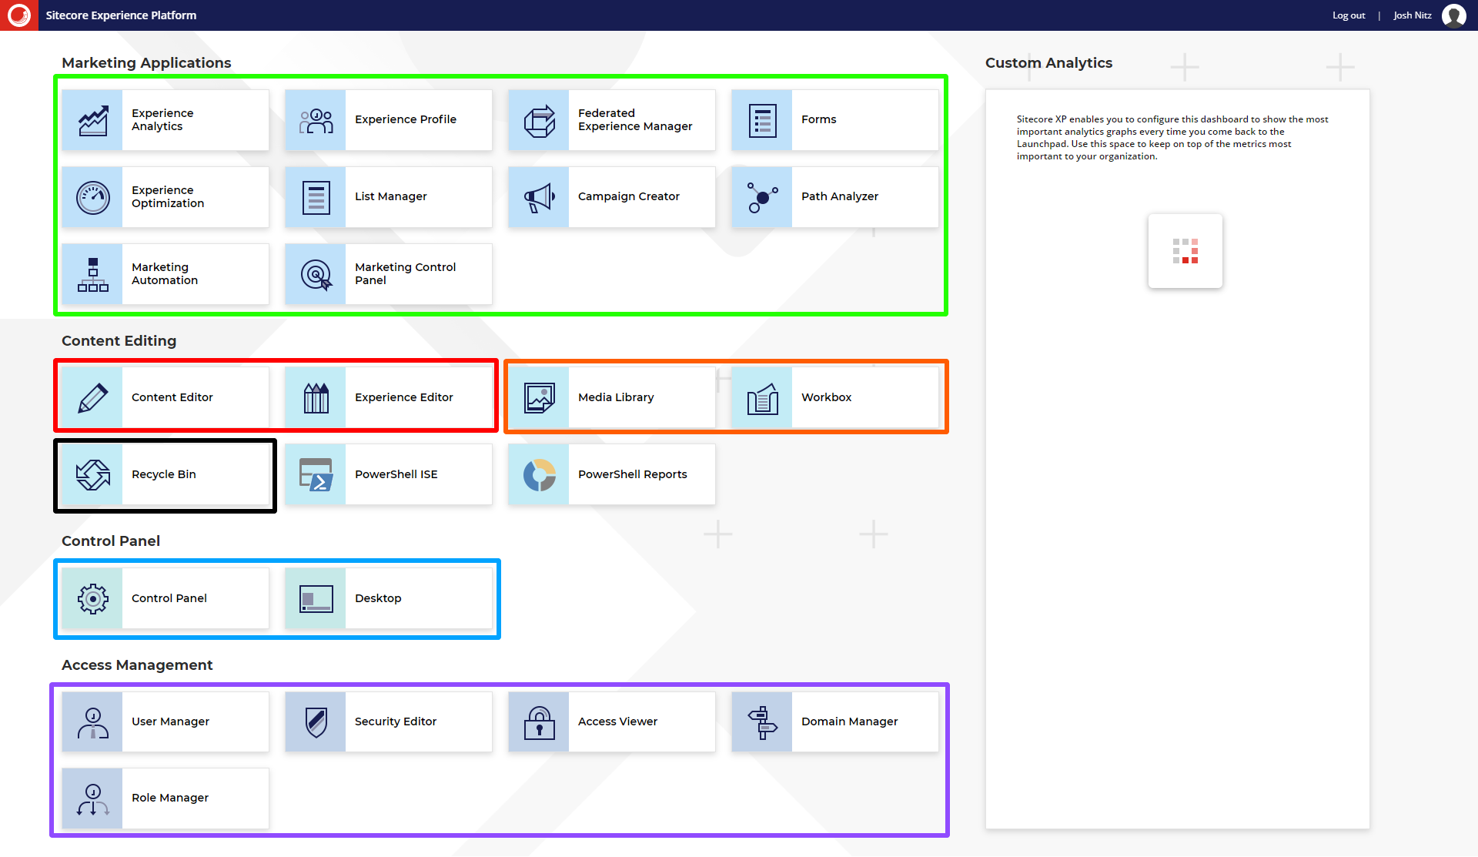

- The contents of this document will focus on:
  - How to change your password
  - How to navigate the SXA framework and edit your page’s front-end and backend content through the Experience Editor.

Changing Your Password
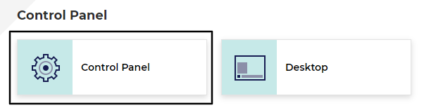
- You should update your password upon logging in for the first time. To do so, select Control Panel
- Select Change Password
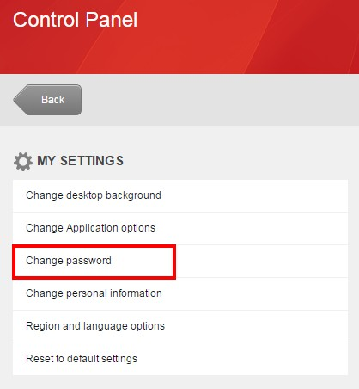
- Complete the following Change Password prompt.

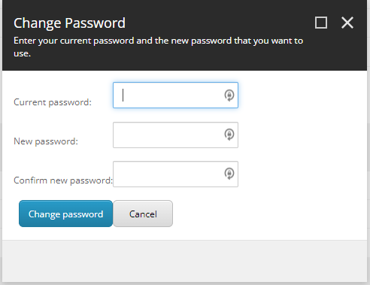

To Start Editing Content
- To start editing from the backend select the Content Editor button
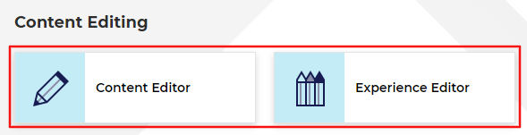

Editing Content Using the Content Editor

- The Content Tree contains all your website’s pages, items, and modules.
  - Note: The HF pages that are found in live will be found under the HFHS > HenryFord > Home > Blog node.
  - Setup your Content Editor with the appropriate settings and menus by opening the View ribbon and having the following checkboxes checked:
    - Content Tree (checked by default)
    - Entire Tree

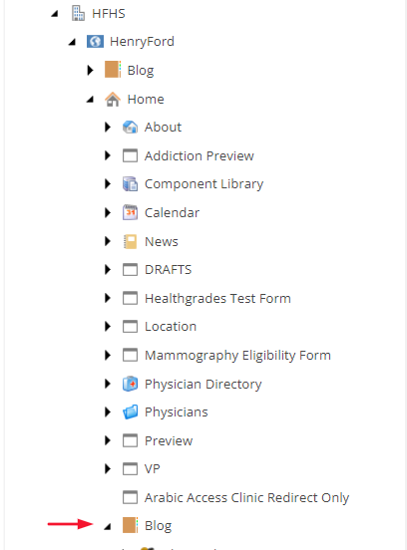

- Click the black arrow in front of the item that you want to expand and branch out.

How to Edit the Page Data through the Content Editor
- Navigate to the page that you want to edit from the Content Tree.

- To start editing the page, use any one of the following options to Lock the page to your user and begin editing:
  - Click the Edit button in the Home ribbon.
  - Click Lock and Edit in the yellow strip of the Content Panel.
    - Note: All fields found on the page template in the Content Editor can also be edited through the Experience Editor (the location you should be editing your content).

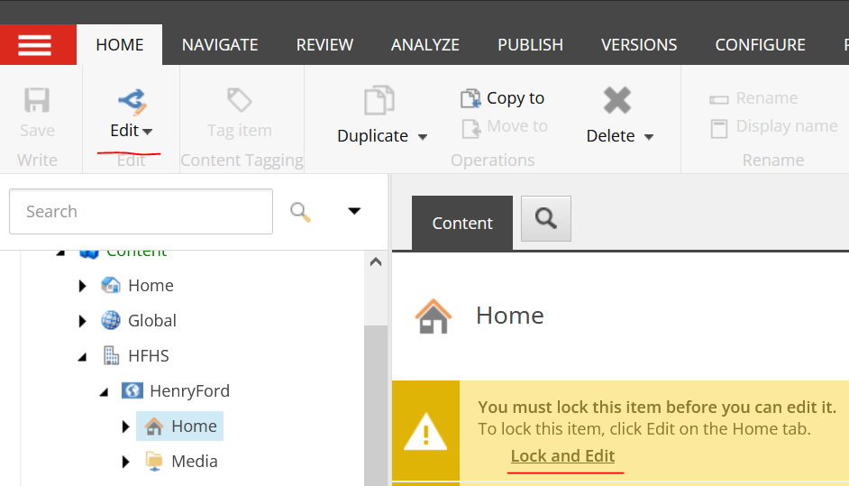

- Red - You can preview the page you are working on in the Content Editor by opening the Publish ribbon and then clicking the Preview button (the system may prompt you to save the page – if the preview window does not open, then click the Preview button again, or check to see if your browser’s pop-up blocker blocked it).

- Orange - You can navigate to the Experience Editor by selecting the Experience Editor button right above the Preview button.

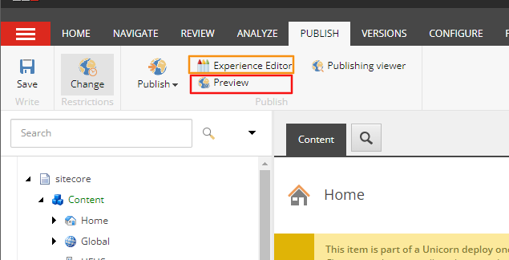

Utilizing the Experience Editor Ribbon

When utilizing the Experience Editor, here are some of the functional items in the Header Ribbon that will be useful when editing your blog posts or blog CTAs.
- Home Ribbon Tab:
  - Edit button (Blue) – Either the Home Tab Ribbon or in the Yellow Notification Bar will enable the page for editing.
  - Preview (Next to the Edit button) – Displays a preview of the current page with an accurate view of how it will appear on the frontend.
  - Component (Red) – Displays on the page template each location that a Component can be added through an Add here button.
  - Insert Page (Green) – Opens an Insert Item window, which enables the user to create and name a new page or redirect. By default the system will assume you are creating this item under the current page, but the user can select from the tree node on the left hand side, where this child item will reside.
  - Delete Page (Blue) – Deletes the page the user is currently on.
  - Move Page (Orange) – Allows the user to move the current page to another section of the Site Tree.
    - Note: Duplication of site pages can be done here by right clicking pages the user want to duplicate and selecting the appropriate Duplicate page option.
  - Rename or Display Name (Purple) – Enables the user to update the Item Name and Title.
  - Publish (Yellow) – Opens the Publish window. Publishing training found at end of this training document.
  - Lock/Unlock (Brown) – If Lock is selected, it will enable the page for editing. If Unlock is selected, it will checks the item back in and disables the page from editing from the user.
  - Close (Navy) – Sends the user to the actual frontend (away from the Experience Editor)
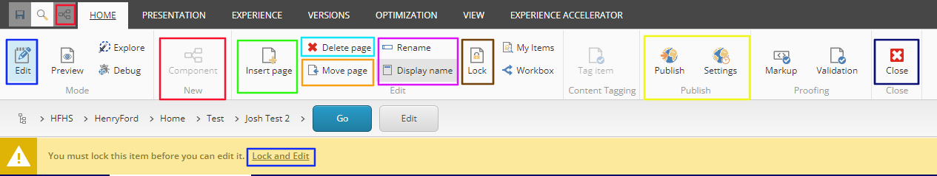
- Versions ribbon Tab:
  - This Ribbon tab enables the user to:
    - Reset the fields back to their standard values.
    - Review the current page’s versions.
    - Remove page versions.
    - Add versions
    - Compare versions.
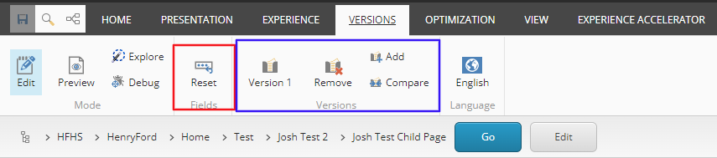
- Experience Accelerator Tab:
  - Pick Page Design (Red) - User selects the page template for the page they wish to create.
  - Page Metadata (Blue) – User can set the metadata that is associated with the page that does not display on the frontend.
    - Note: This enable the user the edit everything that previously be edited through the Content Editor.
    - This contains information such as Tagging, Taxonomy, Open graph information etc.)
  - Publish (Green) – User can publish the entire page or entire site.
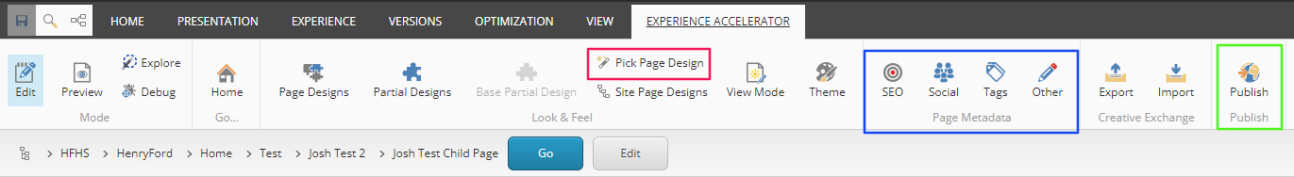

Adding & Editing a Blog Post using the Experience Editor
- To Insert a Blog Post, navigate to the Blog Home node > Year folder > Month folder that you wish the blog post to appear under. Right click the folder item and select Insert > Blog Post item.
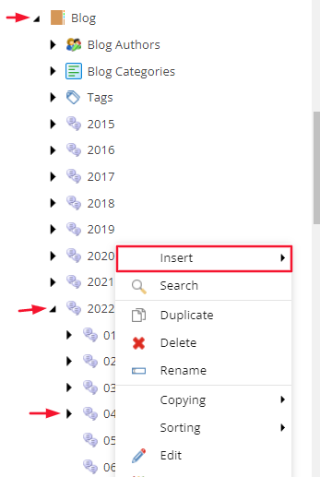
- Once you have selected Blog Post option, a dialog box will appear asking you to name the item. Enter the name of the blog post and select okay.
Note: The name provided here will be the name assigned to the item in the URL.
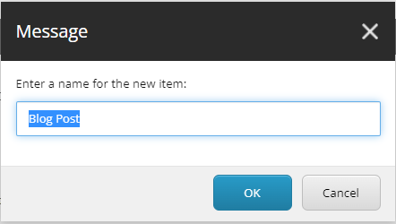
- Once the Blog Post has been created, you will want to edit the Blog Post in the Experience Editor. To do so, select the Publish tab in the Header Ribbon > select Experience Editor.
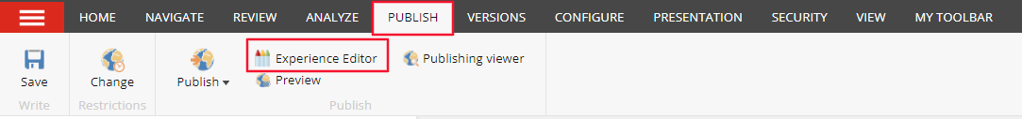
- Edit either the Blog Interior Banner (first image placeholder on the page) and the Blog Mobile Interior Banner (second image on the page) by selecting the Image placeholder item and then selecting the Choose an Image Icon.
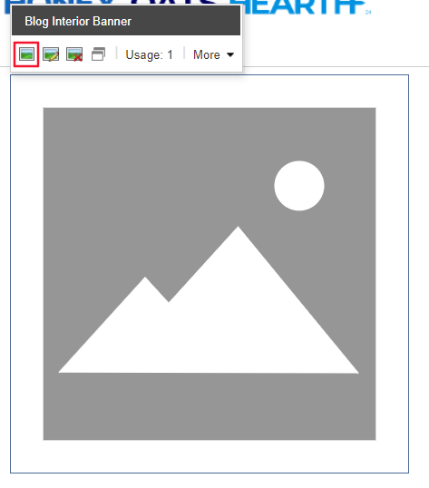
  - Add or select the Image that you want attributed to each item through the Media Library window.
Note: Navigating and utilizing the Media Library can be found in the Media Library in SXA training documentation.
- To edit the Blog Headline, select the Headline area and type in the name of the Blog Headline that you wish to be displayed.
- To edit the Blog Date, select the Blog Date text area (to the right of Posted on) and select the Calendar icon.
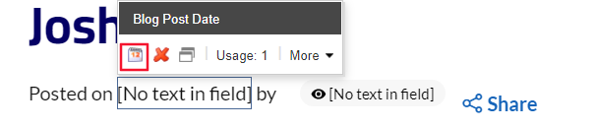
  - Upon selection, a Select a date window will appear. When the window appears, select the date that should apply to the Blog Post and Select Okay.
  - Note: The formatting will be updated to it’s desired state after selecting Save.
- To edit the following items that are associated with a Blog, select the Experience Accelerator in the Header Ribbon and select Other:
  - Blog Introduction – This is the text that will appear in the Blog Tile (up to 150 characters)
    - RTE Field
  - Blog Author
    - Dropdown field
  - Contributing Physician – This will determine if this blog appears on the Physician’s profile page.
    - Selector Field
  - Blog Image – This is the image that appears for the blog on the Home Page (Tile Image)
    - Image Selector Field
  - Blog Category
    - Selector Field
  - Blog Tags
    - Selector Field
  - Blog Featured checkbox – This field will determine whether or not this Blog post will appear on the Landing Page’s Hero Banner Carousel (if the Blog Post date associated with this post is in the top 4 most recent blog posts with this Featured checkbox checked)
    - Checkbox field
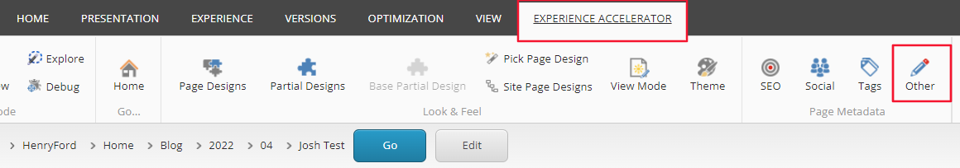

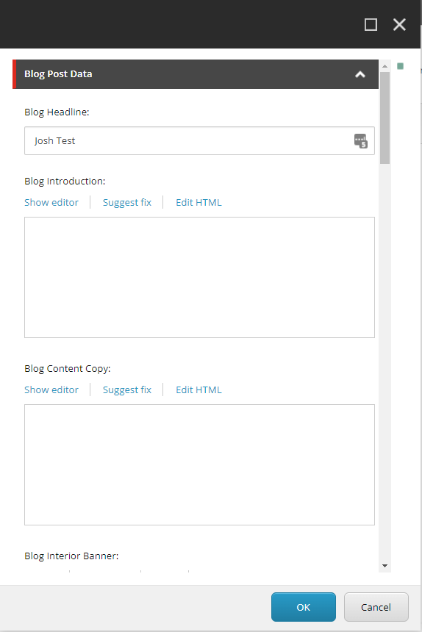
  - Note: In this window, you can attribute the appropriate data of the items mentioned above under the Blog Post Data section.
- To edit the Taxonomy that’s associated with a Blog, select the Experience Accelerator in the Header Ribbon and select Tags:
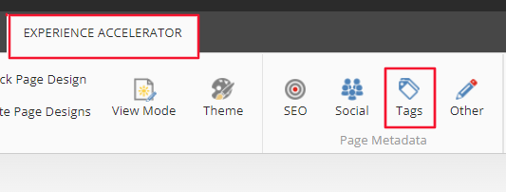
- To edit the Open Graph related information that’s associated with a Blog, select the Experience Accelerator in the Header Ribbon and select Social:
  - Fields found in this section:
    - Title (open Graph Title)
    - Description
    - Image
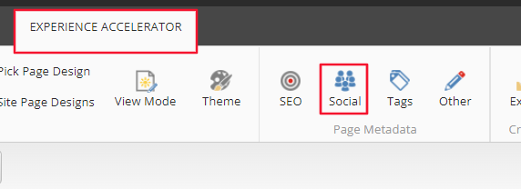
- To edit the Content Copy, select the [No text in field] area, then in the Blog Content Copy tool tip, select the ‘Edit the Text’ button. This will open the RTE field
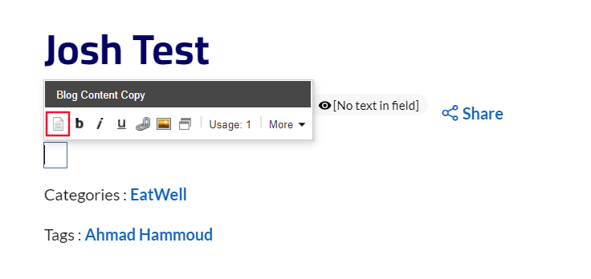

Using the Rich Text Editor

The Rich Text Editor is also known as the WYSIWYG (What You See Is What You Get) and functions mainly like a word program. You can click right inside the field and start typing. The first part of this section will cover each section of buttons from left to right.

Note: hovering your mouse over each button will reveal its function name.
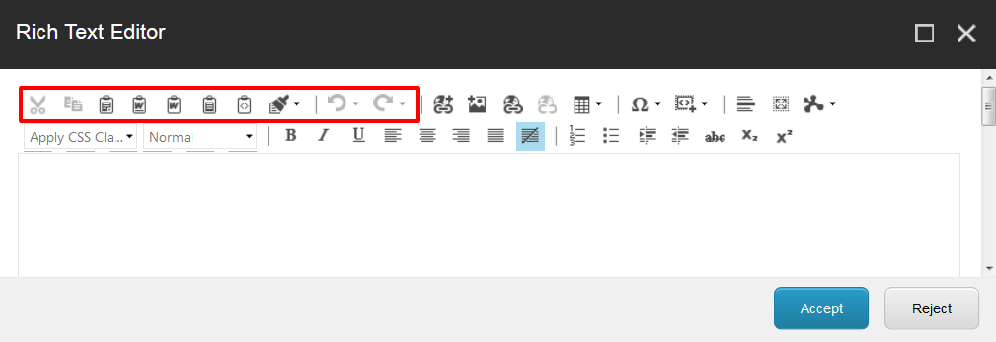


- Cut: cut the selected text and save for immediate pasting.
- Copy: copy the selected text and save for immediate pasting.
- Paste: paste the selected text that was cut or copied.
- Paste from Word: paste cut or copied content copy from a Word Document.
- Paste from Word – Strip Font: strips the formatting of the cut or copied content copy from a Word Document and then pastes.
- Paste as Plain Text: paste cut or copied content copy from any source without any formatting or font codes carried over (this is the recommended solution when placing content from another source).
- Paste as HTML: paste your content for this page in HTML format.
- Format Stripper: strip formatting (bold, italics, underline, etc.) from your content.
- Undo: undo your last action.
- Redo: redo your last action.

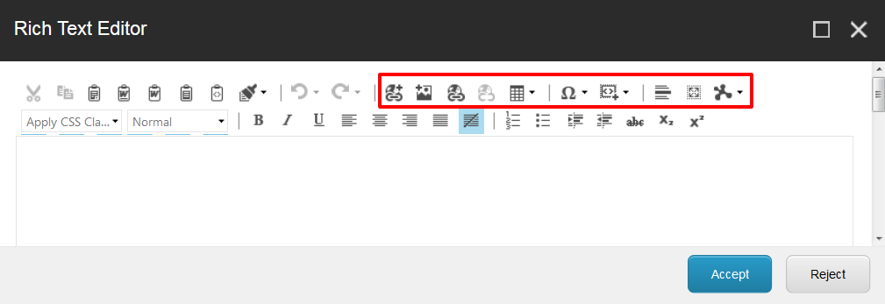

- Insert Sitecore Link: link the selected text to another page within your site or to a PDF document (See Creating Links to Pages & PDF Documents for more information).
- Insert Sitecore Media: inset images, videos, audio files, etc. to the selected area in the content copy (See Adding an Image to Your Page for more information).
- Hyperlink Manager: link the selected text to an external URL (any page outside of your site like Google.com), an anchor on the page, or open a “mail to” email (See Using the Hyperlink Manager on pg. 25 for more information).
- Remove Link: remove the link(s) in the selected text.
- Insert Table: add a table to the page.
Note: verify that your tables are responsive if you have responsive design.
- Insert Symbol: insert various symbols and special characters.
- Insert Code Snippet: add a pre-loaded HTML component to the page such as a callout.
Note: custom HTML codes can be pre-loaded into this section by your System Administrator.
- Horizontal Rule: insert a horizontal rule; a straight line across the page for separation of content.
- Select All: select all items in the Rich Text Editor.
- Module Manager: view and edit Sitecore modules.

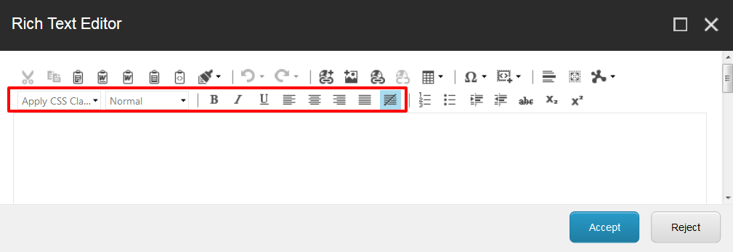


- Apply CSS Class: add a custom CSS class to change the font style or color.
Note: custom CSS class can be pre-loaded into this section by your System Administrator.
- Paragraph Style: define the style of the new or selected paragraph; use this to model your content with sub-category headers (<h2>, <h3>, <h4>…).
- Bold, Italic, Underline: These 3 options will allow you to format the text in Bold, italic or underline.
Note: limit the use of underline as it gives the appearance of a link.
- Align Left, Align Center, Align Right, and Justify: left align, center align, and right align your paragraph of text, or block justify your paragraph of text.
- Remove Alignment: remove the previously selected alignment.

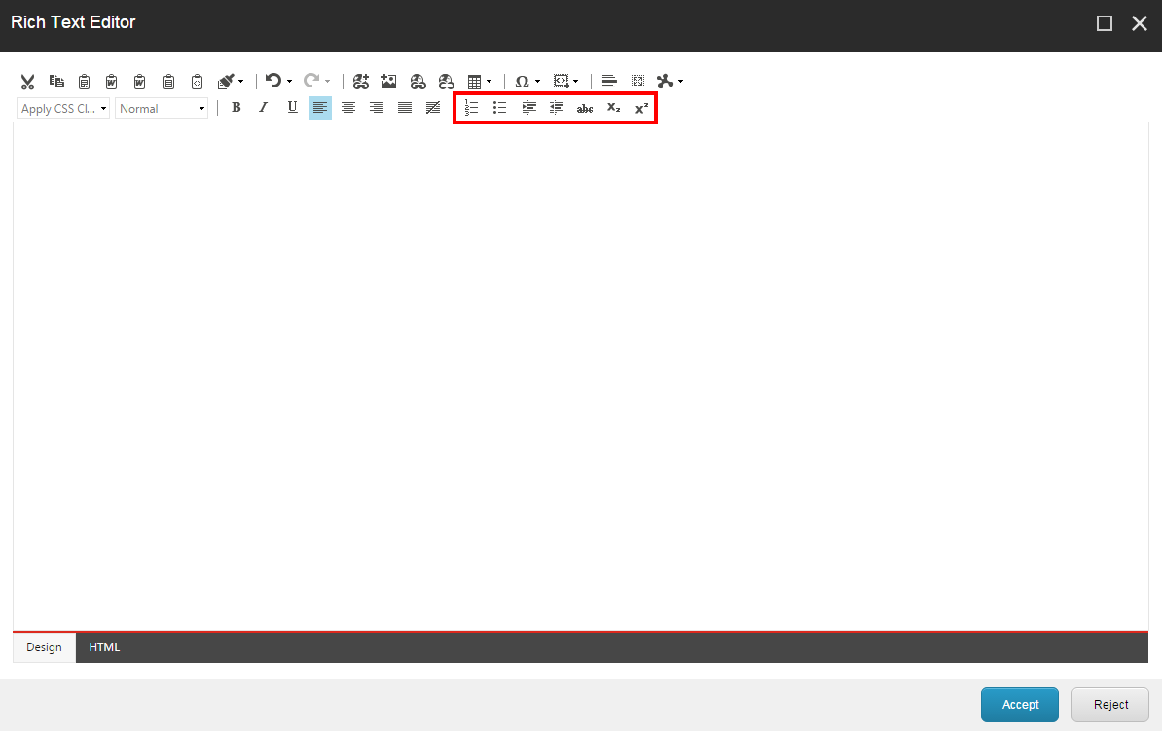

- Numbered List: start a new numbered list or convert selected paragraphs to a number list.
- Bulleted List: start a new bulleted list or convert selected paragraphs to a bulleted list.
- Indent/Out-dent: indent or out-dent the paragraph of text.
- Strikethrough: place a line through the selected text.
- Subscript: add small text font on the bottom right.
- Superscript: add small text font on the upper right.

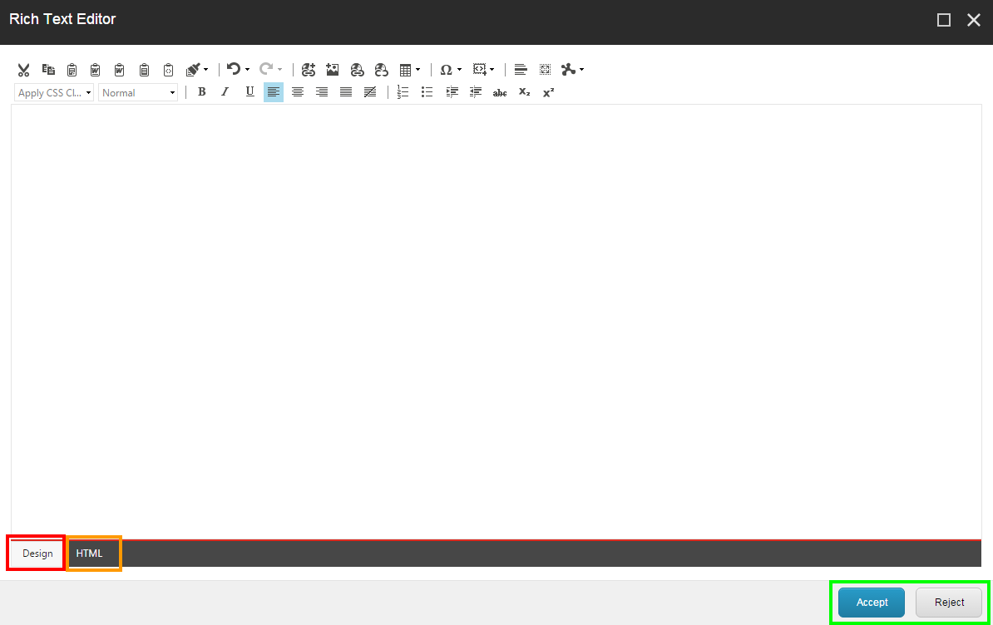

- Design (Red): displays the entered text like a word program.
- HTML (Orange): displays the entered text in HTML.
- Accept: accept the changes you made in the Rich Text Editor and close it.
Note: clicking Accept does not Save the page.
- Reject: reject the changes you made in the Rich Text Editor and close it.

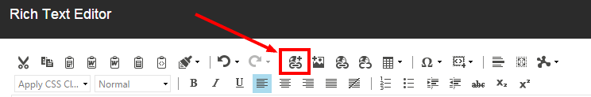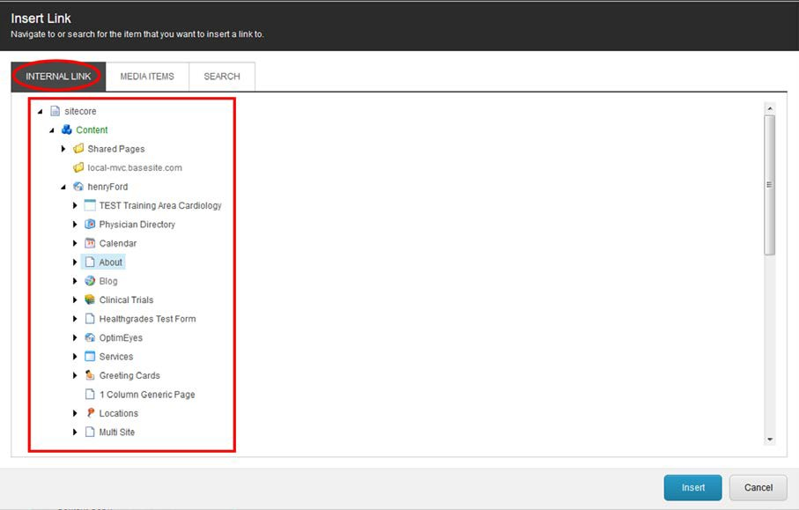

Creating Links to Pages & PDF Documents

Link to a Sitecore Page
- Select the text that you want to link from the Rich Text Editor and then click the Insert Sitecore Link button.

- Find and select the page from the Content Tree in the Internal Link pane and then click Insert.



Link to a PDF Document
- Select the text that you want to link from the Rich Text Editor and then click the Insert Sitecore Link button.

- Click the Media Items pane (Red) to find and select the PDF document from your Media Library, and then click Insert (you can also upload a new file by clicking on the Upload button (Orange) and then clicking Insert (Green).
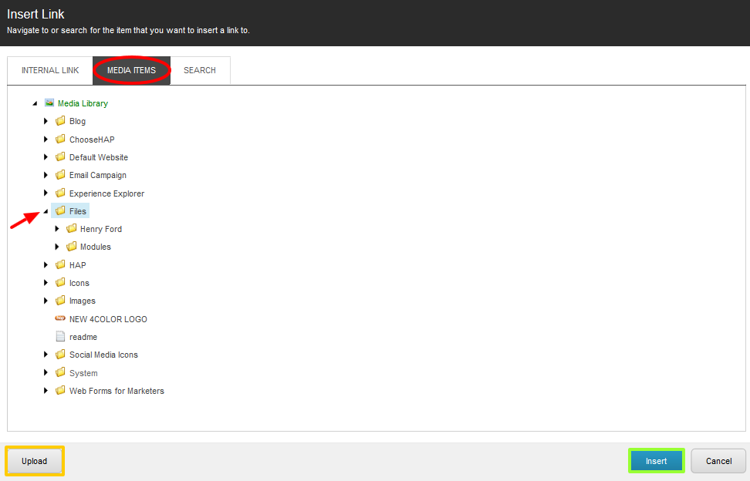

- 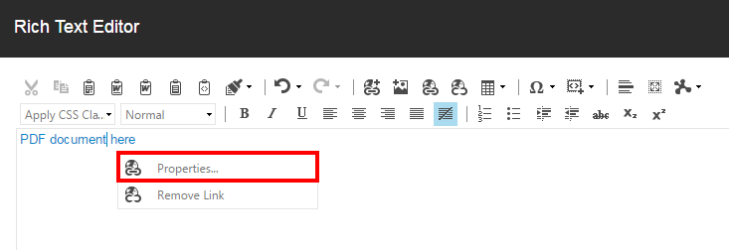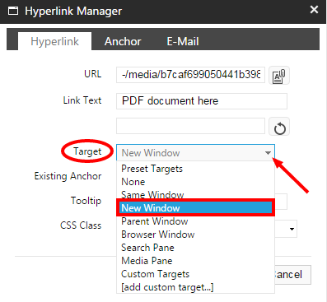To setup the link to open the PDF document in a new tab, right-click the link and select Properties. From the Hyperlink Manager window, click the Target dropdown menu and select New Window.

- If you cannot find the document or media item that you are looking for, then click the Search pane to use Sitecore’s search tool, which allows you to filter your search based on file type (selecting a media item will automatically generate the link – if not, click Insert).
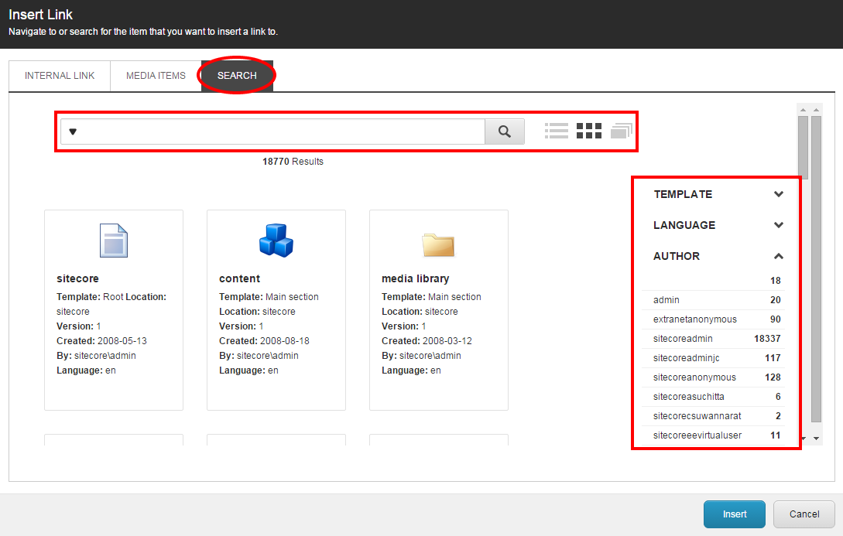

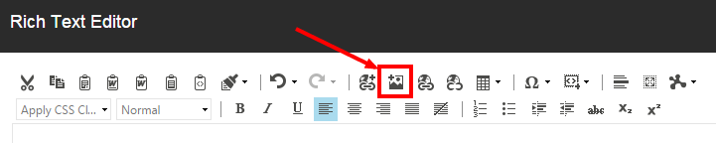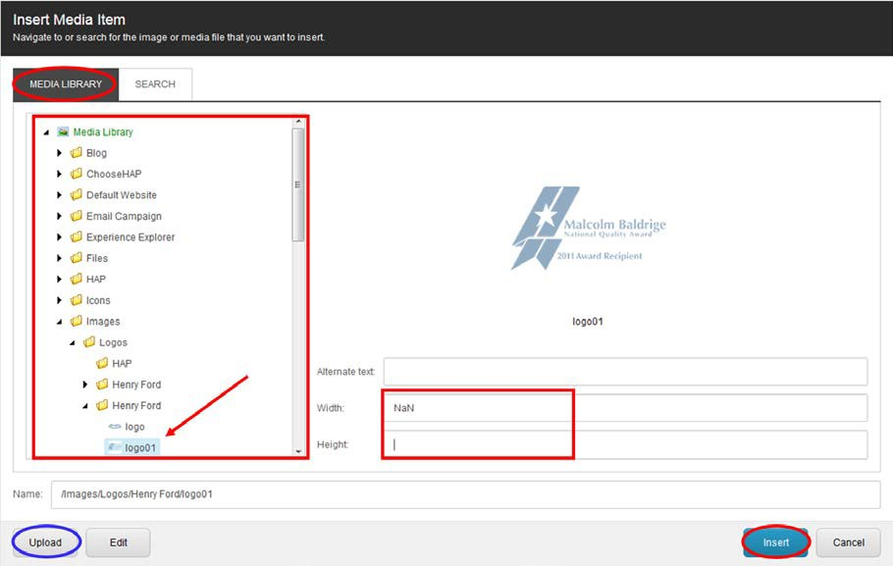

Using the Hyperlink Manager through the RTE

- Select the text that you want to link from the Rich Text Editor and then click the Hyperlink Manager button.
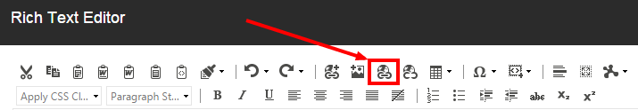
- Enter the full external URL, including the http:// or https://, into the URL field and use the
Target dropdown to open up the external URL in a New Window.
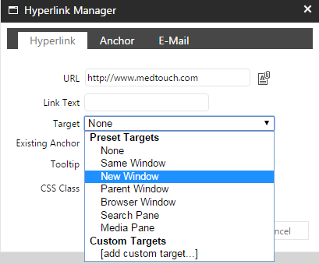

- To create an anchor link on the page, repeat step 1 placing cursor at the beginning of the text (rather than highlighting it), click on the Anchor pane, and then enter a name to identify the anchor.
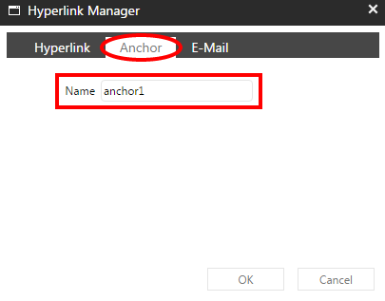
- Select a different text as the pointer, repeat step 1, and then use the Existing Anchor dropdown to select the anchor name to link to

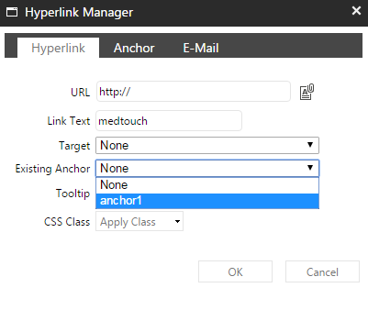

Editing CTA Components
To edit the Components on the Blog Home Page, navigate to the following path in the Content Editor and then select Experience Editor under the Publish tab in the Header Ribbon:
- sitecore/content/HFHS/HenryFord/Presentation/Partial Designs/Blog Landing

To edit the components that appear on the Blog Post side rail, navigate to the following path in the Content Editor and then select Experience Editor under the Publish tab in the Header Ribbon:
sitecore/content/HFHS/HenryFord/Presentation/Partial Designs/Blog:
- /sitecore/content/HFHS/HenryFord/Presentation/Partial Designs/Blog Post
  - Note: Any edits made to this “partial” will update all blog post pages.

Adding a CTA to the side rail
- To add a CTA component to a side rail, select the Add a New Component in the top left corner of the page.
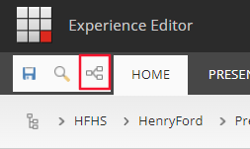

- Select Add here, to the container in which you want to add your CTA component.
  - 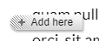
- Once the user has selected ‘Add here’ a ‘Select a Rendering’ window will appear.
  - Navigate to the rendering that you want displayed on the page by navigating through the rendering tabs.
    - To add an Image CTA, go to the Page Content Tab > and select Icon Promo tile.
    - To add a Simple CTA, go to the Page Content Tab and select the Promo tile.
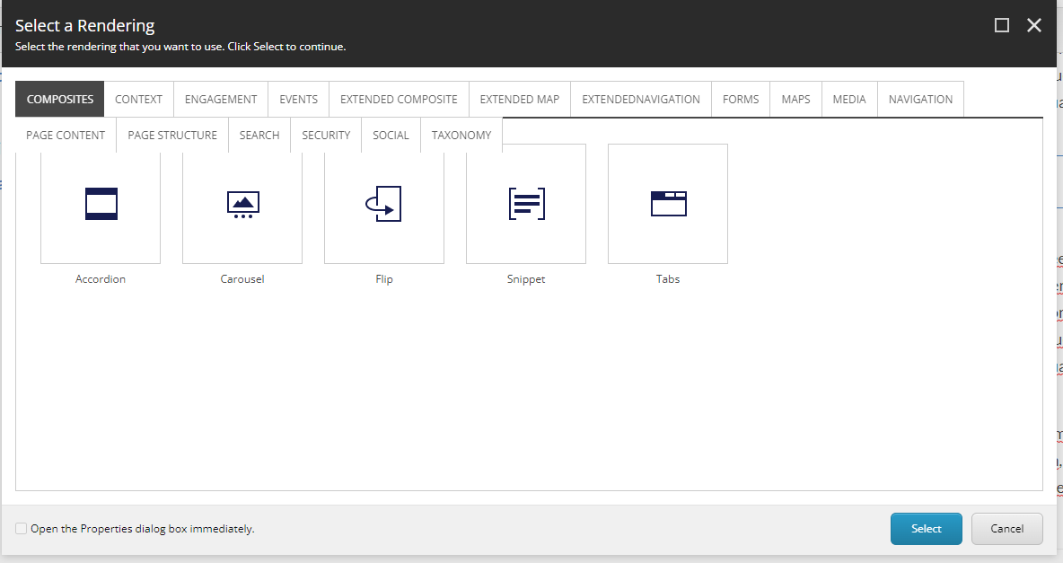
  - Once you have found the correct Rendering, select it’s tile and click “Select”.
    - Since the Rendering is a global component, a select the Associated Content
Window will appear.
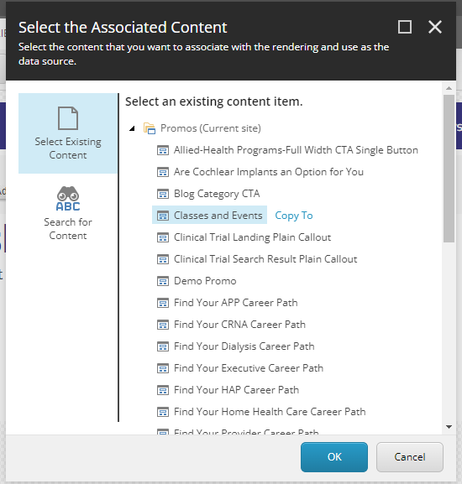
    - From the Associated Content window, the user can:
      - Select an existing component.
        - Select an item in the list and select Okay.
          - Note: Any changes to this component, will update the component in other locations it is used.
      - Copy an existing component.
        - Select an item in the list and select the Copy To link.
          - Changes will not influence the component that this component was copied from.
      - Create a new component or folder
        - This was done by selecting the folder at the top of the list and selecting the Create link.
        - An Insert Item window will appear and the user can create a Promo or Folder, set its name and select in the left hand site tree map where that promo or folder will be stored. Select Okay.

- Once a component has been added to a page, there are several things that can be done to the component through the Editing tool bar. This editing tool bar will appear once the component or element within the component is selected:
Exampe:
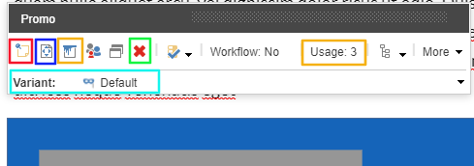

  - Sticky Note (Red) – Allows admins to create internal notes attached to a particular component for other admins or themselves to see in the future.
  - Move component (Blue) – Allows the user to move the component to another section of the page.
  - Paint bucket styling (Orange) – Opens the Paint bucket styling window, which enables the user to alter styling, indenting and other properties to the component.
    - Note: This will not be used for these components.
  - Delete Component (Green) – Deletes the component from the current page.
  - Usage (Orange) – Opens an Associated Content Window which allows the user to see where this component is used across the site as well as some general information about the component (Path, version, workflow state, last modified etc.)
  - Variant (Blue) – Allows the user to select the variant type. This rendering type applies certain stylings and fields to that rendering.
    - If a Promo Variant was selected, scroll down and select Simple CTA
- When adding a Simple CTA, and Step 3 has been completed, the first thing you will want to do is select the variant for this promo.
  - Simple CTA
  - Select the Variant Dropdown, scroll down and select Simple CTA.
    - To update the Heading, select the [No text in field] area that has heading styling and update the text.
    - To update the Content, select the [No text in field] area that has Content field styling and update the text.
    - To update the Button text and link, select the button area and select the Edit the link destination and appearance button.
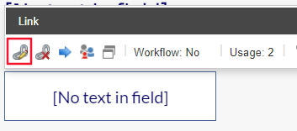
    - Upon selection, an insert link window will appear. Navigate to the link you want the button to navigate to and update the Link description to update the Button’s text.
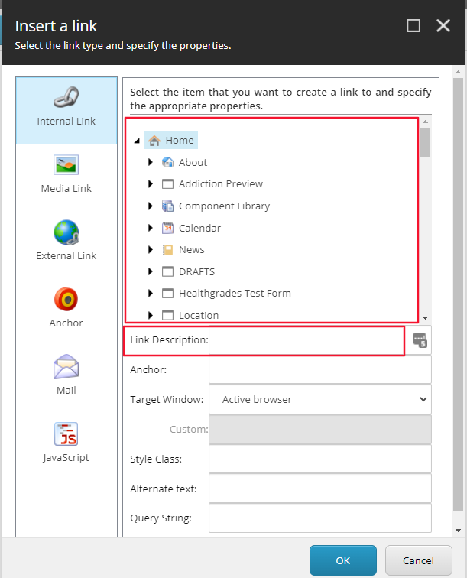
- When adding an Image CTA, and Step 3 has been completed, the first thing you will want to do is select the variant for this promo.
  - Image CTA
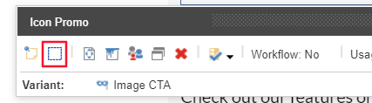
  - Select the Variant Dropdown, scroll down and select Image CTA.
    - To update the icon, select the item highlighted in red above and select the Icon you want associated with the CTA from the Icon dropdown field.
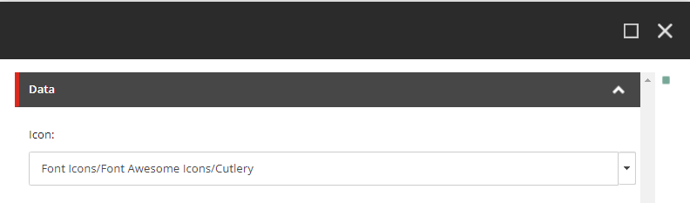
    - To update the Heading, select the [No text in field] area that has heading styling and update the text.
    - To update the Content, select the [No text in field] area that has Content field styling and update the text.
    - To update the Link text and link, select the Link area and select the Edit the link destination and appearance button (Exactly the same way as CTA above).

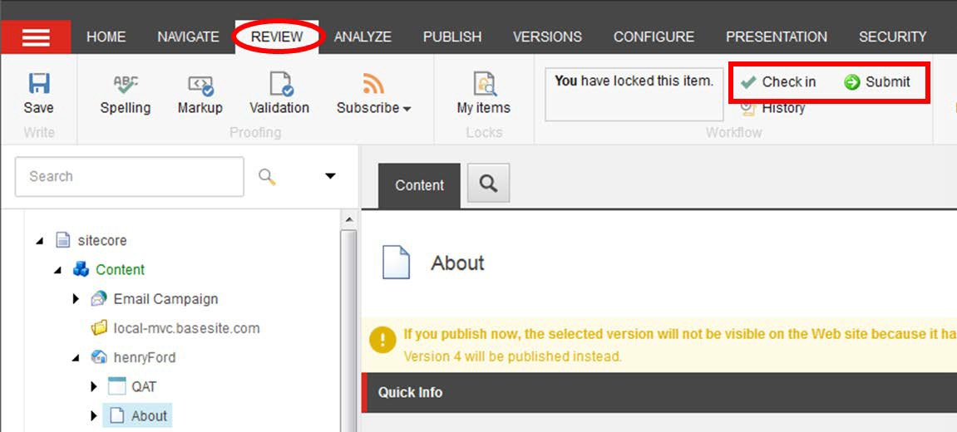

Submitting Your Page through the Blog Workflow

From the Content Editor
- When you are done with your edits, you can:
  - Check In: “unlock” the page from your account and make it available for other users to “lock” the page to their account; this action will keep the current version as Draft and therefore will not be Published
  - Submit: sends the most recent version to the staging area for an approval to be published by a publisher or an administrator

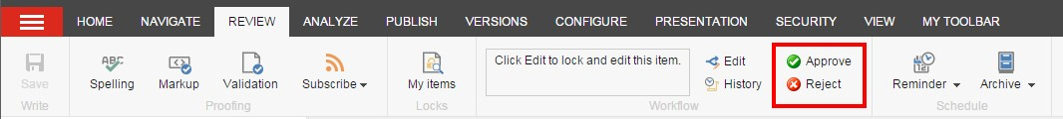
- If you have Publishing rights or are an Administrator, then you will see the Approve and Reject
buttons immediately appear after submitting your page.

- When you click Approve, the page will be staged for Publishing and when you click Reject, it will send the page back to the workflow as a Draft and will not be published.

From the Experience Editor
- After edits are made and then saved by clicking the floppy disk icon, the option to Submit will appear in a blue section. If you have Publishing rights or are an Administrator, then you will see the Approve and Reject links immediately appear after submitting your page.
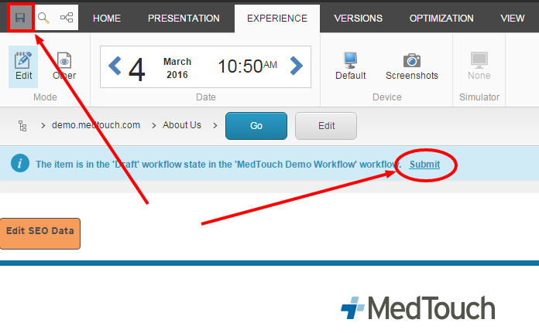

How to Publish Your Page

From the Content Editor
- Select the item or page that you want Publish, open the Publish ribbon and then click the Publish button (in red) or click the down arrow, and then select Publish Item from the drop down menu (in orange).
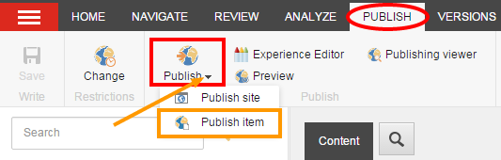

From the Experience Editor
- 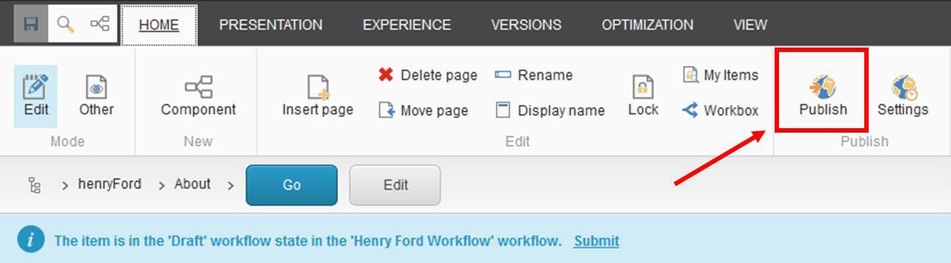Open the Home ribbon and then click the Publish button.

- Select the publishing targets and then click Publish to publish the item, its sub-items, and related items such as media items uploaded directly to the page.
