

BLUE FEATURE STRIP CTA
SITECORE SXA | HENRY FORD HEALTH

Blue Feature Strip CTA: Adding through the Experience Editor

To add a Blue Feature Strip CTA:
- Select the Add component icon in the top left corner and select the +Add here button from an area all the way on the left-hand side of the page. You must select from the side to add the Blue Feature Strip CTA with proper formatting.
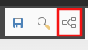
- Select the Page Structure tab, Section Container and then Select.
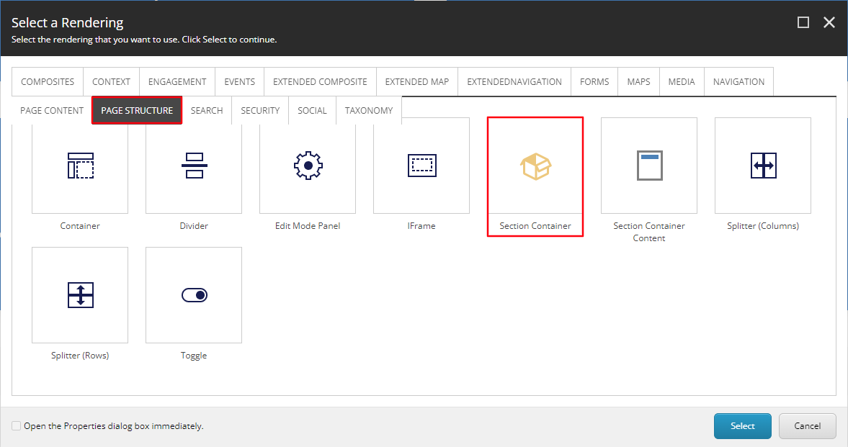
- Once the Section Container appears, select the checkered area, and then + Add here.
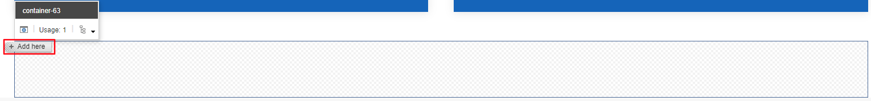
- In the Select a Rending window, select the Page Content tab, then select Icon Promo and Select.
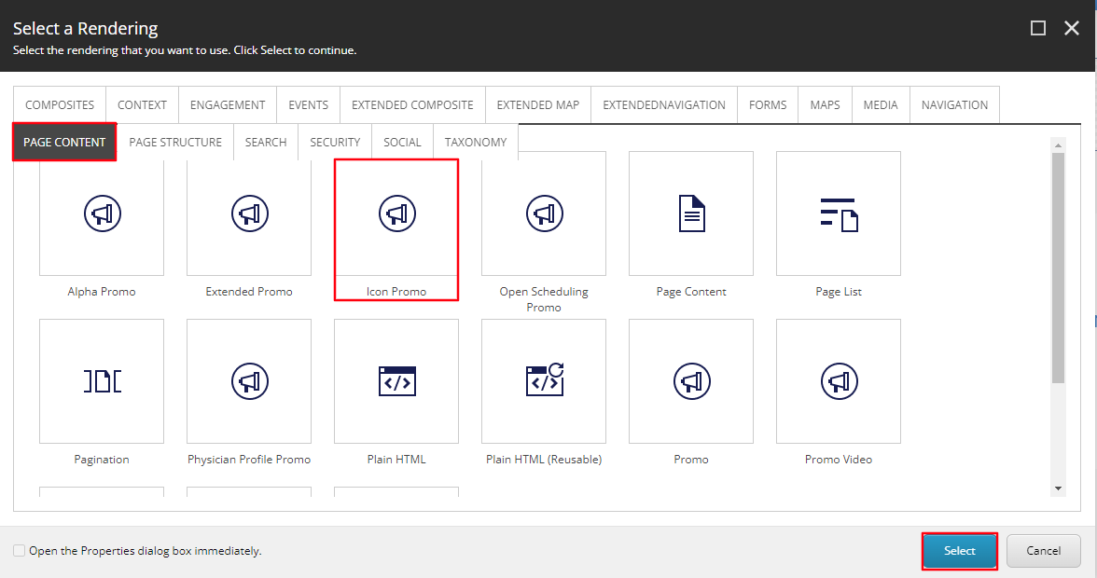
- Select the Blue Feature Strip Folder (or the folder you wish to have this promo stored under) and then select Create.
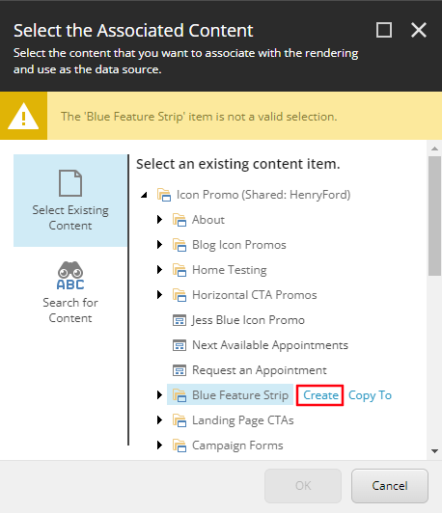
- In the Insert Item window, either create an Icon Promo folder or an Icon Promo and assign a Name to it in the bottom field and select OK.
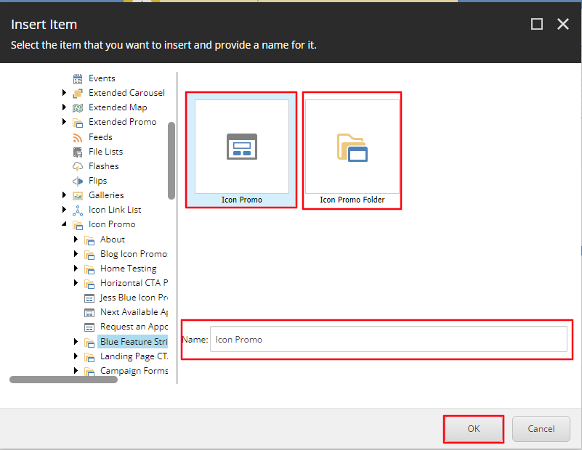
- The CTA will load on the page after a few seconds. Once it does, select the Icon button from the Icon Promo toolbar.
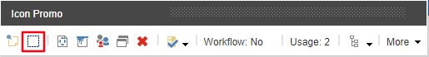
- Select the Icon you want displayed from the Icon Dropdown and select OK.
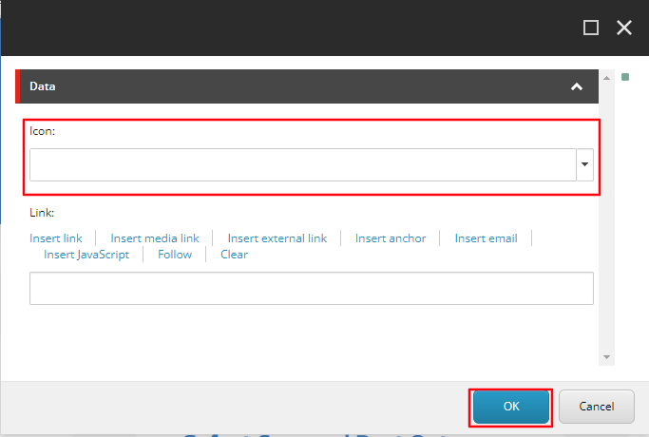
- Select Save in the top right corner for the Icon to display.
- To edit the Heading (Red) and Content Copy (Blue) select the [No text in field] for each field respectively and typing the text you want to display.

  - Note: If a text field is not edited, it will not appear on the front end.
- To edit the Link text (Orange) and link destination, select the text area and select the “Edit the link destination and appearance” icon.
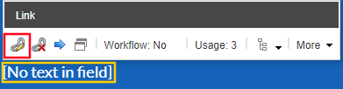
- Once selected, an Insert a Link window will appear. From here you can either:
  - Set the button to an internal link, by selecting the page from the Tree node and setting the Button Text through the Link Description field.
  - Set the button to an External Link by entering the external URL into the URL field and then setting the Button Text through the Link Description field.
  - Set the button to a Mailto: link by entering the email address into the Mailto field and then setting the Button Text through the Link Description field.
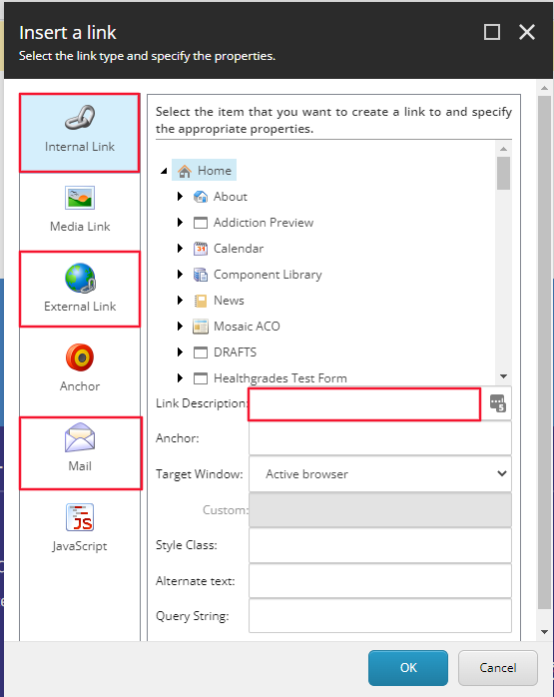
  - Note: If a text field is not edited, it will not appear on the front end.
- Select Okay.
- To make the CTA the proper size, select the Edit style and behavior of the component (aka. Paint bucket styling) icon.
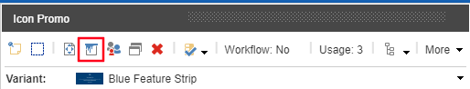
  - A window will appear. From here, under the size section add 6 to the Tablets field and select Okay.
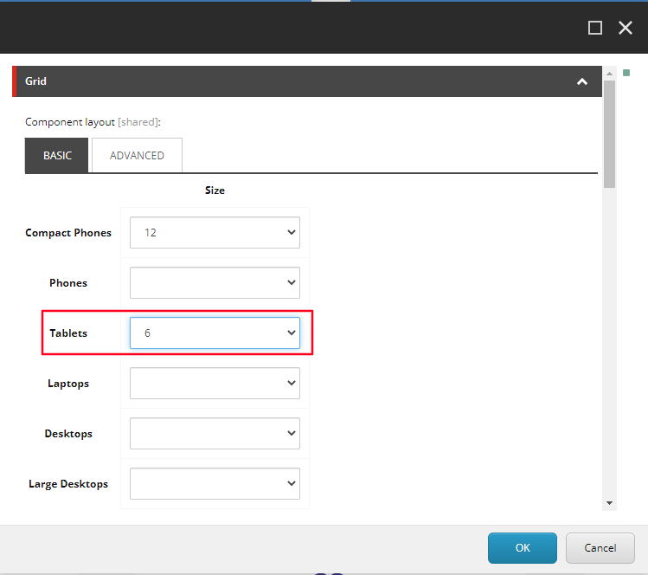
  - Note: Select Save, the CTA will now be the correct size.
- To add a second Blue Feature Strip CTA, select the Add component icon in the top left corner and select the +Add here button from an area above or beneath the Icon Promo you just created.
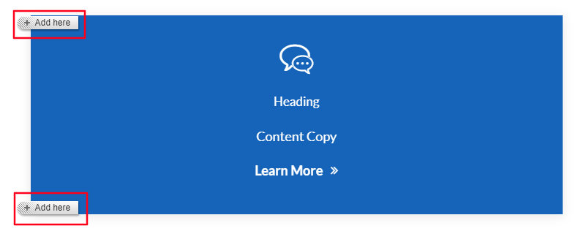
  - Note: Selecting the one above will add the new CTA to the left of this CTA, selecting the one below will add the new CTA to the right of the CTA.
- Follow the same steps outlined from 4 – 14. Once step 14 is created, your Blue Feature Strip CTAs should be ready publishing.
- When Publishing, it is recommended to have Smart publish and Publish related items both checked.

