CALENDAR & EVENTS ENTRY AND CONFIGURATION
SITECORE SXA | HENRY FORD HEALTH

Table of Contents
The Launchpad – The Experience Platform 3
Navigating to your Calendar Module 4
Configuring Your Calendar Module 5
Adding a New Category 6
Adding a New Location 7
Adding a New Promo Code 9
Adding a New Event 11
Adding Event Details 14
Adding an Event Session 19
Event Registration Management 22
Submitting Your Item through the Workflow 22
How to Publish Your Item 24
Appendix I: Setting Up a Recurring Event 25

Logging into Sitecore

- Enter your User Name, Password, and then click Login to log into Sitecore

- Forgot Your Password – enter in your User Name to have Sitecore email you a newly generated password (this may go to your junk email folder – sender: donotreply@website.net)

- It is recommended that you use either Chrome, Mozilla or Edge.

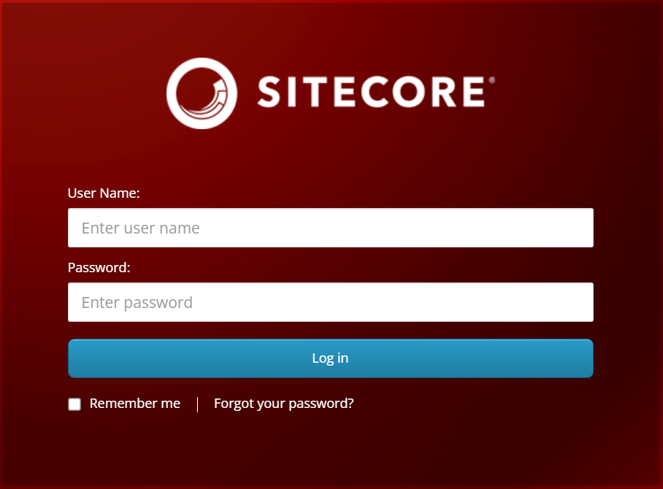

The Launchpad – The Experience Platform

Note: Based on the access rights of your account and role, your launchpad may look different.

- The Sitecore Launchpad is well organized in the following categories:
  - Green – marketing and analytics tools
  - Red – content editing tools
  - Orange – tools to organize your digital assets and page workflows
  - Black – recycle bin to retrieve your deleted items
  - Blue – account configuration, system setup and app installations
  - Purple – user account settings

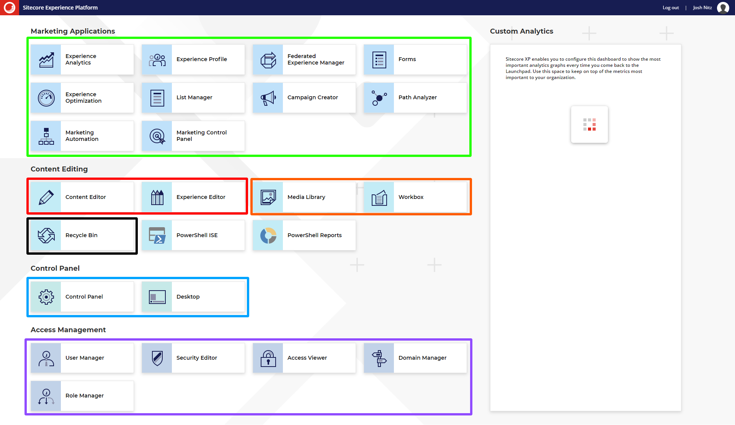

- The contents of this document will focus on:
  - How to change your password
  - How to navigate the SXA framework and edit your page’s front-end and backend content through the Experience Editor.

Navigating to your Calendar Module

To Start Editing your Physician Directory
- Select the Content Editor button.
  - To start editing from the backend select the Content Editor button
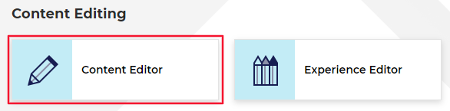
- The Content Tree contains all your website’s pages, items, and modules (including Calendar).
  - Note: The Calendar Events and Topics that are found in live will be found under the HFHS > HenryFord > Home > Calendar node.
  - Setup your Content Editor with the appropriate settings and menus by opening the View ribbon and having the following checkboxes checked:
    - Content Tree (checked by default)
    - Entire Tree
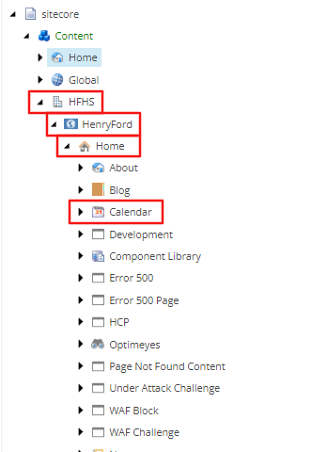

Configuring Your Calendar Module

1. Go to the Content Tree, open Global, and then open the Calendar folder.
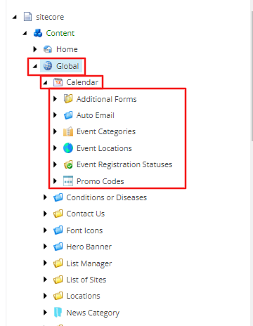

Adding a New Category
- Right-click the Event Categories folder, select Insert, and then Event Category (The insert Event Category Folder option can be used to group categories).
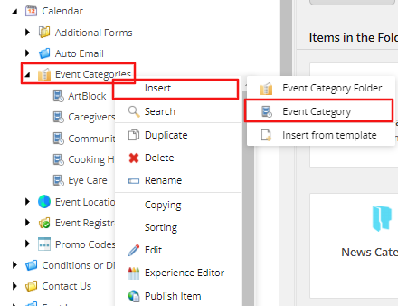
- Enter the category name and then save and publish the item (the name given will be displayed on the front-end of the module).
Note: to edit an existing name, select the category that you want to edit and update the
Category Name field and then save and publish.
Note: if no active classes are associated with the category, then it will not show as an option in the front-end.
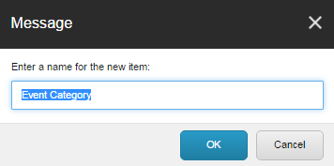
- Save the item and Publish the parent folder (details about publishing).

Adding a New Location
- Right-click the Event Locations folder, select Insert, and then Event Location (The insert Event Location Folder option can be used to group locations).
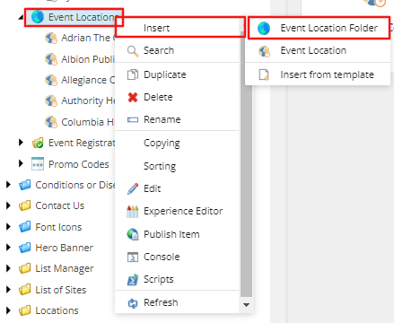
- Enter the Location name when prompted and then click OK.

- Fill out the following fields:
  - Location Name – this should default to the name you gave when creating the location profile; click inside the field to edit the name of the location.
  - Address 1, Address 2, City, Zip Code and State – click inside each field to add the appropriate information; these fields are connected to Google API to calculate latitude and longitude for dynamic Google Maps creation and radius calculation.
  - Main Phone – click inside the field and enter the Main Phone Number.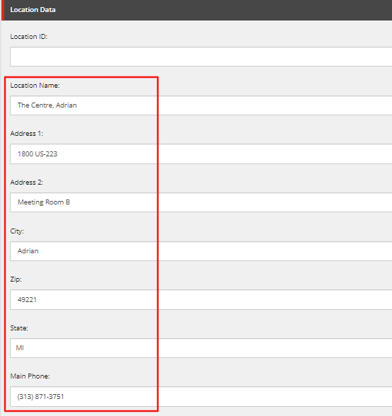

- Save the item and Publish the parent folder (details about publishing).

Adding a New Promo Code
- Right click on the Promo Codes folder, select Insert, and then Promo Code (The Promo Code Folder option can be used to group promo codes).
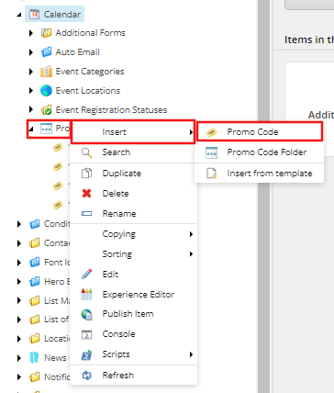
- Enter the Promo Code name when prompted and then click OK.

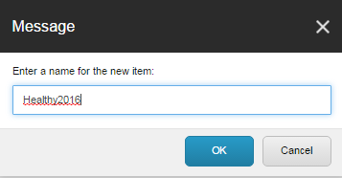

- Promo Code Data fields:
  - Promo Code Name (Red): click the field to add the actual code that users will enter to receive the discount
  - Description (Orange): click the field enter a description
  - Amount (Green): Enter dollar or percentage off amount in the Amount field. Checking the Is Percent box tells the system that the discount amount is a percentage
  - Is Active (Blue): checking this box (default) is needed for Promo Code to be active
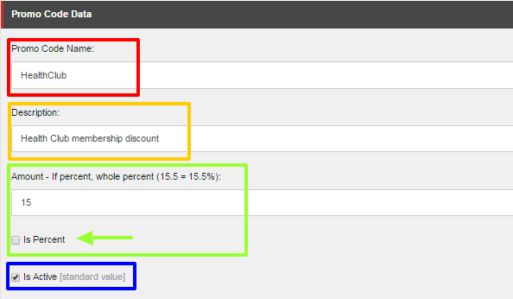
6. Save the item and Publish the parent folder (details about publishing).

Adding a New Event

- Select the Calendar module, right-click it, and then select Insert.
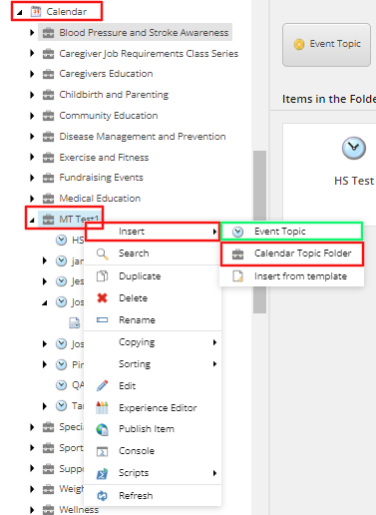
From here you can:

  - Insert a Calendar Folder (red) – using this is highly recommended to help organize your events based on service lines, dates, categories, or departments.
  - Insert an Event Topic – (green) use this option to create an event with one registration price.

- After creating a new event, enter a name for the event.
Note: this name will be part of the event detail page’s URL.
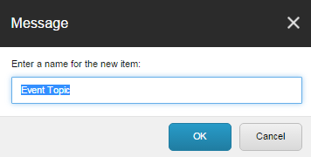


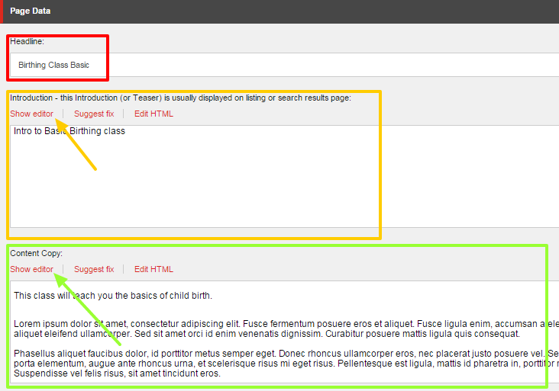

Adding Event Details

- Page Data fields:
  - Headline (Red) – Click inside the field to edit the displaying title of the page; this defaults to the name given when creating the event profile.
Note: do not include the word "success" it will conflict with the payment gateway
  - Introduction (Orange) – a short summary about the event for your website’s Site Search only and it will not display on the web page; click Show Editor to open up the Rich Text Editor to edit or enter text.
Note: if this field is left empty, the system will automatically use the first 150 characters of your content copy
  - Content Copy (Green) – any relevant information about the event such as a detailed summary of the class; click Show Editor to add content.

- Tagging fields:
Depending on how your website is set up, you may choose to use one, multiple, or none of these fields. Associate the event to the tag item(s) by highlighting the term(s) on the left side (All) and moving it over to the right side (Selected) by using the blue arrows.
Note: please contact your administrator if uncertain on how to proceed.
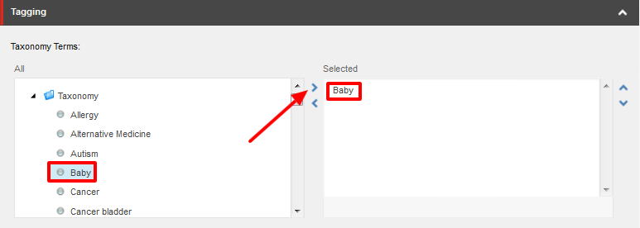
- Event Topic Data:
  - Event Thumbnail (Red) – click Browse to select a thumbnail image from the media browser.
  - Event Categories (Orange) – select a category or categories that are associated with the event by using the blue arrows to move an item from All to Selected.
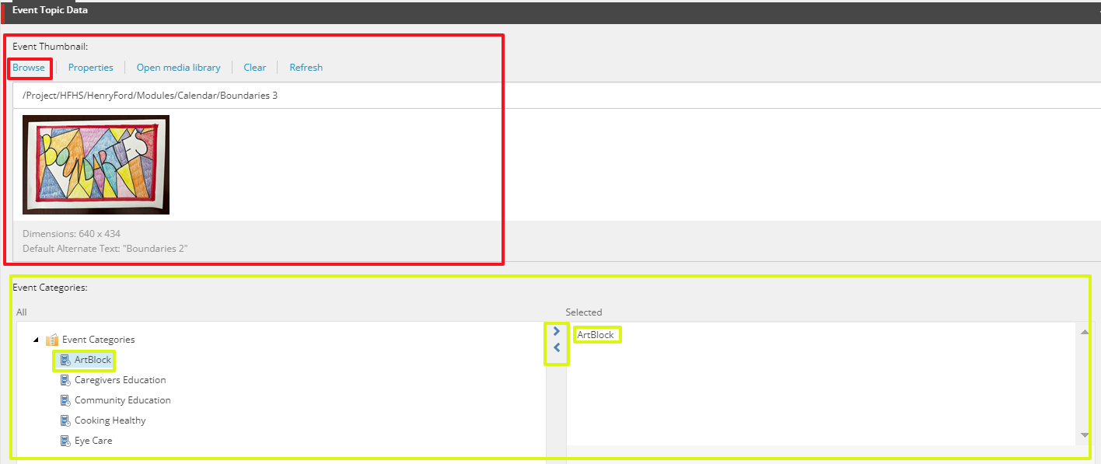

  - Event Contact Name (Red) – click inside the field to add the name of the event contact
  - Event Contact Phone (Orange) – click inside the field to add the phone number of the event contact
  - Event Contact Email (Green) – click inside the field to add the email of the event contact
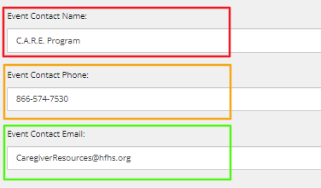

- Registration Data fields:
  - Requires Registration (Red) – if checked, then user must complete registration form to register for the event
  - Registration Instructions (Orange) – additional registration information can be added here; click Show Editor to edit or enter information
  - Email Notification (Green) – click inside the field to add the email of the person that should be notified when someone registers for the event
  - Fee (Blue) – click inside to enter the cost of the event
Note: multiple event fees are entered in a different section (refer to Adding Multiple Fees appendix)
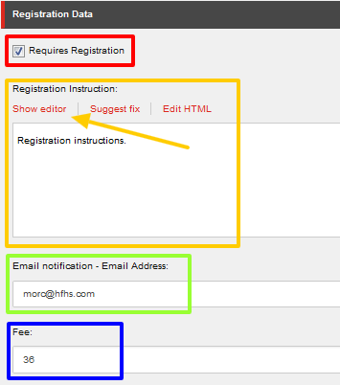

- Premium Registration Data fields:
  - Promo Codes (Red) – select the promo code from the All column using the blue arrows to add to the Selected column
  - Send Reminder Days Before (Orange) – when the system should send a reminder email to the registrants
  - Internal Code (Green) – depending on your organization, use this field to enter an internal number for billing
Note: do not include the word "success" it will conflict with the payment gateway
  - Additional Form (Blue) – some events require additional registration information and additional custom forms can be added using this dropdown.
  - Additional Form Height - No longer included or necessary.


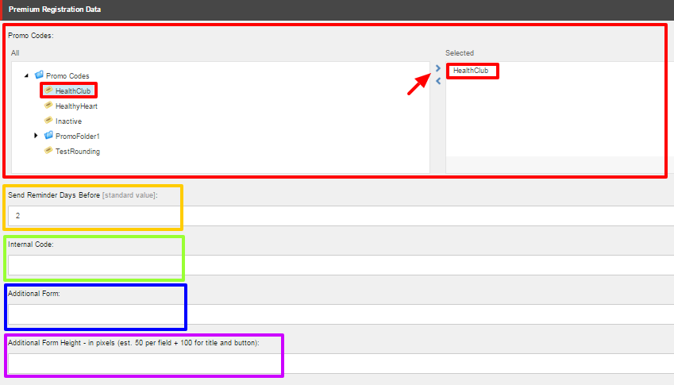

- To display the event sessions related to this event throughout the site for the public to view, check the “Show in Site Search Results” checkbox within the Site Search Settings.
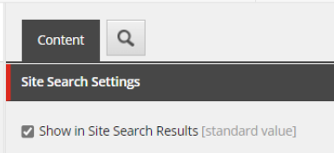
Note: Upon checking “Show in Site Search Results”, the event sessions will appear in the global site search results, calendar search results, and the “Classes & Events” tab of the Show Me component.
- The next step is to add Event Sessions. Without active sessions, the event will not display on the front-end of the website.

Adding an Event Session

- Select the event that you want to add sessions to. Right click on the event, select Insert and then select Event Session (insert Event Session Folder to organize and group the sessions such as the year or month of the sessions).
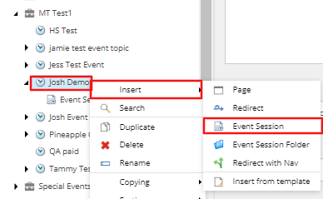

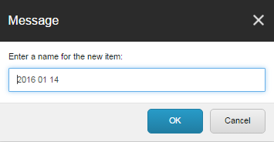
- Name your event session when prompted and then click OK.

- Fill in the Event Timeslot Properties in the Event Timeslot Properties section of the new session:
  - Session Start Date – Type date and time in each box or select from calendar menu by clicking the arrows.
  - Session End Date – Type date and time in each box or select from calendar menu by clicking the arrows.
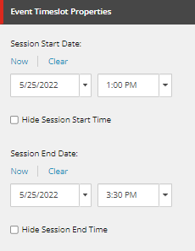

- Fill in the Event Session Data fields in the Content tab of the new session:
  - Event Location (Orange) – select the location of the event using the dropdown.
  - Virtual Online Link (Green) – If the event is online, you can leave the Event Location field blank and add a Virtual Online Link which will display in place of the Event Location.
  - Is Ongoing (Red) – check this box if the event is an ongoing event (for example, a yoga class that occurs all year round and the registrant can attend any session)
  - Attending Dates information (Orange) – Click Show editor to enter additional dates of the event if it is a series

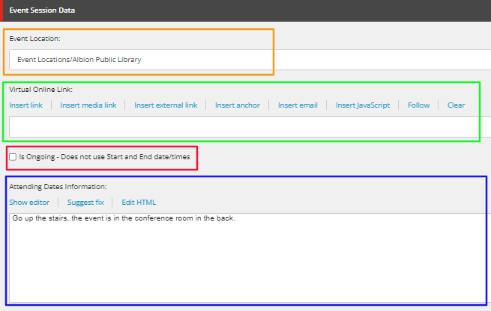

- Registration Data fields:
  - End Date (Red) – last day to register for this session (registration will close on this date)
  - Capacity (Orange) – the number of allowed registrants for this session
  - Promo Codes (Green) – select the promo code(s) using the blue arrows to move from
All box to the Selected box
  - Reminder Set Time (Blue) – This field will no longer appear.
  - Wait List Capacity (Purple) – enter maximum size of wait list in the field

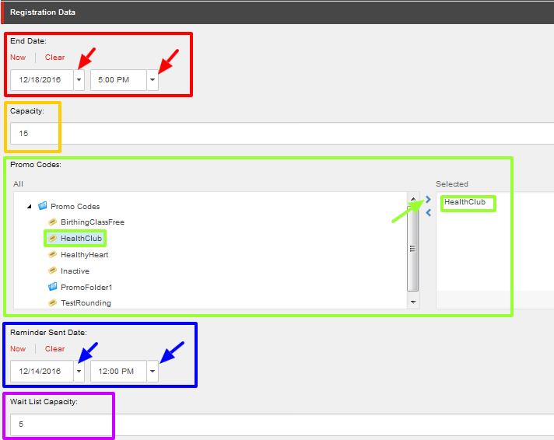

Event Registration Management
The Event Registration management is a tab which enables you to Edit and Export Registrants for individual Event Sessions.
- Navigate to the Event Session you are interested in reviewing. The Registrations Tab will be displayed by default (takes a few seconds to load) and if there are registrants that have signed up for the event a Table will be displayed with the information pertaining to each registrant.
  - 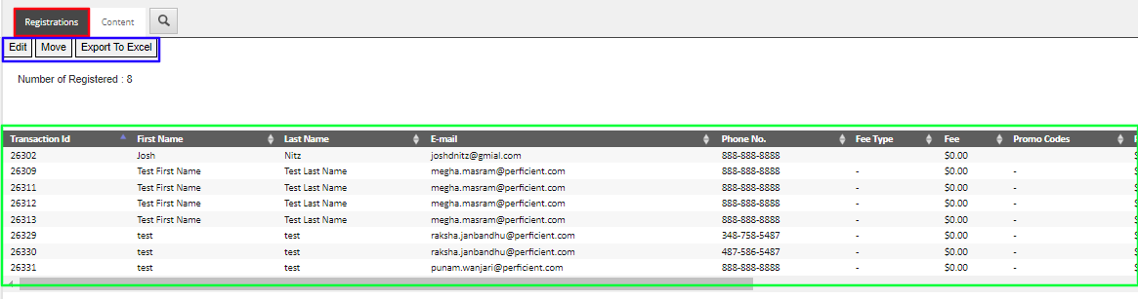
  - If there are 0 Registrants for the event session, the Table will not display.
- To Edit a registrant’s information, select the row of the registrant and select the Edit button at the top of the Tab Area (blue).
- An Edit Registration Window will appear and allow you to change the Name, Address, Phone Number, and Status of the registrant, as well as any information that was entered into the Additional Form fields.
- To Save your updates, scroll down to the bottom of the window and select OK.
  - Select Cancel to cancel your changes.
- To export the list of registrants of the Event Session to an Excel File, select Export to Excel. Wait a few seconds and an Exported version of the table will be downloaded to your computer.

Submitting Your Item through the Workflow

- When you are done with your edits and have saved your work, from the Review tab you can:
  - Check In: “unlock” the page from your account and make it available for other users to “lock” the page to their account; this action will keep the current version as Draft and therefore will not be published.
  - Submit: sends the most recent version to the staging area for an approval to be published by a publisher or an administrator.

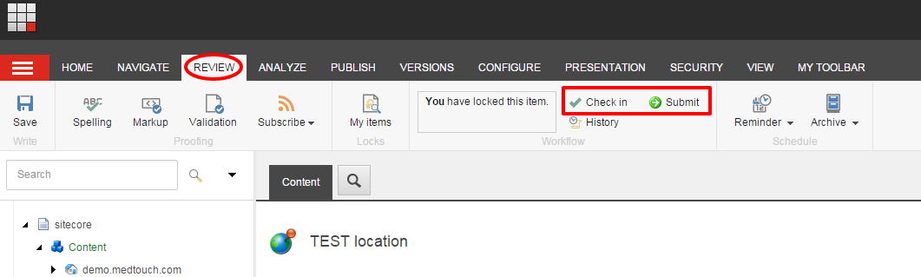
- If you have Publishing rights or are an Administrator, then you will see the disabled Approve and Reject
buttons immediately appear after Submitting your page. To enable the buttons, select Edit.
Note: You can ignore the Approve with Test for the purpose of this section.
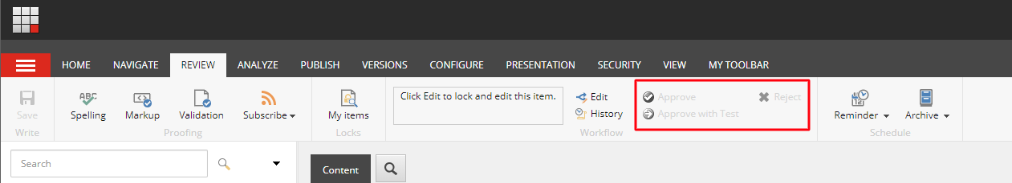

- When you click Approve, the page will be staged for Publishing and when you click Reject, it will send the page back to the workflow as a Draft and will not be published.

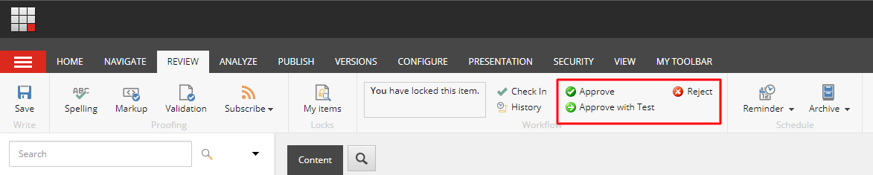

How to Publish Your Item

- Select the item or page that you want Publish, open the Publish ribbon and then click the Publish button (Red) or click the down arrow. Then select Publish Item from its drop-down menu (Orange).

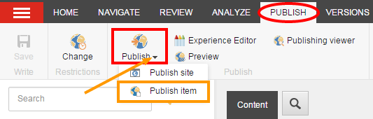
- Click Publish to publish the item, its sub-items, and related items.

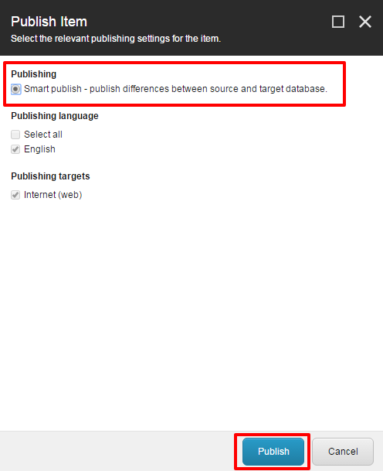

Appendix I: Setting Up a Recurring Event

- Create the event and add one session to the event that will have recurring sessions. *Note: the first session created is counted as the first session of the recurring series. Use this option to set up recurring sessions occurring after the first session.

- Select and highlight the first session (NOT event topic). Right click the first event session under the event topic and select Add Recurrence.
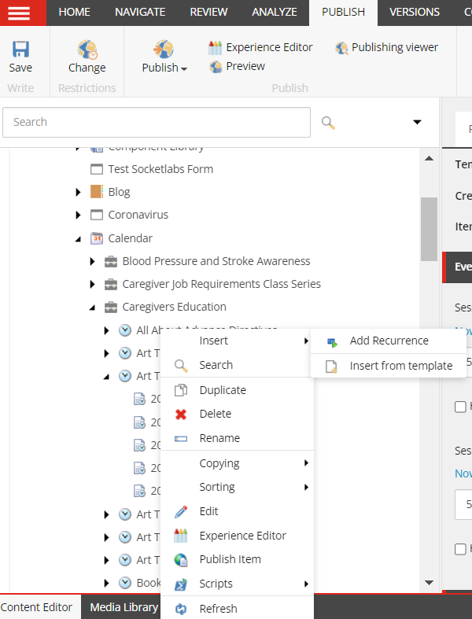

- Recurring events can be setup by:
  - Weekly Recurrence – Select the radio button next to Weekly sessions that will recur multiple times a week; check the days on which the event will occur.
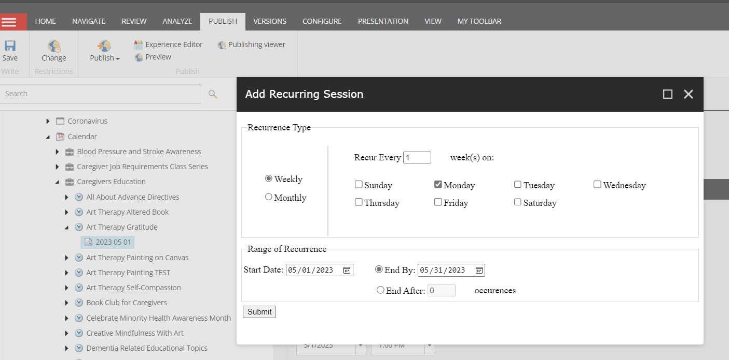

  - Monthly Recurrence – Sessions that will recur multiple times a month; select the Date (for example, 14th, 22nd, etc.) of the month on which the event will occur or select the day (for example, Monday, Tuesday, etc.) of the month on which the event will occur.
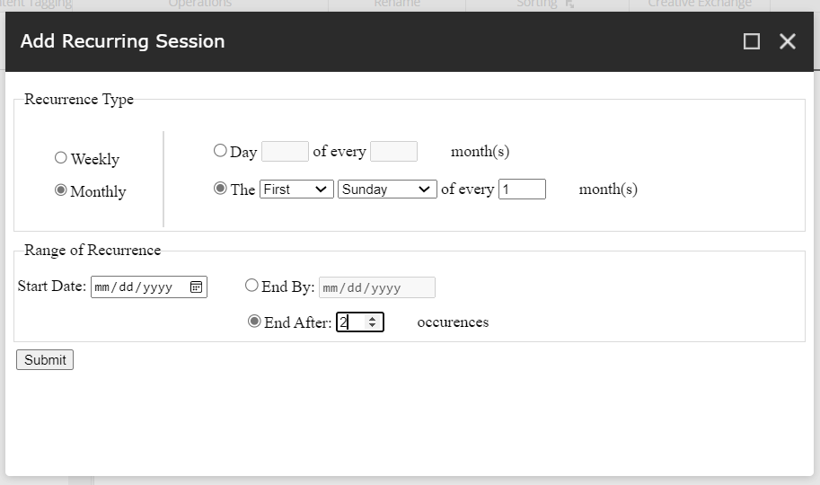

  - Range of Recurrence – Enter the Start Date of the recurrence and enter either an End Date or number of sessions for the recurrence in the End After field.
    - When entering a number of sessions in the End After field, the recurrence will end after that number of sessions.

- When done editing the recurrence details click Submit. All sessions will appear beneath the first session under the event. *Note: Individual sessions may be edited at any time. You may have to click Refresh in order for the sessions to appear.

- To organize the recurrences under an event, create folders to store a series of recurring sessions. This is helpful when more than one recurrence exists under an event or if you would like to keep track of when the sessions are recurring. Right click on the event, hover over Insert, and click Event Session Folder.
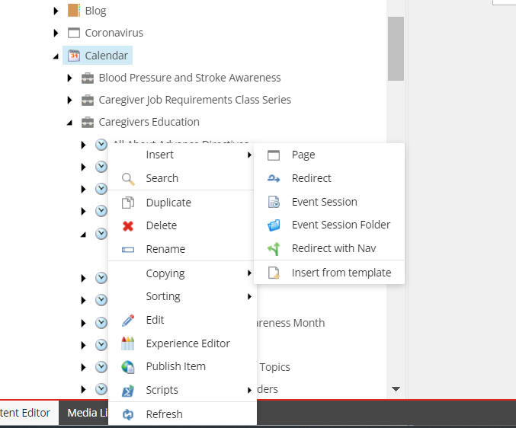

- Enter a name for that folder in the window that launches. Click Ok save the folder under the event. *Note: It will be helpful to name the folder according to the type of recurrence you have created for the event to remember in the future which exact recurrence is being stored in the folder. For example, if the recurrence is to occur every first Monday of the month, the folder name shown below can be used including the Start Date on which the recurrence will begin.
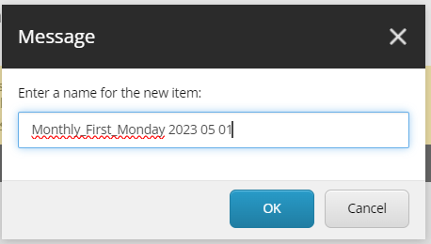

- To move sessions into a folder, drag and drop the sessions over the desired folder under the event.

- When done, click Save and Publish on the parent Event to make the sessions live on the site.

