

SITECORE FORMS & FORMS MANAGMENT
HENRY FORD HEALTH

Table of Contents
The Launchpad – The Experience Platform 3
Campaigns Page Designs and Components 4
Campaigns Header 4
Adding a Form to a Campaign Landing page 5
How to Publish Your Page 9

Logging into Sitecore
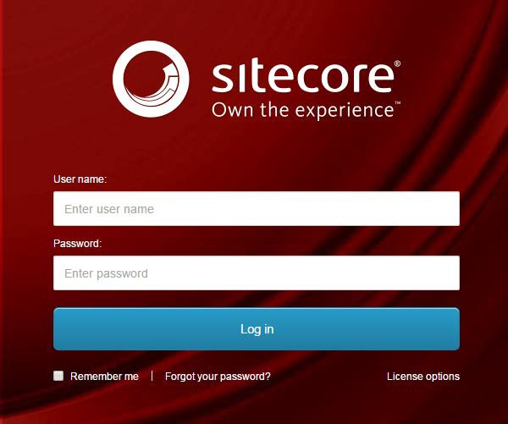
- Enter your User Name, Password, and then click Login to log into Sitecore

- Forgot Your Password – enter in your User Name to have Sitecore email you a newly generated password (this may go to your junk email folder – sender: donotreply@website.net)

- It is recommended that you use either Chrome or Mozilla.

The Launchpad – The Experience Platform

Note: Based on the access rights of your account and role, your launchpad may look different.

- The Sitecore Launchpad is well organized in the following categories:
  - Green – marketing and analytics tools and Sitecore forms
  - Red – content editing tools
  - Orange – tools to organize your digital assets and page workflows
  - Black – recycle bin to retrieve your deleted items
  - Blue – account configuration, system steup and app installations
  - Purple – user account settings

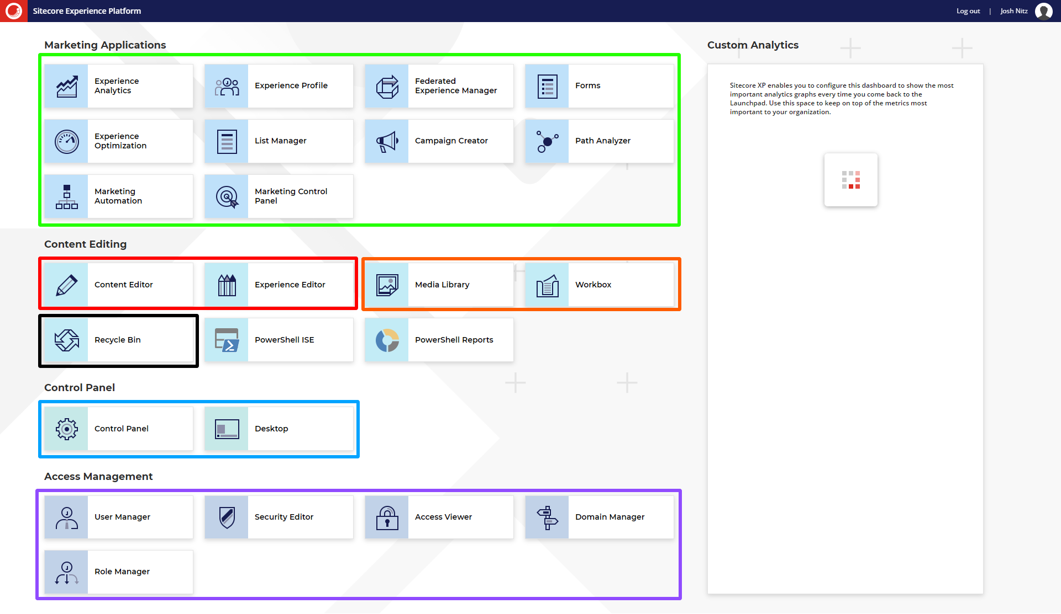

- The contents of this document will focus on:
  - How to change your password
  - How to navigate the SXA framework and edit your page’s front-end and backend content through the Experience Editor.

Campaigns Page Designs and Components
Campaign pages are typically stand-alone pages that allow content editors to have more control over the front-end experience. There are three Campaign Page designs that allow for flexibility of what can display on the front-end.

Campaign Templates:
- Campaign Landing
  - Contains a Form of the Right side of the page.
- Campaign Landing No Form
  - No form and all content is centered in the middle of the page.
- Campaign 2 Column Wide Right Generic Page
  - No form, contains proximity nav and is best for Campaign that have sub-pages.
The only truly unique components on campaign pages are Campaign Forms and Campaign Headers and therefore this training doc will only cover these two elements.

Campaigns Header
To edit the Header of the Campaign page, you will need to edit in the Content Editor.
Under the Header Section, there are 3 fields.
- To change the Logo (default Logo is logo used on the rest of the site), select Browse and select the image of the logo you wish to display.
- Alter where the user is navigated to when they select the Image in the header mentioned above by selecting the Logo Link field. These links can be external, internal or mail to links.
- To set the text or links that appear in the right of the Campaign header, select the Text and Mobile Content Field.
  - When the RTE field appears, it is recommended selecting the HTML tab at the bottom of the window to make edits. This ensures that you maintain the styling classes that make the header look good.
  - To edit the Text that appears in the Header, edit the text highlighted in Green.
  - To edit the Phone Number, edit the text that appears highlighted in blue and the value of the phone number in purple.
  - 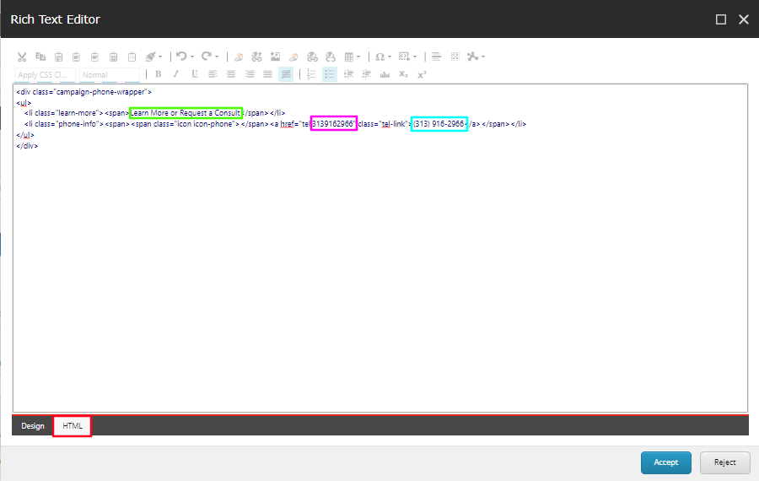
  - Once completed, the front-end should look something like this.

Adding a Form to a Campaign Landing page
From the Experience Editor
Adding Campaign Forms follows a slightly different experience than “normal forms”. Please refer to the following section for assistance around Campaign Forms.
- On a Campaign Landing page design, open the Home ribbon and then select Component. Gray + Add here buttons will show on the page to show you where you can add new components.
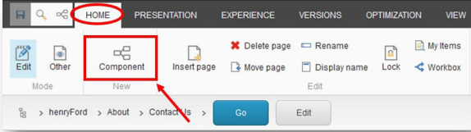
- Click one of the + Add here buttons in the Right Side Rail Panel area, the area of the page where the campaign forms are placed.
- In the Select a Rendering window, select Page Structure then select Container.
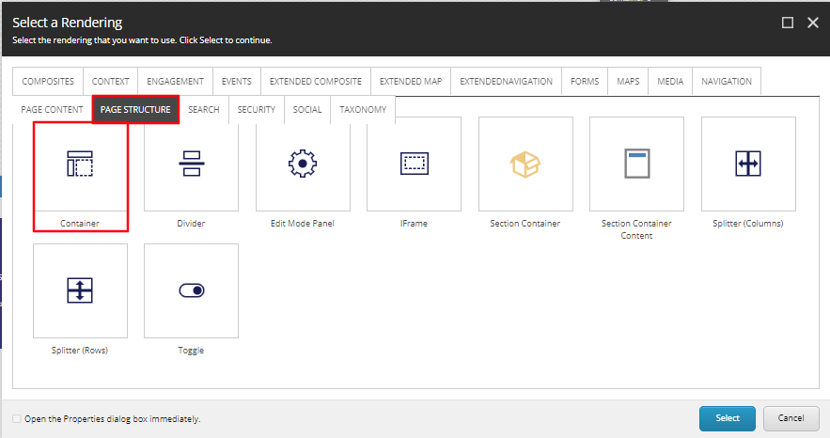
- On load of the Container, select the Paint bucket icon. In the window that appears, scroll down to the Styling section and under Background color, select Blue Background. Select OK.
- Select the Blue Container that was just created and select + Add here.
- In the Select a Rending window, select the Page Content tab, then select Icon Promo and Select.
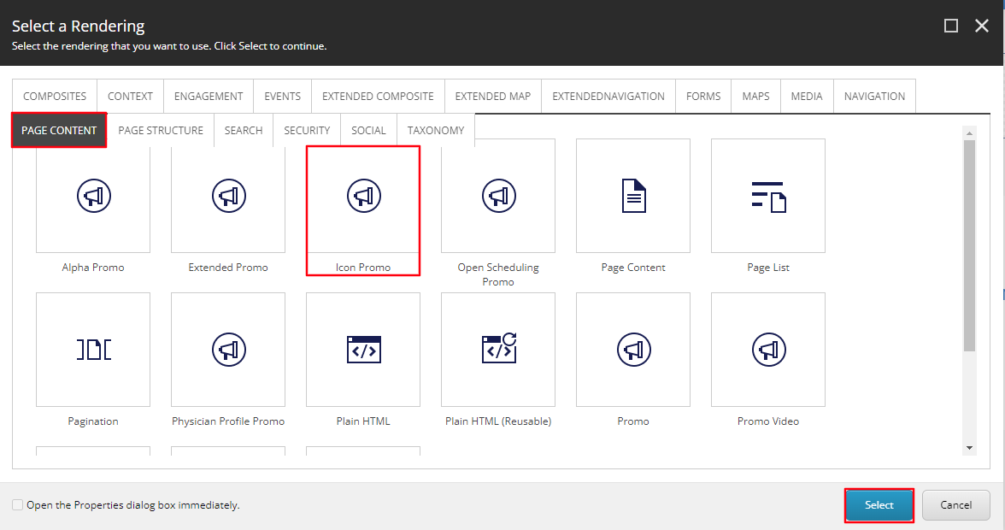
- Navigate to the Campaign Forms folder and then select Create.
- In the Insert Item window, either create an Icon Promo folder or an Icon Promo and assign a Name to it in the bottom field and select OK.
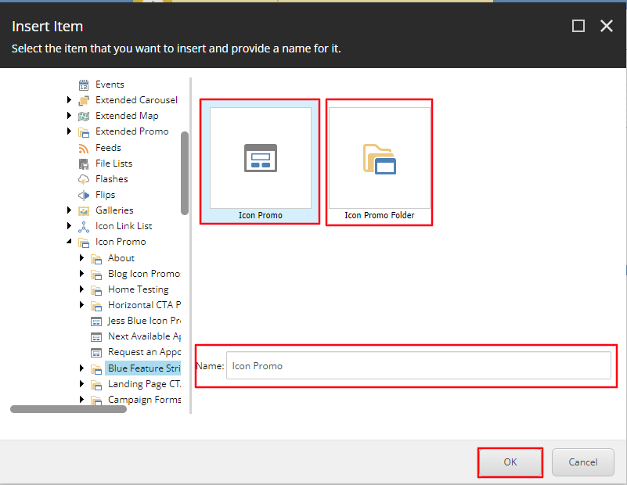
- The CTA will load on the page after a few seconds. Once it does, wait a few more seconds for the Variant Dropdown to appear under the Icon Promo Toolbar, then select the Form Icon option from the Variant Dropdown.
- To edit the Icon displayed, select the Icon button from the Icon Promo toolbar.
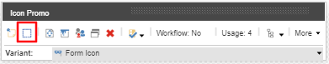
- Select the Icon you want displayed from the Icon Dropdown and select OK.
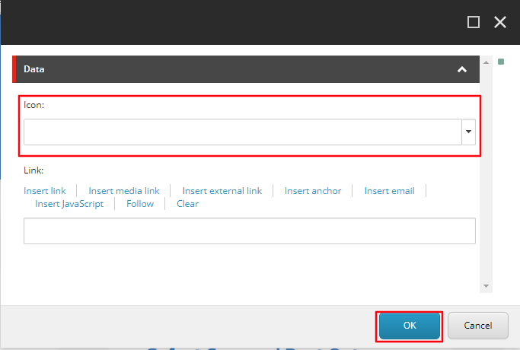
- Select Save in the top right corner for the Icon to display.
- To edit the Heading (Red) and Content Copy (Blue) select the [No text in field] for each field respectively and typing the text you want to display.
- Next, open the Home ribbon and then select Component. Gray + Add here buttons will show on the page to show you where you can add new components. Click the + Add here buttons in the Right Side Rail Panel area below the Icon promo you just created. Select the Forms tab and select the Sitecore Form Wrapper rendering and click Select.
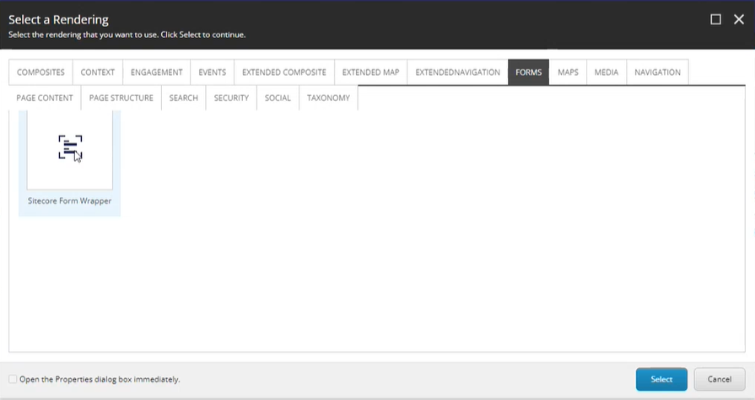
- Then select the container where that Sitecore Form Wrapper appeared and select the +Add here button.

- A select a Rendering window will appear again with the following two options:
  - Form with Validation Summary and MVC Form.
- Select the Form with Validation Summary option and click Select.
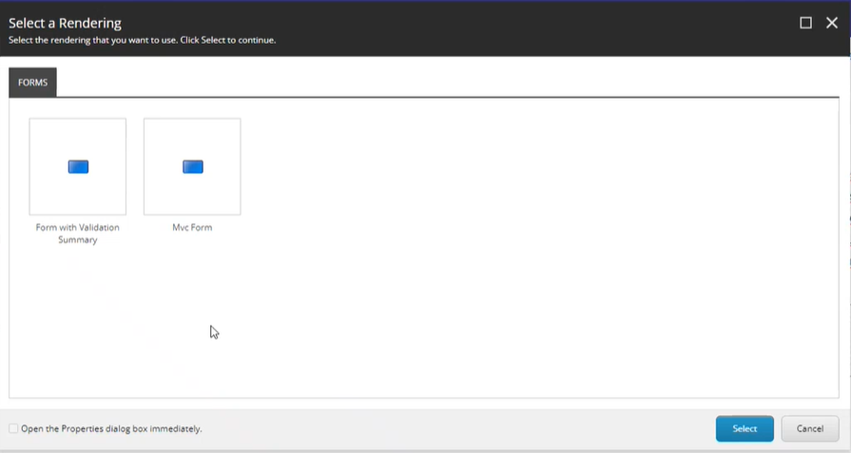
- A Select the Associated Content window will appear. Select the Form that applies to this page and click OK.
  - 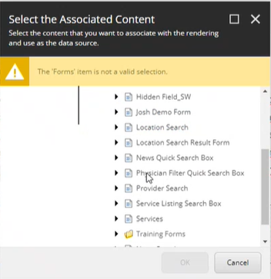
- The form will be added to the page with the correct white text styling. To have this form appear on the front-end publish the page as outlined in the following step.

How to Publish Your Page

From the Experience Editor
- 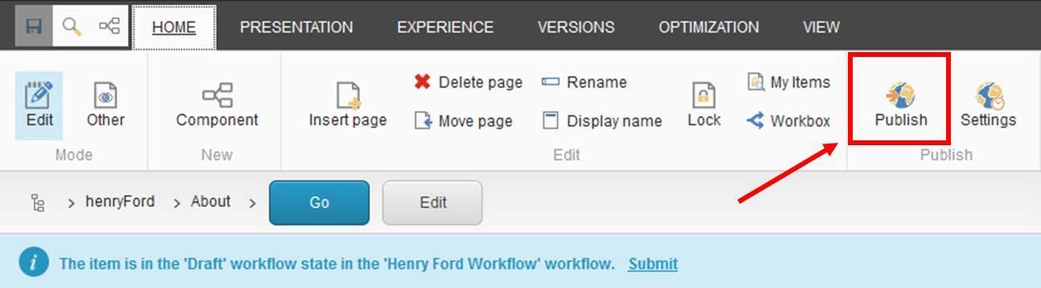Open the Home ribbon and then click the Publish button.

- Select the publishing targets and then click Publish to publish the item, its sub-items, and related items such as media items uploaded directly to the page.
