

CARE LOCATIONS COMPONENT
SITECORE SXA | HENRY FORD HEALTH

Care Locations Component: Adding through the Experience Editor

To add a new Care Locations Component:
- Select the Add component icon in the top left corner and select the +Add here where you would like to add the Care Locations Component (should be added at the full-width section at the bottom of the page).

- In the Select a Rendering window, select the Section Container (under the Page Structure tab) and Select.
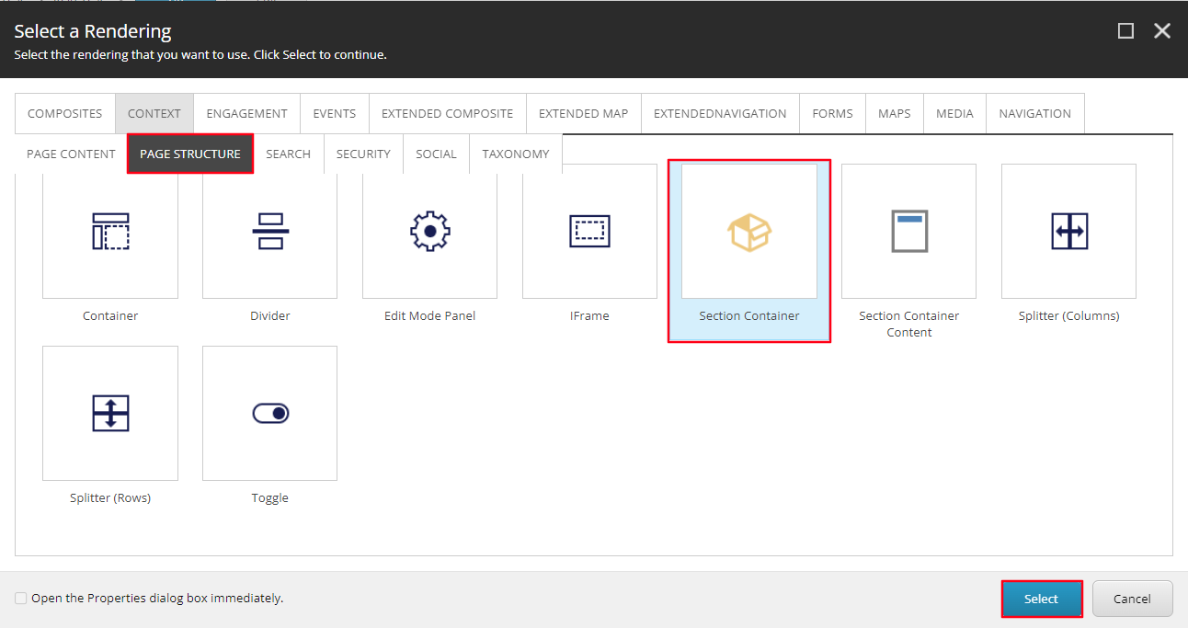
- Once the Section Container loads, select inside that container, and select the +Add here button. In the Select a Rendering window, select the Rich Text tile (under the Page Content tab) and Select. This text will be the Title of the Care Locations component.
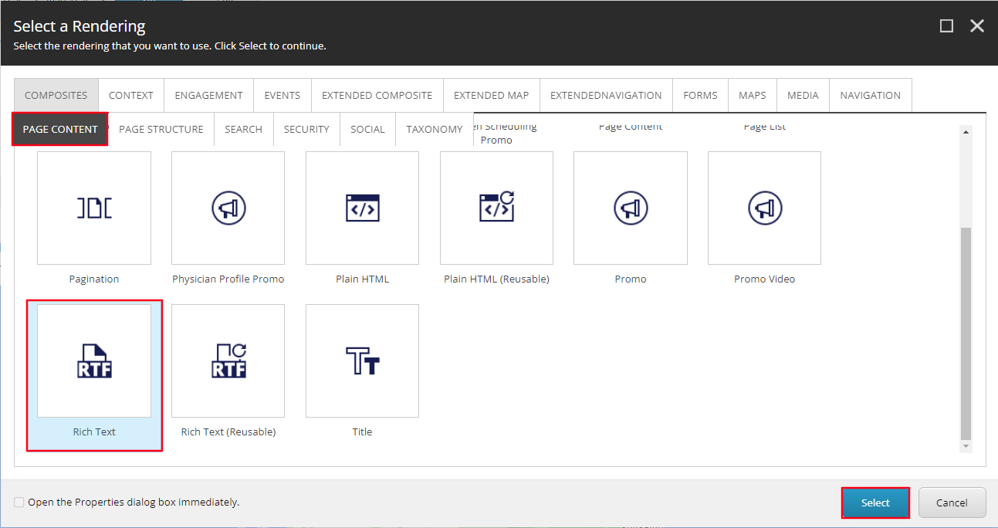
- Select the [No text in field] text and then select the Edit the Text icon in the Text toolbar. Enter the Title of the Care Locations component in the RTE field and apply Heading 4 styling, then select Accept.
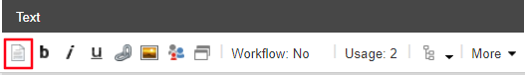
- Next, select the Add component icon in the top left corner and select the +Add here under the Title you just created.
- In the Select a Rendering window under composites, select the Snippet tile and Select.
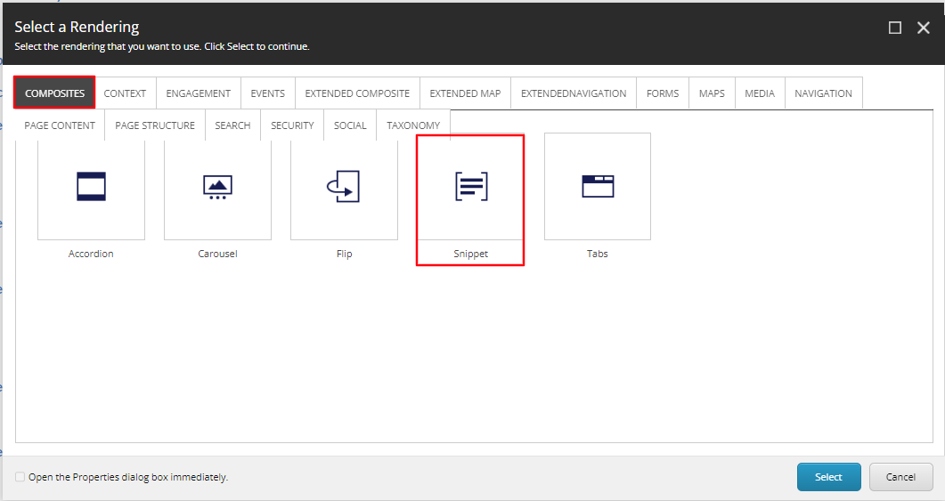
- In the Select the Associated Content window, select the Map Locations Component value and select OK.
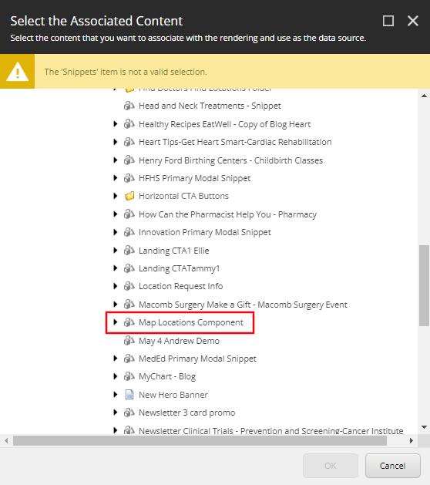
- The Care Locations component will now display.
  - Note: The list will only appear correctly on the frontend once it is published and the page has the appropriate taxonomony associated with it.
- To alter the link text found in the bottom right of the component under the location listing, go to the page in the Content Editor. Then select the Data folder > Map Locations Component > Data > View More Link.
Example:
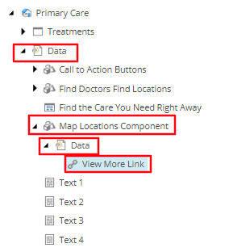
- Then select the Insert link option above the Link field.
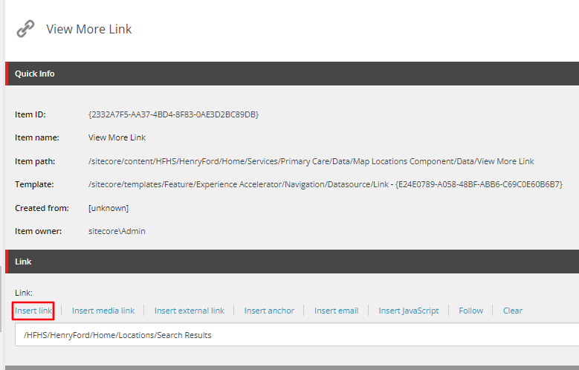
- Update the text in the Description field to the text you want displayed on the frontend.
  - Note: Do not alter any other field or destination of this link.
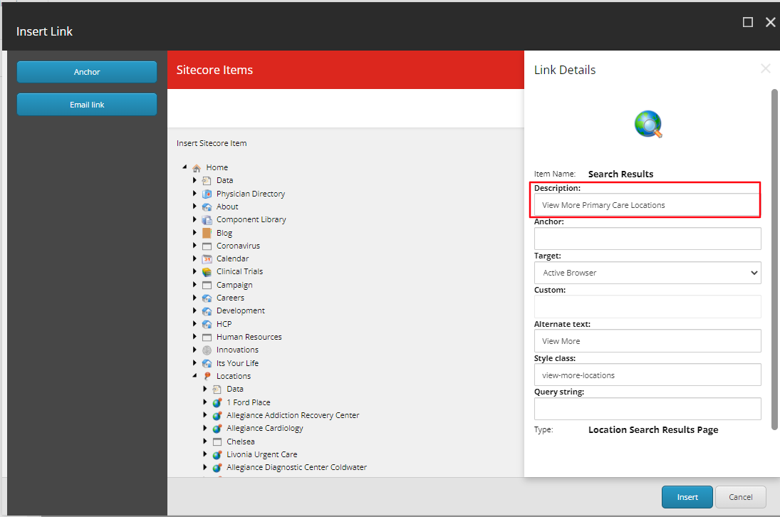
- You have now completed creating the Care Locations Component. The locations will be populated by the Services and specialties tagging associated with the page.
- When Publishing, it is recommended to have Smart publish and Publish related items both checked.

