

CLINICAL TRIALS
SITECORE SXA | HENRY FORD HEALTH

Logging into Sitecore

- Enter your User Name, Password, and then click Login to log into Sitecore

- Forgot Your Password – enter in your User Name to have Sitecore email you a newly generated password (this may go to your junk email folder – sender: donotreply@website.net)

- It is recommended that you use either Chrome, Mozilla or Edge.

The Launchpad – The Experience Platform

Note: Based on the access rights of your account and role, your launchpad may look different.

- The Sitecore Launchpad is well organized in the following categories:
  - Green – marketing and analytics tools
  - Red – content editing tools
  - Orange – tools to organize your digital assets and page workflows
  - Black – recycle bin to retrieve your deleted items
  - Blue – account configuration, system steup and app installations
  - Purple – user account settings

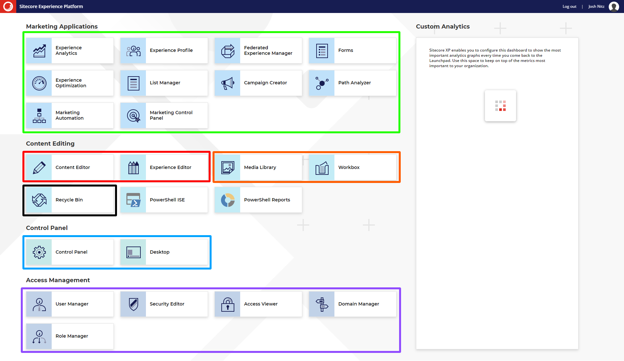

Editing Content Using the Content Editor

- To navigate to the Content Tree, select the Pencil Icon Tile.

- The Content Tree contains all your website’s pages, items, and modules.
  - Note: The HF pages that are found in live will be found under the HFHS > HenryFord > Home node.
  - Setup your Content Editor with the appropriate settings and menus by opening the View ribbon and having the following checkboxes checked:
    - Content Tree (checked by default)
    - Entire Tree

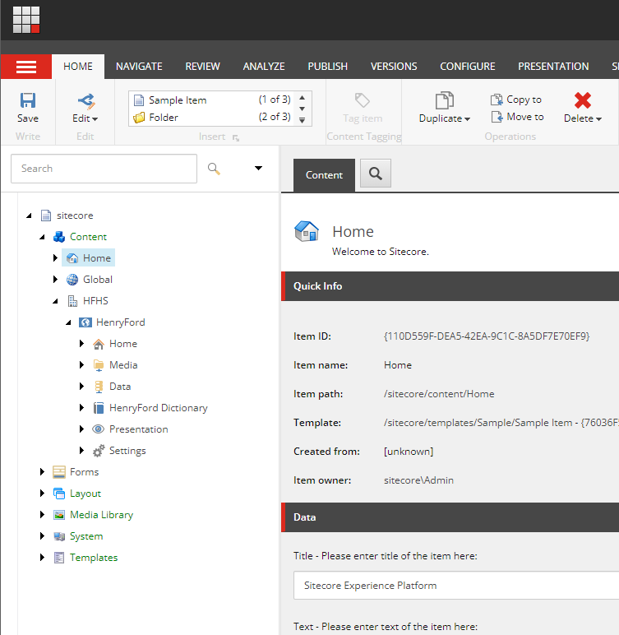

- Click the black arrow in front of the item that you want to expand and branch out.

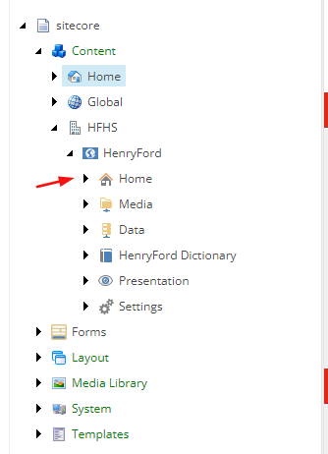

Setting Up Your Clinical Trials Global Items

Conditions or Diseases
- Click the triangle in front of Global > Conditions or Diseases.
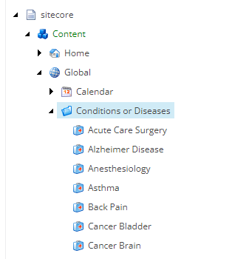
- To add a new Condition or Disease, do one of the following:
  - Right-click the Conditions or Disease folder, select Insert, and then Condition Disease.
  - Select the Conditions or Disease folder and then click the Condition Disease
Item
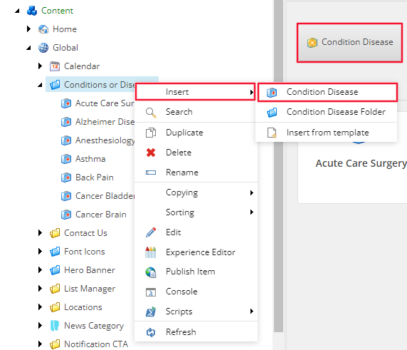
- Name the item when prompted and then Save and Publish.
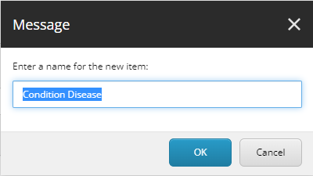

Statuses
- Click the triangle in front of Global, Clinical Trials, and then Statuses.

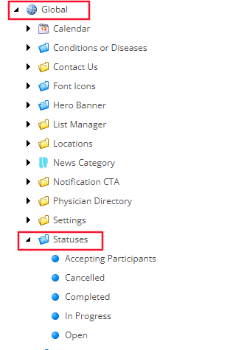
- To add a new Status, select Statuses and then do one of the following:
  - Right-click the Statuses folder, select Insert, and then Status.
  - Select the Home ribbon and click Status in the Insert section.
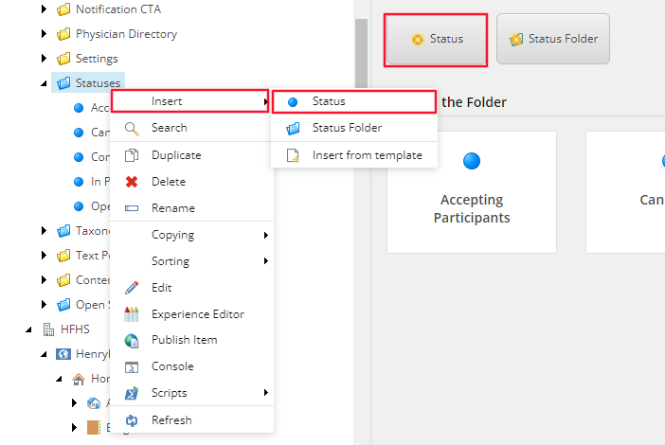

- Name the item when prompted and then Save and Publish.
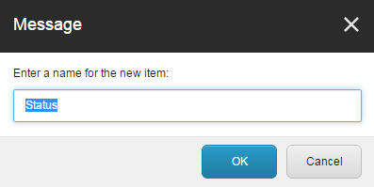

Accessing Your Clinical Trials Module

- Click the triangle in front of the Home item and then navigate down to Clinical Trials.

- The folder structure of your Clinical Trials module is organized by folder groups that can be manually created.
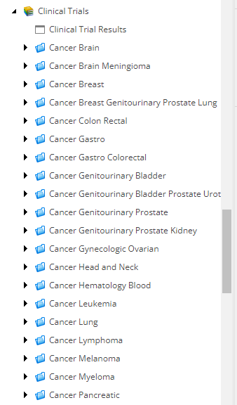

Adding a New Clinical Trial Posting

- Start by adding a Clinical Trial. To do this right-click the Clinical Trials Folder, select Insert, and then select Clinical Trials.
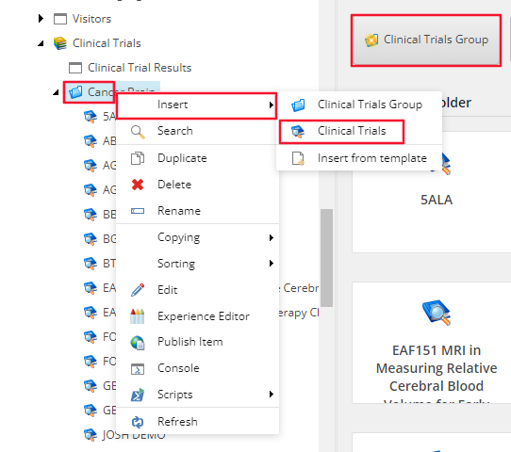

- Name your Clinical Trial when prompted and then click OK.
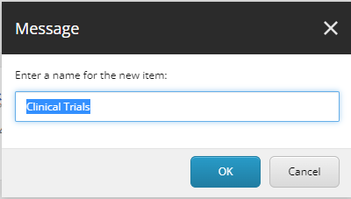

How to Edit the Clinical Trials Data

- All fields that are typically edited will be found under the Page Data section:
  - Headline – this is the main header <h1> or title of your page; click inside the field to start editing. Use Study Formal Title.
  - Start Date, and Expire Date: click the down arrow to access the date picker or click inside the field and manually enter it.
Note: this date does not define when the clinical trial listing will be published and taken down.
  - Introduction – this is a short description about your clinical trial for your website’s Site Search and Clinical Trial module’s search results page. This will not display on the Clinical Trial detail page; click Show Editor on top of the field to open up the Rich Text Editor to edit or enter text.
Note: if this field is left empty, the system will automatically use the first 150 characters of your content copy.
  - Condition/Disease: select the associated item(s) from the All box and move it over to the
Selected box by using the blue arrows.

  - Content Copy (Green) – this is the copy of your page; click Show Editor on top of the field to open up the Rich Text Editor to edit or enter text.
  - Status: To add information, select Accepting Participants, In Progress, Completed or
Cancelled from its dropdown menu.
Note: not required; if no content, then the fields will not show on the page.

  - Principal Investigator: click inside the field to enter the lead researcher’s name (Orange) Note: Use this field if the investigator is not in the Physician Directory. If the investigator is in the Physician Directory, please use the next field, Principal Investigators.
  - Principal Investigators: to link to the investigators page in the Find a Doctor module, select the associated item from the All box and move it over to the Selected box by using the
blue arrows (Green)
Note: not required; if no content, then the fields will not show on the page.
  - Keywords: These keywords will assist in the Search functionality of the Clinical Trials module
  - To add data to the following fields, click inside the field and enter the Contact Phone Number or Email.

Submitting Your Page through the Workflow

From the Content Editor
- When you are done with your edits, you can:
  - Check In: “unlock” the page from your account and make it available for other users to “lock” the page to their account; this action will keep the current version as Draft and therefore will not be Published
  - Submit: sends the most recent version to the staging area for an approval to be published by a publisher or an administrator

- If you have Publishing rights or are an Administrator, then you will see the Approve and Reject
buttons immediately appear after submitting your page.


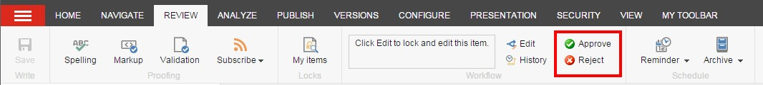

- When you click Approve, the page will be staged for Publishing and when you click Reject, it will send the page back to the workflow as a Draft and will not be published.

How to Publish Your Page

From the Content Editor
- Select the item or page that you want Publish, open the Publish ribbon and then click the Publish button (in red) or click the down arrow, and then select Publish Item from the drop down menu (in orange).

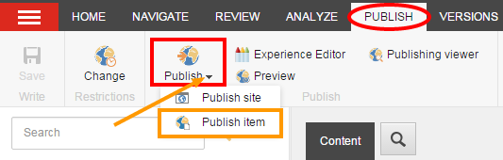

- Select the publishing targets and then click Publish to publish the item, its sub-items, and related items such as media items uploaded directly to the page.

