

DYNAMIC DOCTORS COMPONENT
SITECORE SXA | HENRY FORD HEALTH

Dynamic Doctors component: Adding through the Experience Editor

To add a Dynamic Doctors component:
- Select the Add component icon in the top left corner and select the +Add here where you would like to add the Dynamic Doctors Component.

- In the Select a Rendering window, select the Snippet (under the Composites tab) and Select.
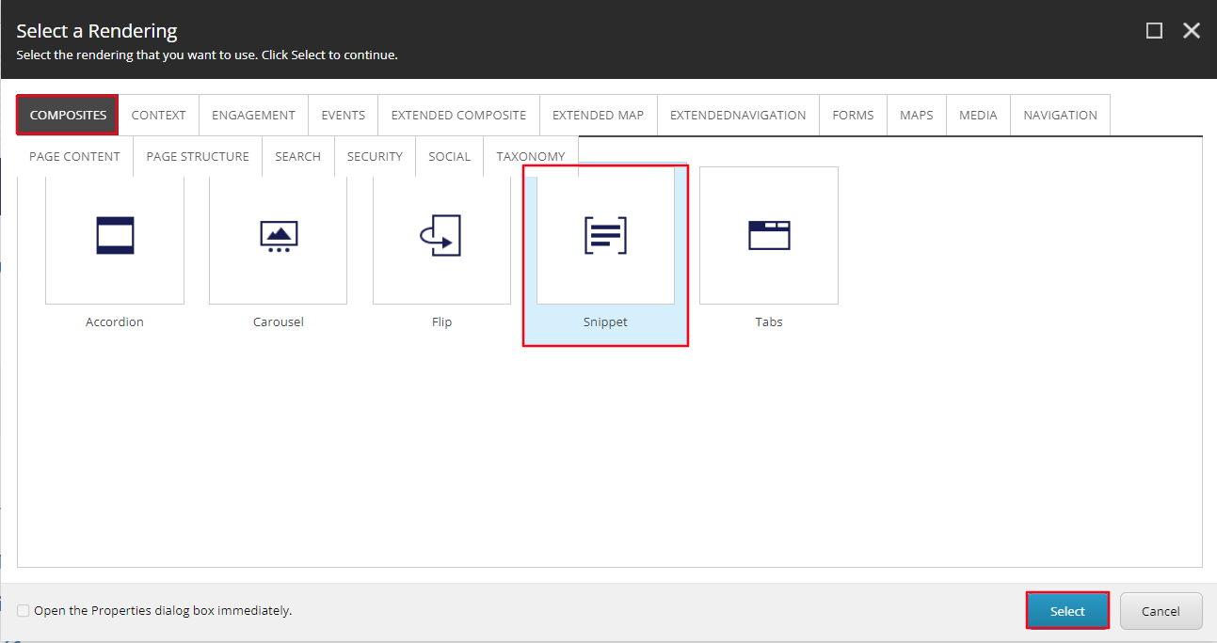
- In the Select the Associated Content window select the Dynamic doctor snippet (red) or the Dynamic doctor MedEd snippet (blue) if you only want to filter out any physician that is not attributed to Med-Ed (determined on Physician directory). Then select OK.
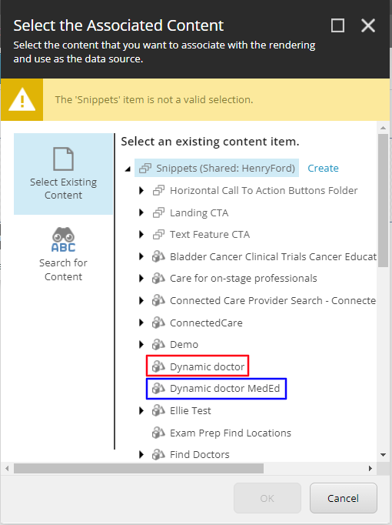
  - Note: The component will only display Physicians that share the same Specialties tag as the current page.
- You have now created a Dynamic Doctors component.
- When Publishing, it is recommended to have Smart publish and Publish related items both checked.

