

FULL WIDTH MULTIPLE BUTTON
SITECORE SXA | HENRY FORD HEALTH

Full Width - Single Button CTA: Adding through the Experience Editor

To add a Full Width – Multiple Button CTA:
- Select the Section Container at the bottom of the page and select Add Here.
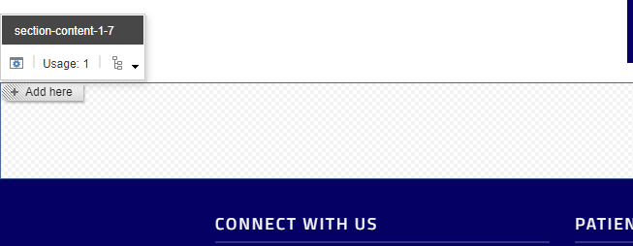
- Select the Page Content tab from the Select a Rendering window, then select Extended Promo and Select.
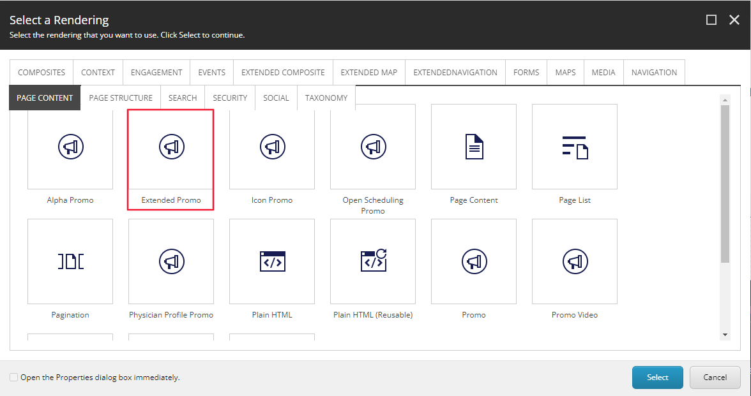
- Select the Full Width CTA – Multiple Button CTA (or the folder you wish to have this promo stored under) and then select Create.
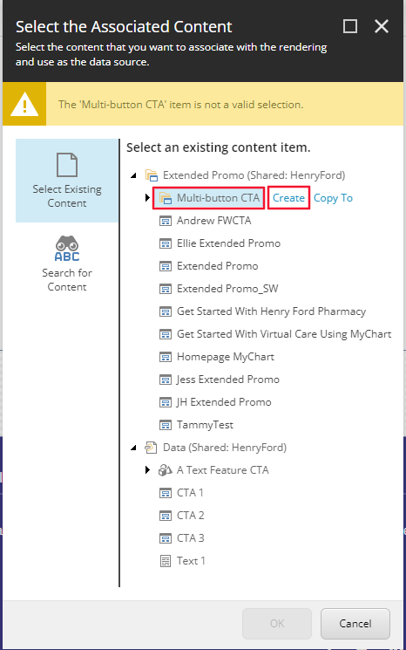
- In the Insert Item window, either create an Extended Promo folder or an Extended Promo, and assign a Name to it in the bottom field and select Okay.
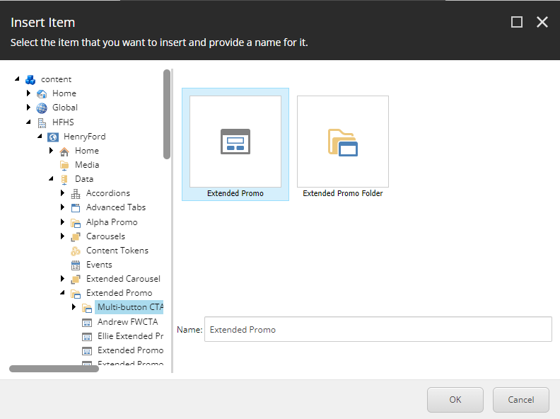
- The CTA will load on the page after a few seconds. Once it does, select the Paint bucket icon.
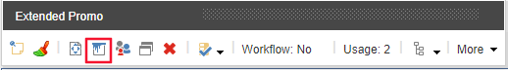
- Once selected, in the new window, scroll down to the Styling section and under Background color, check the Light Blue Background checkbox and select OK.
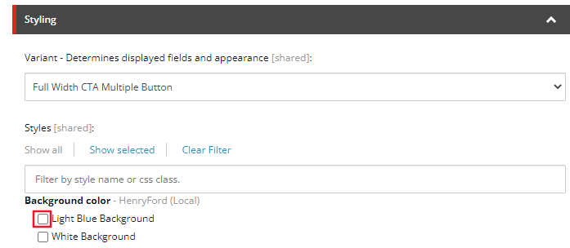
- The proper formatting of the CTA will load, from here you can edit the Heading and Content Copy by selecting the [No text in field] for each field respectively.
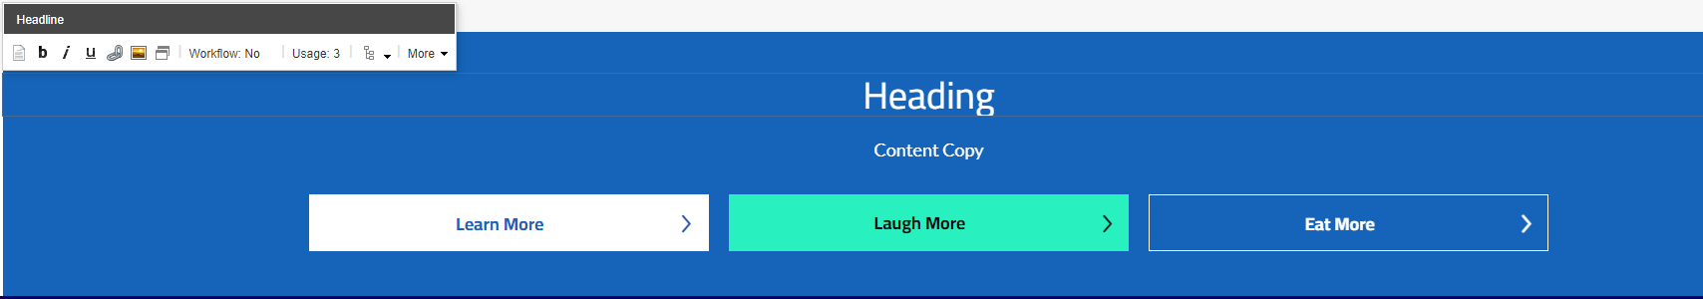
- To edit a Button’s text and link, select the button area and select the “Edit the link destination and appearance” button.
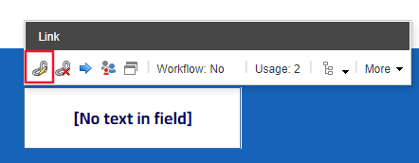
- Once selected, an Insert a Link window will appear. From here you can either:
  - Set the button to an internal link, by selecting the page from the Tree node and setting the Button Text through the Link Description field.
  - Set the button to an External Link by entering the external URL into the URL field and then setting the Button Text through the Link Description field.
- Set the button to a Mailto: link by entering the email address into the Mailto field and then setting the Button Text through the Link Description field. Select Ok.
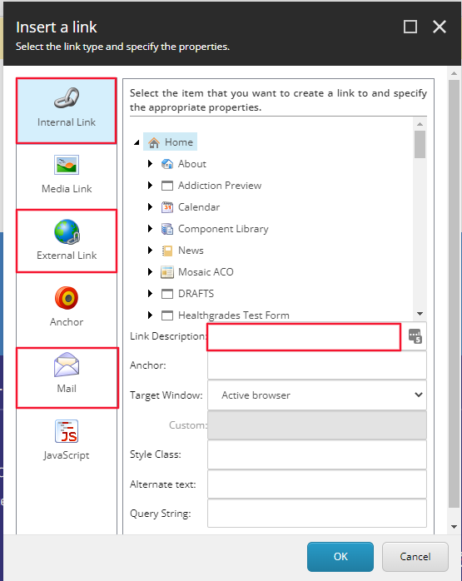
- To edit individual button styling, select the Paintbrush icon in the Extended Promo Toolbar.
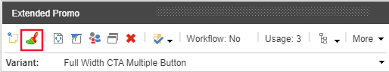
- A window will appear, from this window designate the button styling for each button used in the CTA by selecting the appropriate value from the dropdown. Select OK.
  - Default Button – (White button with blue text)
  - Primary Button – (Green button)
  - Secondary Button – (Blue button with white Text)
- Select save in the Banner. You have now completed the adding a Full Width CTA – Multiple Button.
- When Publishing, it is recommended to have Smart publish and Publish related items both checked.
