

FULL WIDTH SINGLE BUTTON
SITECORE SXA | HENRY FORD HEALTH

Full Width - Single Button CTA: Adding through the Experience Editor

To add a Full Width – Single Button CTA:
- Select the Section Container at the bottom of the page and select Add Here.
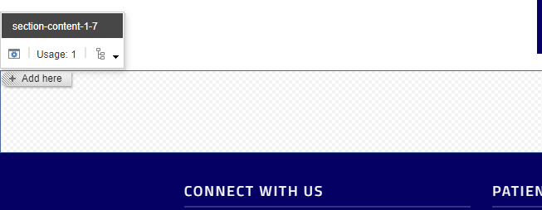
- Select the Page Content tab from the Select a Rendering window, then select Promo and Select.
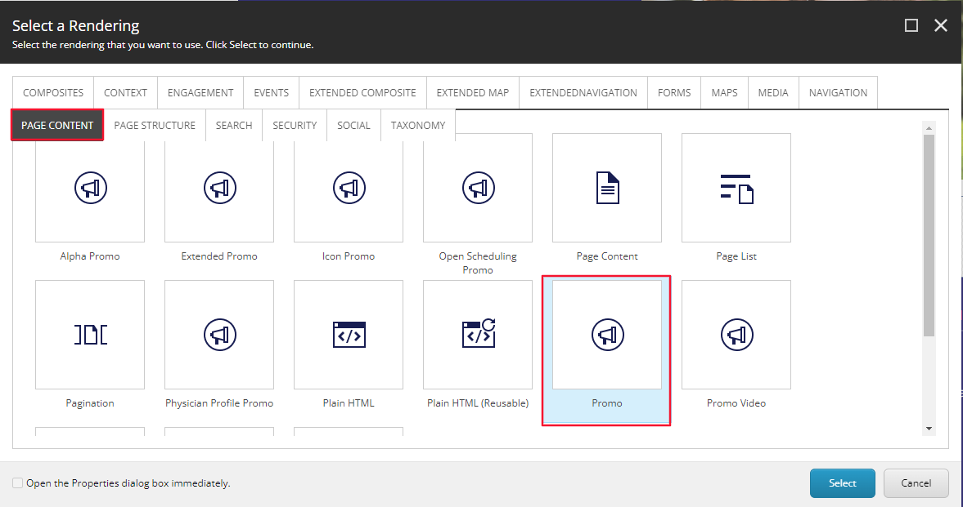
- Select the Full Width CTA – Single Button Folder (or the folder you wish to have this promo stored under) and then select Create.
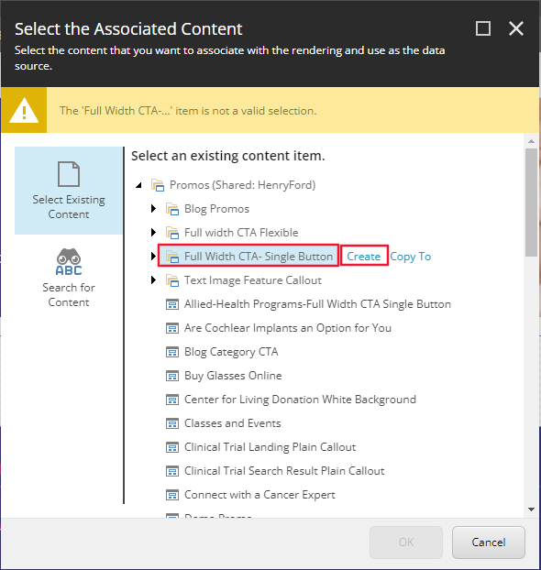
- In the Insert Item window, either create a Promo folder or a Promo, and assign a Name to it in the bottom field and select Okay.
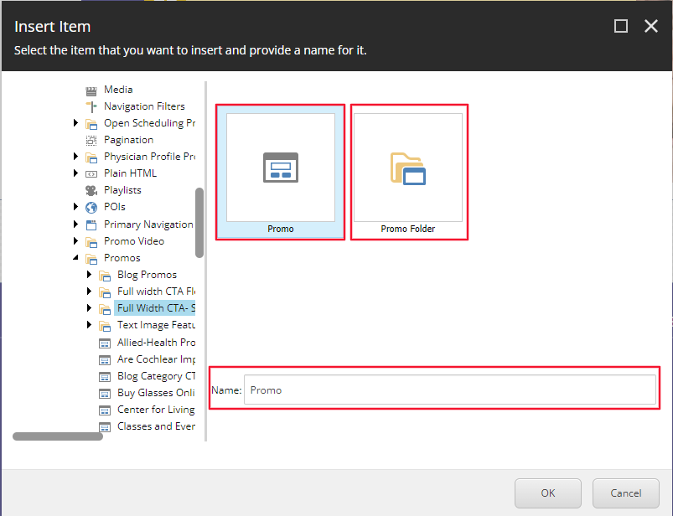
- The CTA will load on the page after a few seconds. Once it does, select the Variant dropdown and then the Full Width CTA Single button from the dropdown.
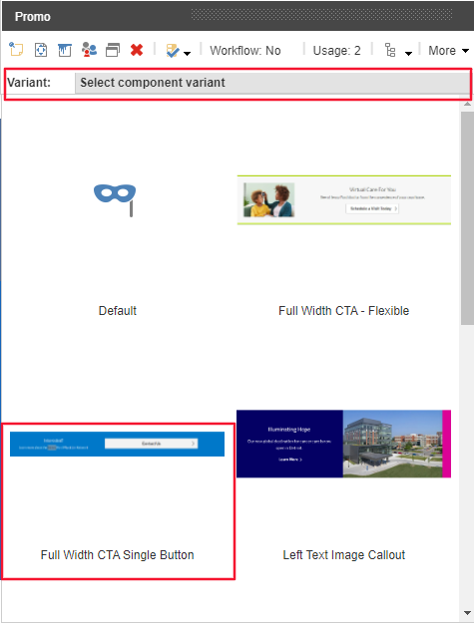
- Once selected, the proper formatting of the CTA will load, from here you can edit the Heading and Content Copy by selecting the [No text in field] for each field respectively.

- To edit the Button text and link, select the button area and select the “Edit the link destination and appearance” button.
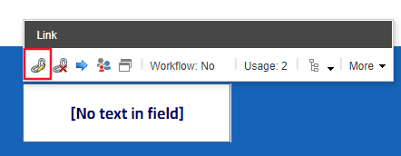
- Once selected, an Insert a Link window will appear. From here you can either:
  - Set the button to an internal link, by selecting the page from the Tree node and setting the Button Text through the Link Description field.
  - Set the button to an External Link by entering the external URL into the URL field and then setting the Button Text through the Link Description field.
  - Set the button to a Mailto: link by entering the email address into the Mailto field and then setting the Button Text through the Link Description field.
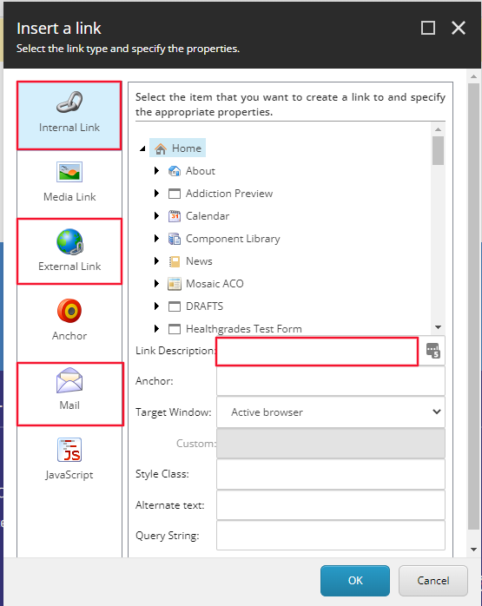
- Select Okay.
- Select save in the Banner. You have now completed the adding a Full Width CTA – Single Button.
- When Publishing, it is recommended to have Smart publish and Publish related items both checked.
