

Creating a Generic Wizard in Sitecore

Text to Remember:
Action | Text
Adding Wizard Link to CTA button/link | js-open-scheduling

Configuration

In the Physician Directory Module settings (/sitecore/content/HFHS/HenryFord/Settings/Open Scheduling Settings) under the Open Scheduling section admins can set the following items:
- IFrame Headline
- Accepts New Patients Checkbox
- The Open Scheduling Epic IFrame URL
  - This is the foundational URL. Parameters are appended through the individual Open Scheduling Decision Tree.
- IFrame Close Text

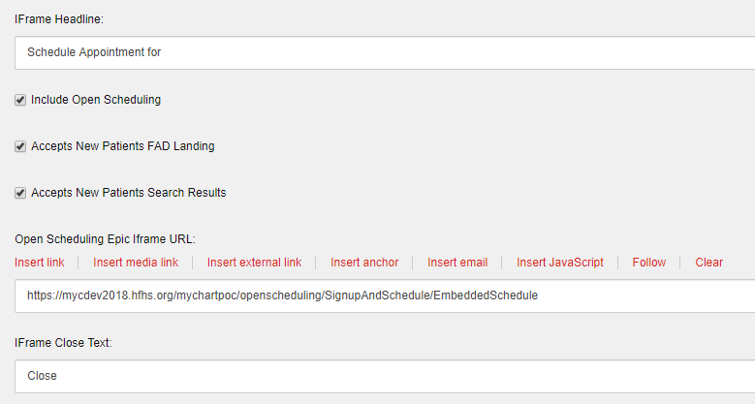

Setting up a Generic Wizard
- When creating a Generic Wizard, go to the Open Scheduling folder in Global > Right click the Folder > Select Insert > Select Decision Tree. A window will appear, enter the name of this Wizard and select Okay.

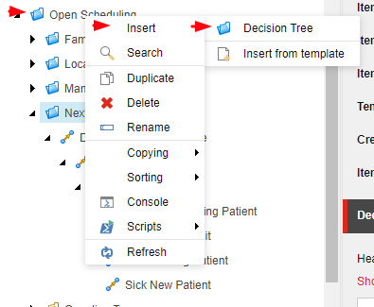

- Select the folder that you just created. Here you will enter the header and the footer of the Generic Wizard. This text will remain consistent throughout the entire Wizard experience.
  - Header (Red Arrow): This field has RTE capabilities, but this text should be entered as a H3.
  - Footer (Blue Arrow): This field has RTE capabilities.

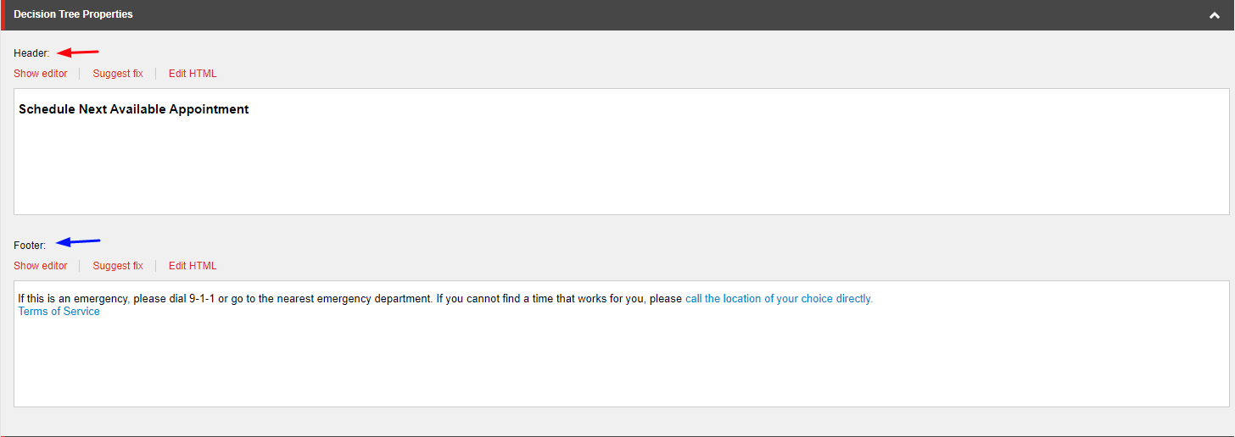

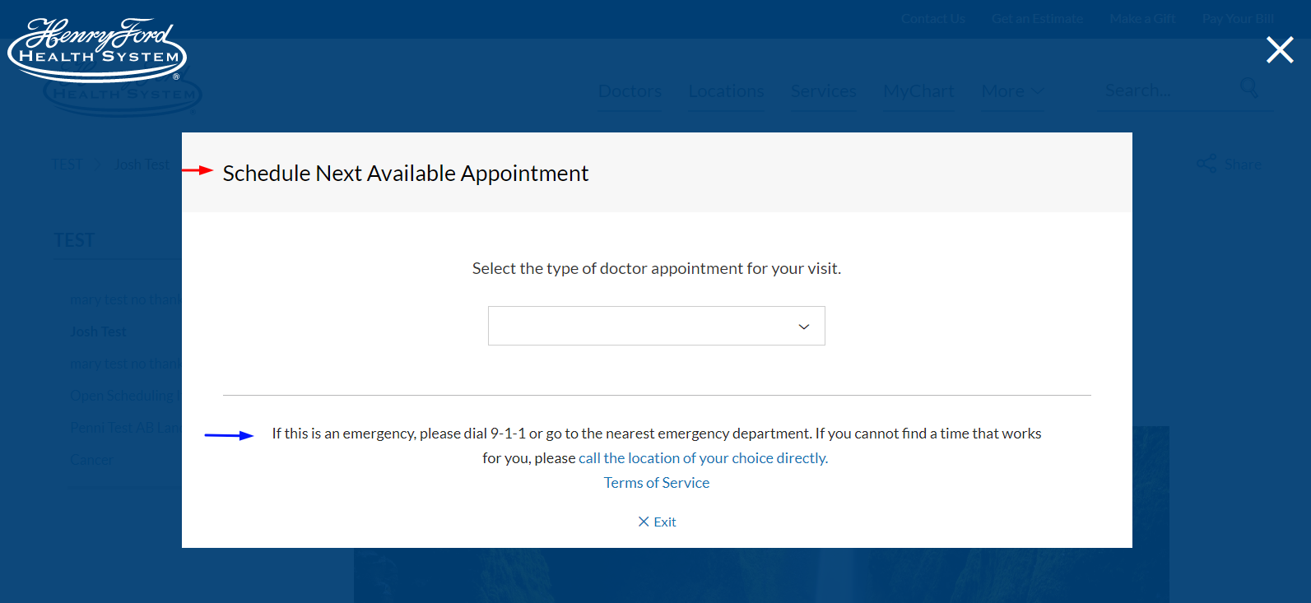

Creating a Decision Item
- To add your first Decision Item, right click the Folder that was created in the previous steps > select Insert > Decision. A window will appear, enter the name of this Decision item and select Okay. Note: Each Decision item is essentially a page of a Generic Wizard.
- If you already have a Decision Item created, you can always right click an existing Decision and insert a child Decision item, which is essential in creating a decision tree.
  - The Name that you create for the Decision item will not appear on the front end, but the naming convention used should make sense to admins for organizational purposes.

Decision Item Template
- Once you have created a Decision item, a template will be displayed with many different fields which you can enter data for
  - Answer Value (Red): The Answer Value will populate the:
    - Values of the dropdown found in the current Decision item’s parent Decision.
    - Text of the buttons found in the current Decision item’s parent Decision.
    - Note: Since the Answer Value is only necessary when a Decision has a Parent Decision item, the Answer Value is not necessary for the first Decision item of a Wizard.
  - Question Text (Blue): This field has RTE capabilities. Enter the question that the user will answer here and utilize the RTE capabilities to insert links (cannot be links to other Wizard Decisions) or organize your questions as desired.
  - Question Type: (Purple): Dictate what question type the Decision item will display from the following Question Options:
    - None: This Generic Wizard page will simply show text entered in the Question Text Field. Same as leaving the value blank. We recommend not selecting this value and simply leaving this blank. If you are trying to just display a message use the Display Message field mentioned below (See 1h).
    - YesNoButton: This question type will display a Decision item with two buttons. While this will most commonly be used as a Yes/No question, it can also be used as an Either/Or question.
      - (e.g Where do you live? Buttons: “United States” or “Canada”)
      - Button Text will be dictated by the child Decision’s Answer Values.
    - Dropdown: This question type will display a dropdown. This is the best option when utilizing a question that has 3 or more potential options.
      - Dropdown values will be dictated by the child Decision’s Answer Values.
    - VisitTypeSelection: This question type will display Visit Type Buttons, which lead to the Open Scheduling IFrame.
      - The Visit Type Buttons displayed will be determined by the child Decision items of this current Decision.
  - Dropdown Default Text (Light Purple): Set the Hint Text that is found in the dropdown when the Decision item is loaded.
  - Show Radio Button (Green): If the Question Type is a Dropdown and the values would be better displayed as Radio Buttons, check this checkbox.
  - Visit Type (Light Purple): Adds the Visit Type selected to the parent Decision when the Parent Decision item has “VisitTypeSelection” as the Question Type.
  - Jump to (Light Green): Allows the user to be sent to an Internal Link or a different Decision item in the current Wizard that doesn’t follow the current tree node path.
  - Display Message: Use this field when you have reached the end of a Decision tree branch and all you need to display instructions via text and links. This field has full RTE capabilities and can be used like a Content Copy field found elsewhere in the site.
  - Endpoint URL (Light Blue): Utilized for Visit Types. Fully explained in the Creating a Visit Type Endpoint URL section below.

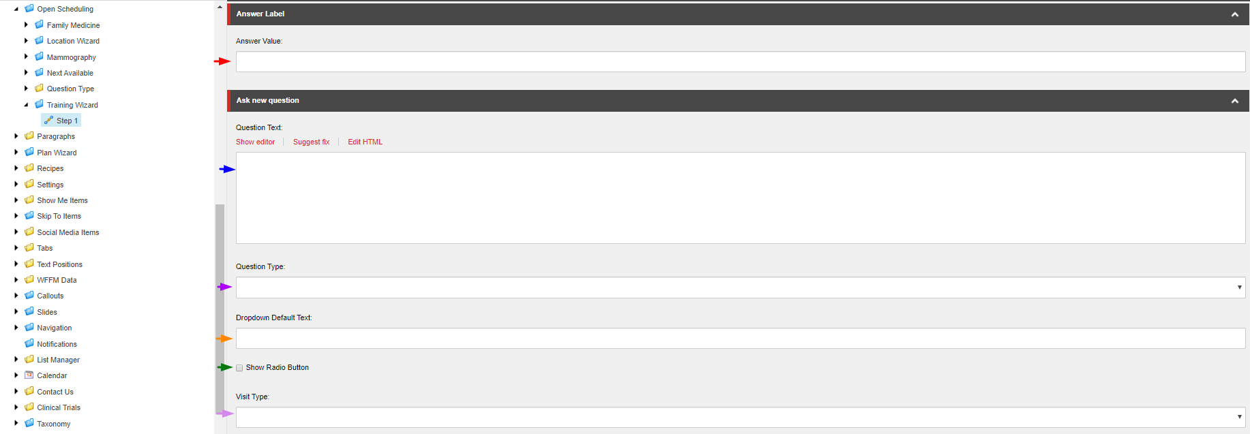

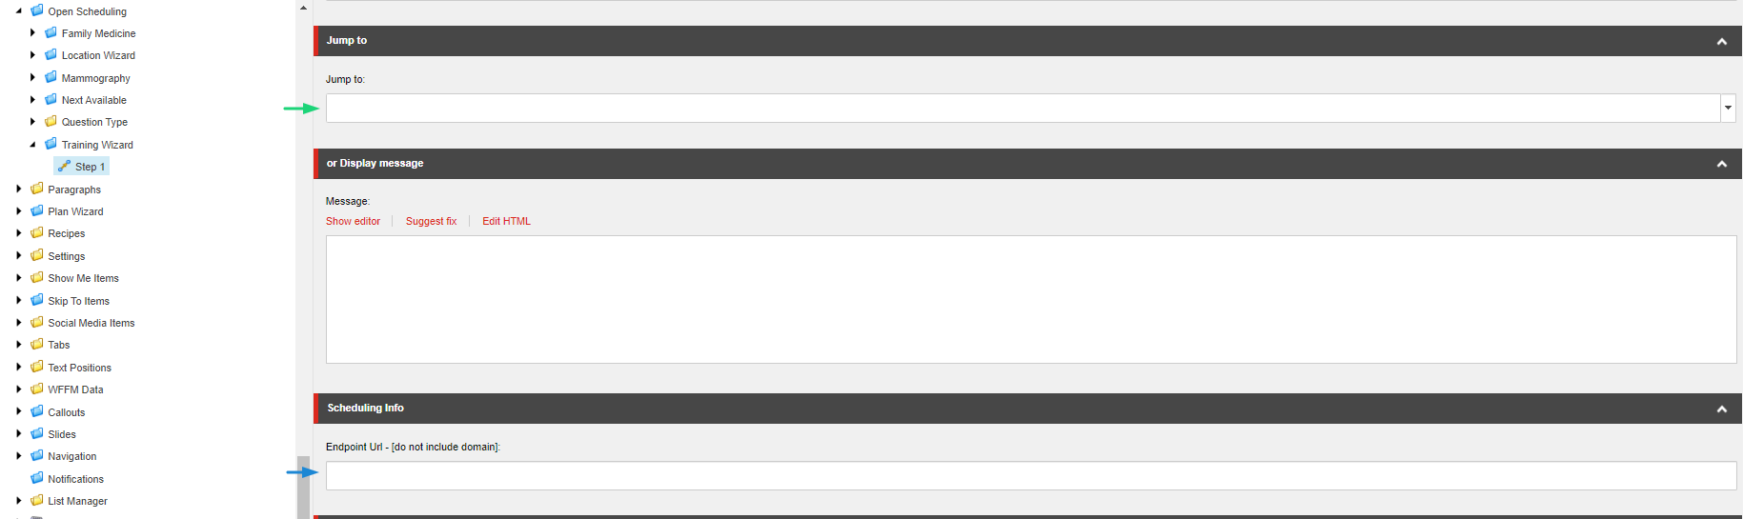

Creating an Either/Or Decision
- Once you have entered the Question Text, select the YesNoButton from the Question Type.
- Next Insert a child Decision item by right clicking the current Decision item and selecting Insert > Decision. A window will appear, enter the name of this child Decision item and select Okay.
  - Once you have added two Decisions, enter the text that you want the buttons to display for the Parent Decision item in the Answer Value field of both child Decision items.

Creating a Dropdown/Radio Button Decision
- Once you have entered the Question Text, select the Dropdown from the Question Type.
  - If needed, add the hint text to the Dropdown Default Text field.
  - The same logic applies when utilizing the Radio Button decision.
- Next insert as many child Decision items as needed by right clicking the current Decision item and selecting Insert > Decision. A window will appear, enter the name of this child Decision item and select Okay.
  - Once you have added as many Decision item’s as there are dropdown values, enter the text of those values which will display for the Parent Decision item’s dropdown in the Answer Value field of all child Decision items.

Creating a Visit Type Decision
- Once you have entered the Question Text, select the VisitTypeSelection from the Question Type.
- Next Insert a child Decision item by right clicking the current Decision item and selecting Insert > Decision. A window will appear, enter the name of this child Decision item and select Okay.
  - Once you have added as many child Decision items as Visit Types that you hope to display on the parent Decision, select the Visit Type from the Visit Type field for each of the Child Decision items. Then add the Endpoint URL by following the steps below in the Creating a Visit Type Endpoint URL section.

Creating a “Jump to” Answer Value
- After creating a child Decision item, if you don’t want the selection of the Answer Value from the parent Decision item to lead to another Wizard page, but instead want it to send the user to a particular section of your site, utilize the Jump to section by selecting the page you want to user to go to.

Creating a Visit Type Endpoint URL

In order to append the correct parameters to the IFrame, you’ll need to utilize an Excel sheet that will be provided to your team. This Excel sheet will enable your team to easily filter down the required ID numbers and add them to the Endpoint URL field. Adding the Endpoint URL correctly will result in an IFrame of MyChart filtered down to display the physician’s schedules that meet your criteria.

For example: If the IFrame needs to display all Family Medicine Physicians in Detroit that are accepting New Patient Visits…
- Under Column F, filter Specialty to only show Family Medicine.
- Under Column K, filter the City to only show Detroit.

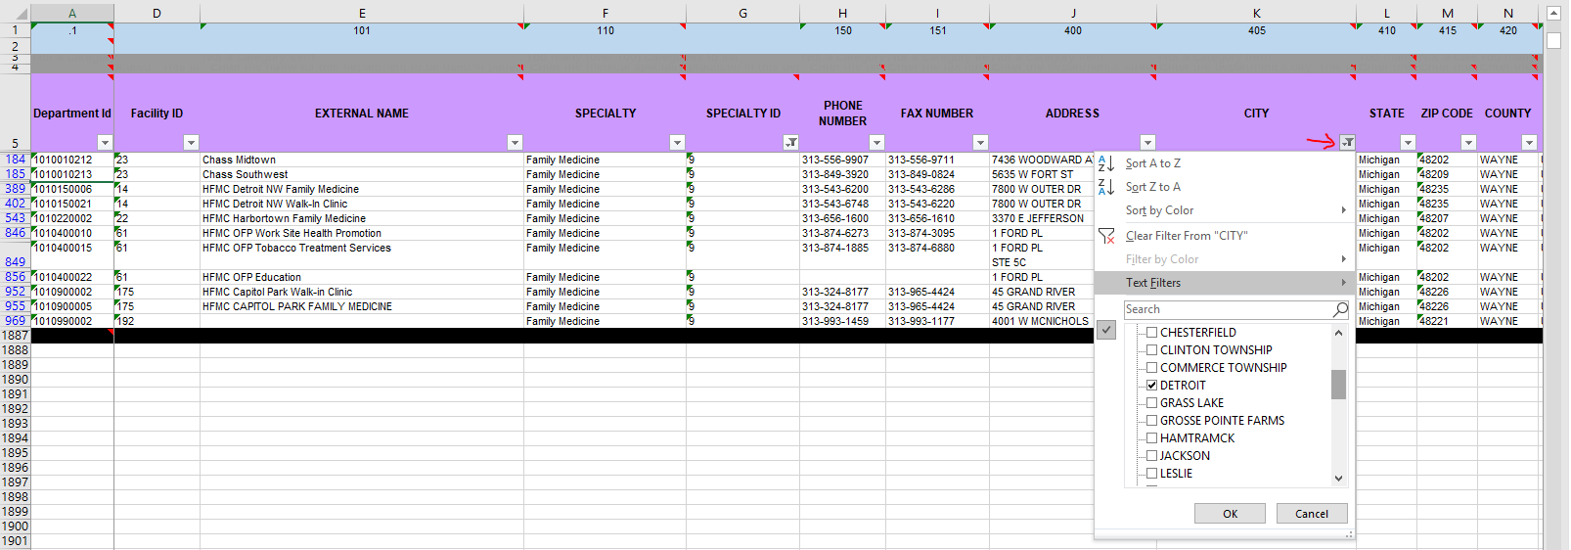
  - Now that this is completed, column A will have all the Department ID’s of Family Medicine departments in Detroit.
- Add these Department ID’s to the Endpoint Url by first adding a question mark “?” then adding “dept=” followed by all Department ID’s separated by a comma.
  - Example of Endpoint URL with department ID filters: ?dept=1010010212,1010010213,1010150006,10150021,1010220002,1010400010,1010400015,1010400022,1010900002,1010900005,1010990002
- Next, add the Visit Type ID so that Physicians that are accepting New Patient Visits are shown.
  - This is done by adding “&vt=” to the Endpoint URL followed by the Visit ID.
  - To find the Visit Type ID go to /sitecore/content/Global/List Manager/Visit Types, find the Visit Type you are filtering the IFrame by and it’s Visit Type ID, then copy it into the Endpoint URL.
    - Example of Endpoint URL with department ID and Visit Type ID filters: ?dept=1010010212,1010010213,1010150006,10150021,1010220002,1010400010,1010400015,1010400022,1010900002,1010900005,1010990002&vt=42794
- Lastly add “&view=grouped” to the End of the URL. This will now open the IFrame with the correctly appended parameters to show the correct Physician’s MyChart availability IFrame.
  - Example of Final URL: ?dept=1010010212,1010010213,1010150006,10150021,1010220002,1010400010,1010400015,1010400022,1010900002,1010900005,1010990002&vt=42796&view=grouped

Adding Generic Wizard link to CTA Button/Link
- When adding a Generic Wizard link to a CTA button, navigate to the Hero Banner or Callouts that you wish to link to the Generic Wizard to.
- Once in the Banners/Callout’s template select “Insert External Link” for the General Link field and enter the path of the first Decision of the Open Scheduling folder that this button/link should open. For the Button/link text you want to display, enter this into the Link description field.
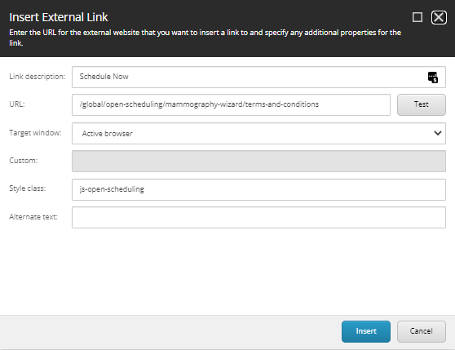
- Enter “js-open-scheduling” into the Style class field and select insert.
- Once you have published this CTA with related items checked, all pages that utilize this CTA/Hero Banner will open the Wizard you designated.

Adding Generic Wizard link to Rich Text Editor
- Add your text to the Rich Text Editor.
- Highlight it and select Hyperlink manager Link.
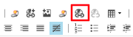
- Enter the path of the first Decision of the Open Scheduling folder that this highlighted text will open in the URL field and select the js-open-scheduling CSS class. Select Accept.

