HERO BANNERS
SITECORE SXA | HENRY FORD HEALTH

Hero Banners: Adding through the Content Editor

To add a new Hero Banner:
- Go to the Global Folder, and under the Hero Banner Folder, navigate to the folder that you wish to add your Hero Banner to.
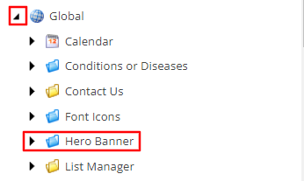
- Right-click the folder, select Insert and then the Hero Banner item.
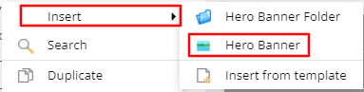
- A Message window will appear. Enter the name of this Hero Banner and select OK.
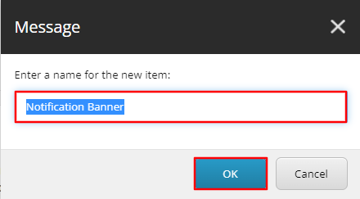
- On the Hero Banner Template, there will be 7 fields that control the display of the Hero banner.
  - Hero Image –The Image that will display on Desktop.
    - Desired Dimensions: 1048 x 542
  - Hero Image Tablet –The Image that will display on Tablet.
    - Desired Dimensions: 824 x 651
  - Hero Image Mobile–The Image that will display on Mobile.
    - Desired Dimensions: 600 x 592
  - Content Copy – The Text that will display in the text area of the Hero Banner.
    - Note: To have the desired styling, in the Rich Text Editor, highlight the text of the Heading of your Hero Banner and then select the hero-headline class from the CSS dropdown.
  - Link – The link destination and link text that appears below the content copy.
    - Note: Select the insert link text above the field. An Insert Link window will appear. Select the destination you wish the button to navigate to and add the Button text that should display in the Description field on the right-hand side. Select Insert.
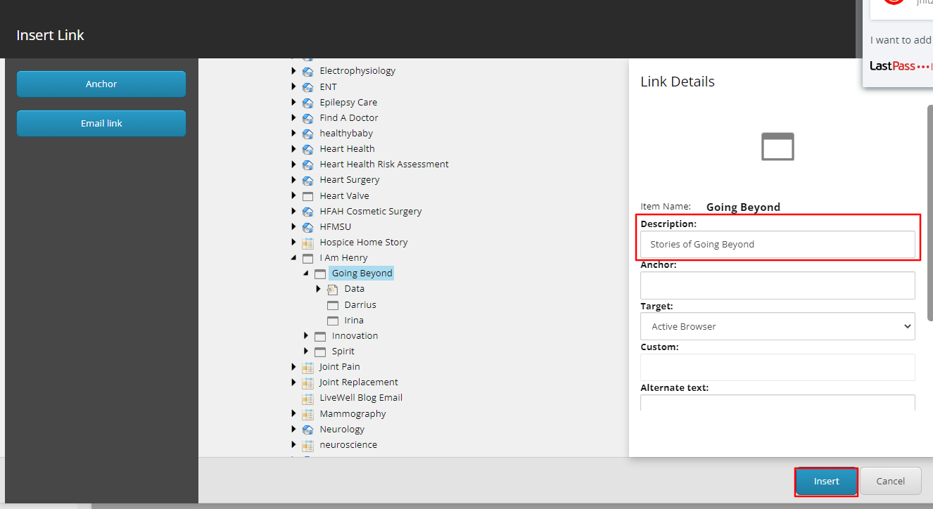
  - Show Button – If checked, it will display the link and text mentioned above. If unchecked, it will not display on the front-end.
  - Text Position – Select from the dropdown the Right or Left value, to determine which side the text area displays.
- To have this Hero Banner display on a page, navigate to the page in the Content Editor. Under the Hero section, select the appropriate Hero Banner from the Banners selector field.
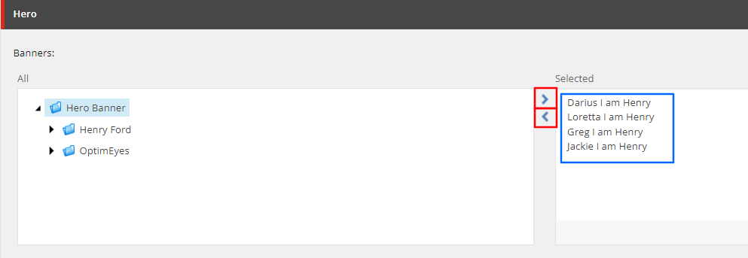
  - Note: To add Hero Banners to a page, double click the Hero Banner title in the All field or select the Hero Banner title in the All field and click the forward button (red).
  - Note: To remove Hero Banners from a page, double click the Hero Banner title in the Selected field (blue) or select the Hero Banner title in the Selected field and click the back button (red)
- When Publishing, it is recommended to have Smart publish and Publish related items both checked.

Hero Banners: Adding a New Component

To add a new hero component to pages that do not already have one:

- Navigate to the page in the Sitecore architecture tree, select Experience Editor under the Publish tab in the top ribbon.

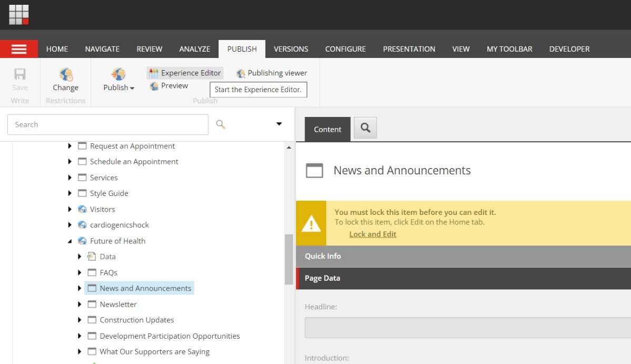
- The Experience Editor panel will open. Add new component using Add Here button, select the container #13 at the top of page (above the gray banner/breadcrumbs). Then select Page Content > Page Content. This will add the component placeholder.

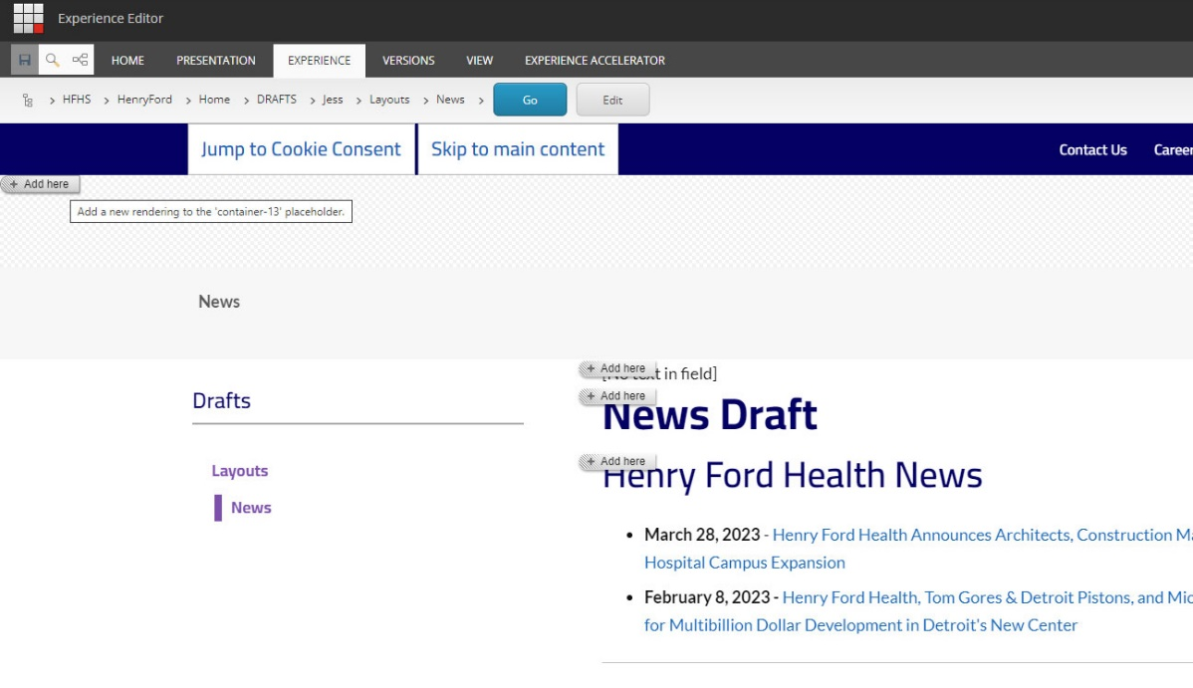

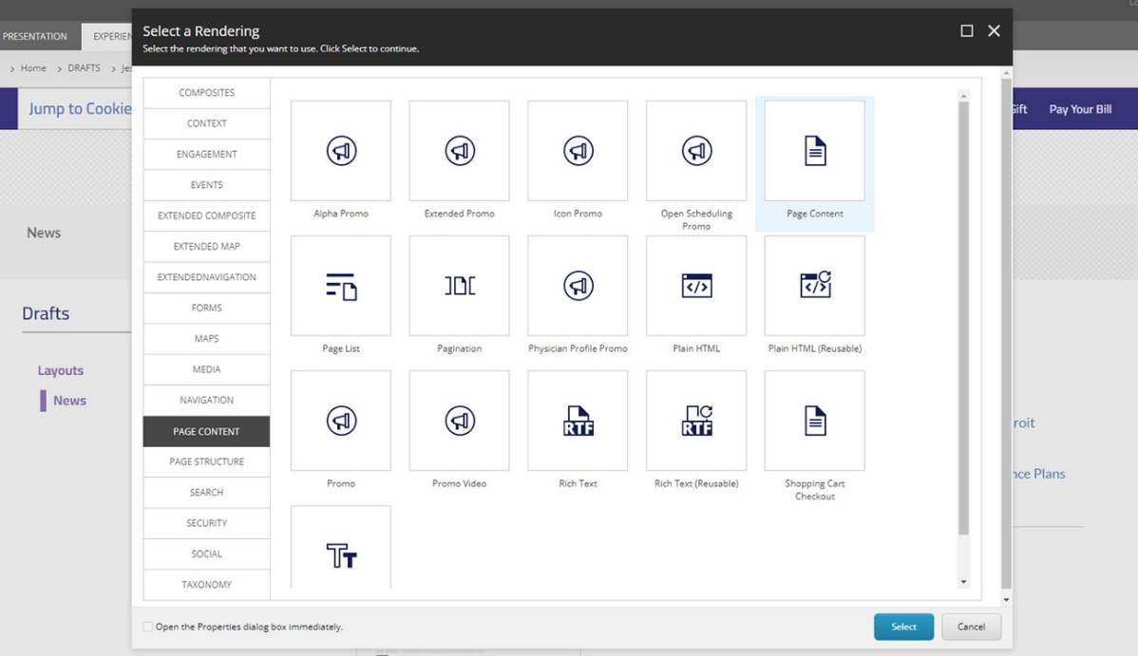

- Once the component is added, update the variant under Select Component Variant > Hero Banner. This will add the hero component to the page.

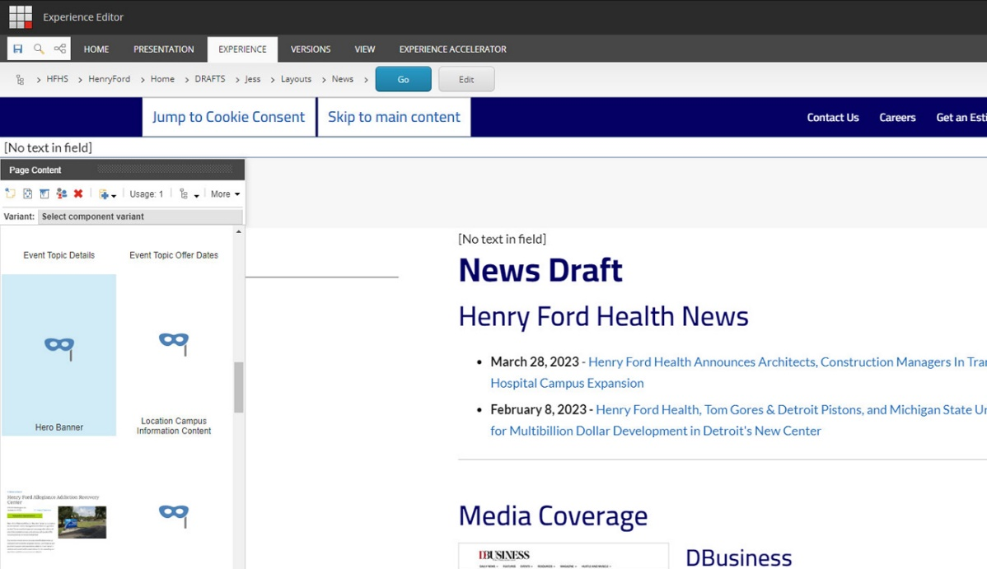

- From here, assign the hero record to the component from the content panel (as shown in above instructions) or from the top ribbon, go to Experience Accelerator > Other, then navigate to the Hero section.

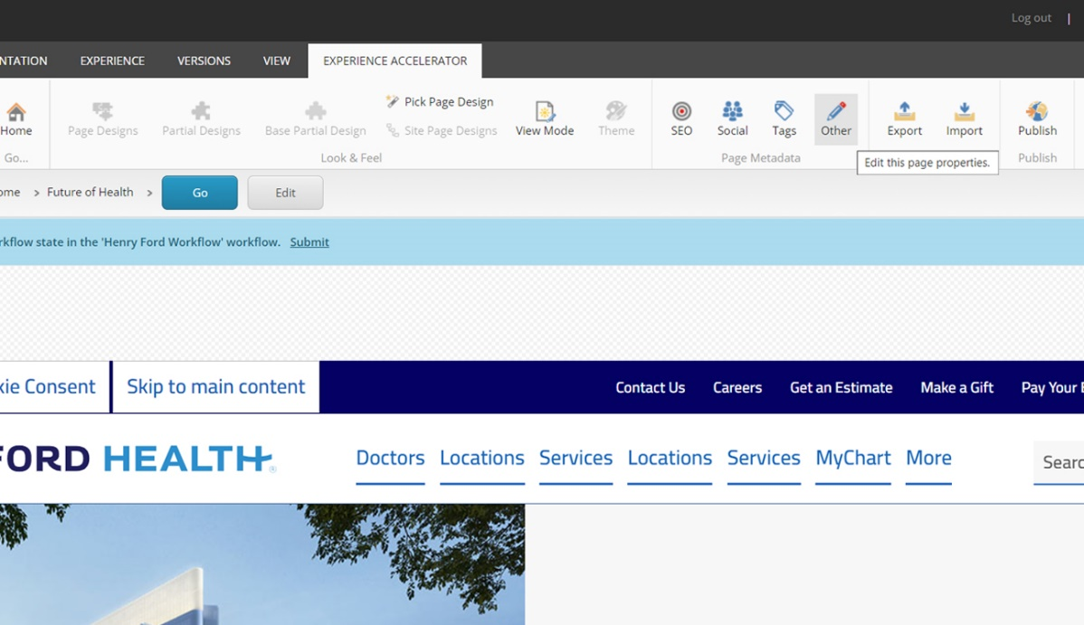
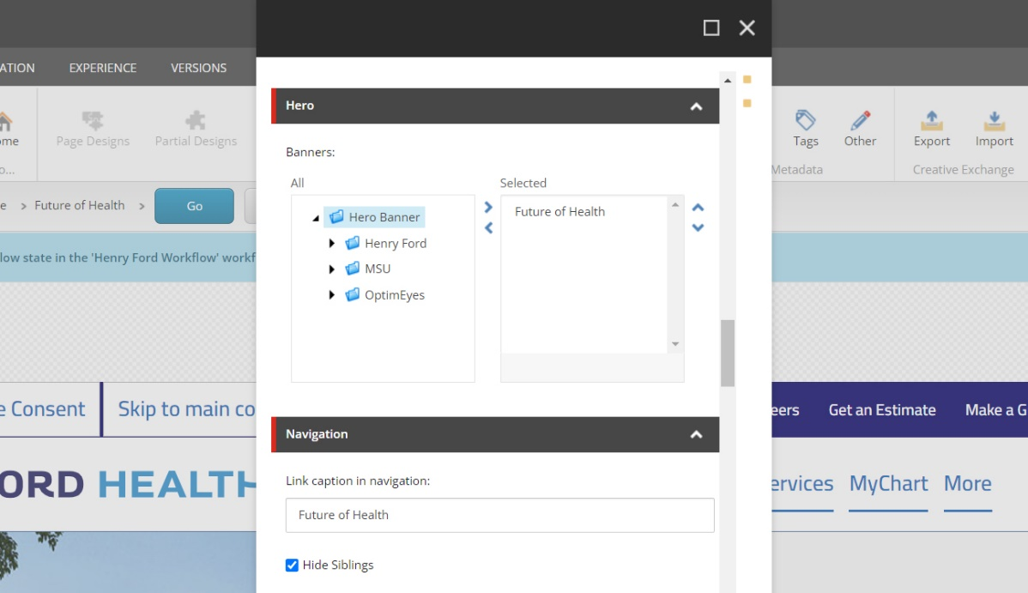

- Save and publish your changes. When Publishing, it is recommended to have Smart publish and Publish related items both checked.

