

HF LANDING BUTTON CTAS
SITECORE SXA | HENRY FORD HEALTH

HF Landing Button CTA: Adding through the Experience Editor

To add a HF Landing Button CTA:
- Select the Add component icon in the top left corner and select the +Add here where you would like to add the HF Landing Button CTA.

- In the Select a Rendering window, select the Snippet tile (under the default Composites tab) and Select.
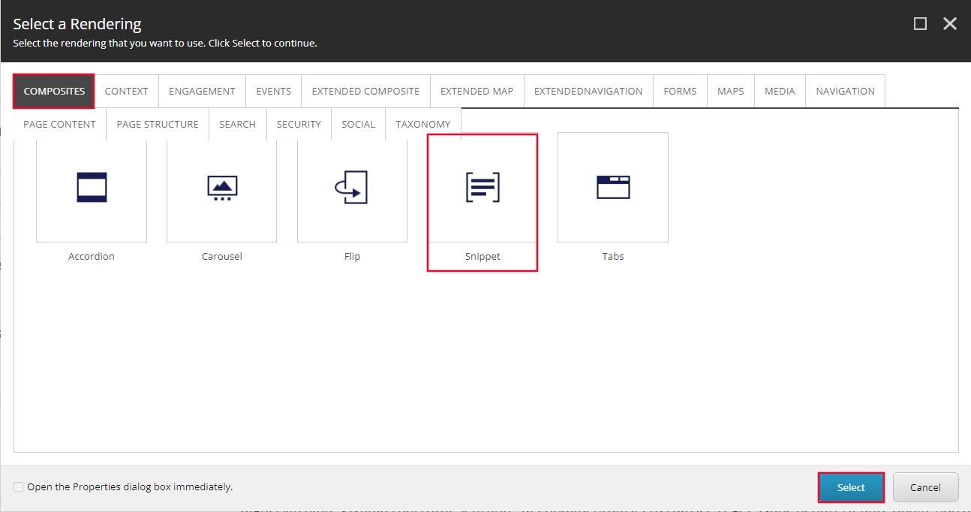
- Open the Landing CTA folder and select the top option under that folder called A Landing CTA1. Select OK, an information window will appear, from here, select the Yes button. Note: This will create a copy of the data source and make for very easy editing.
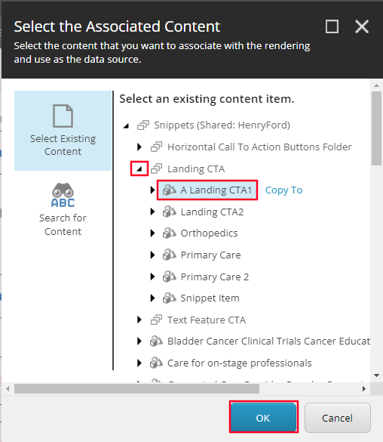
- Both Buttons will load on the page after a few seconds. Once it does, select the button that you want to edit the link for and then select the edit link icon.
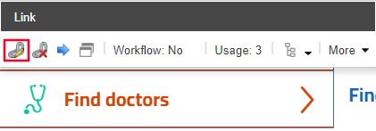
- In the Insert a link window, select the link you wish the button to navigate to and enter the text into the Link description field to edit the text and select OK.
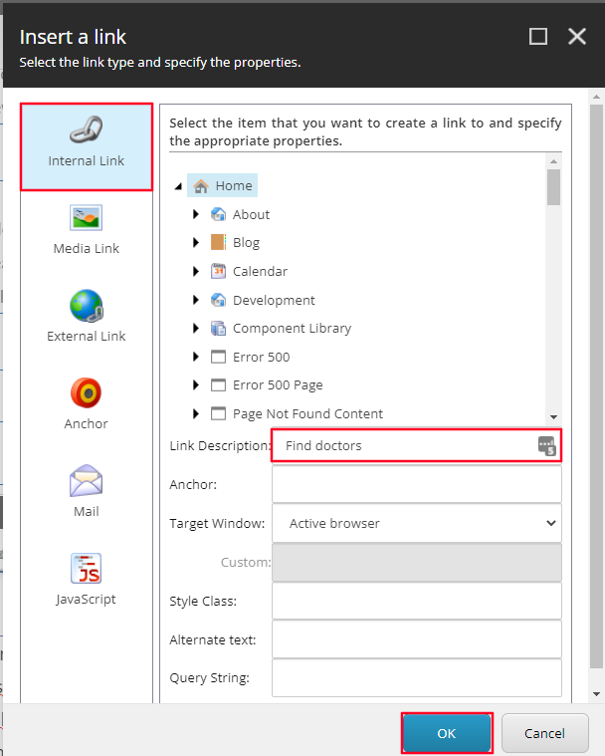
- To edit the button’s mobile text, select the text to the right of each button respectively and alter the text in the text field. Then select Save in the top left corner in the header ribbon.
- You have now created a HF Landing button CTA.
- When Publishing, it is recommended to have Smart publish and Publish related items both checked.

