

NOTIFICATION BANNER
SITECORE SXA | HENRY FORD HEALTH

Notification Banner: Adding through the Content Editor

To add a Notification Banner:
- Go to the Global Folder, and then right-click Notification CTA.
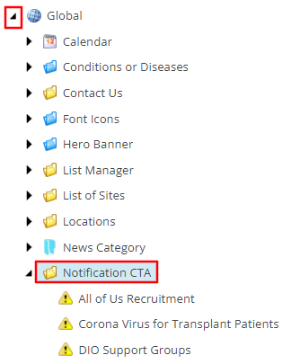
- Select Insert, then select the Notification Banner item.
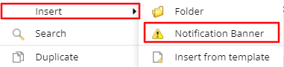
- A Message window will appear. Enter the name of this Notification Banner and select OK.
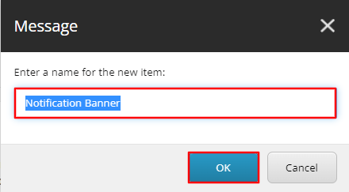
- On the Notification Banner Template, there will be three fields that control the display of the Notification banner.
  - Urgent – If checked, the banner will display with different styling.
Urgent = Unchecked
Urgent = checked
  - Notification Text field – Enter the text you wish to appear in the Notification Banner.
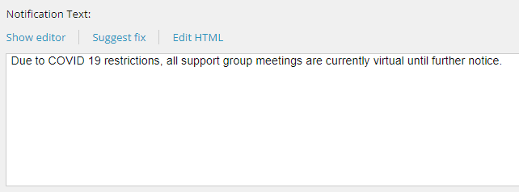
  - Show Notification Box – If checked, this Notification Banner will display on all pages this banner is attributed to. If unchecked, the banner will not appear on the front-end at all.
- To have this Notification Banner display on a page, navigate to the page in the Content Editor. Under the Notification Box Properties section, select the appropriate Notification Banner from the Notification Banner dropdown field.
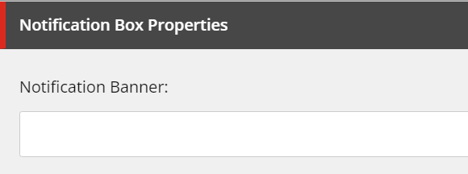
- When Publishing, it is recommended to have Smart publish and Publish related items both checked.

