

IMAGE GALLERY
SITECORE SXA | HENRY FORD HEALTH

Image Gallery: Adding through the Experience Editor
To add an Image Gallery:
- Select the Add component icon in the top left corner and select the +Add here button from an area all the way on the left-hand side of the page. You must select from the side to add the Image Gallery component.

- Select the + Add here button. In the Select a Rending window, select Gallery (under the default Media tab) and Select.
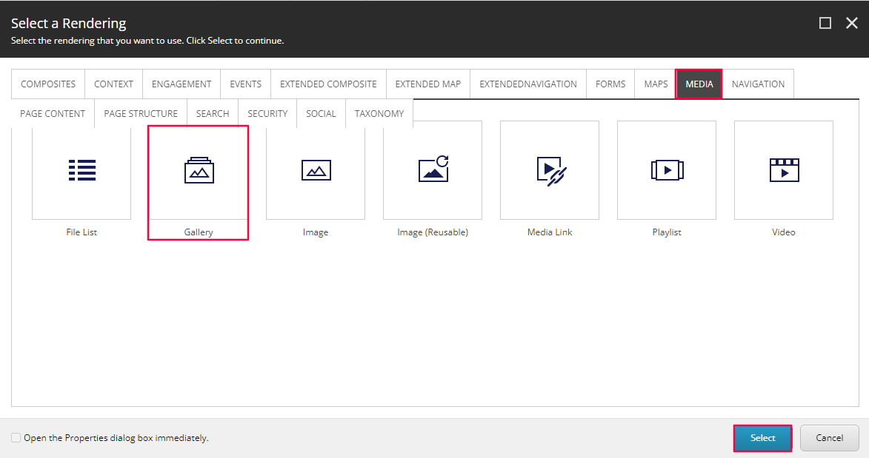
- In the Select the Associated Content window, create a new Gallery by selecting the Galleries folder and then selecting the Create link.
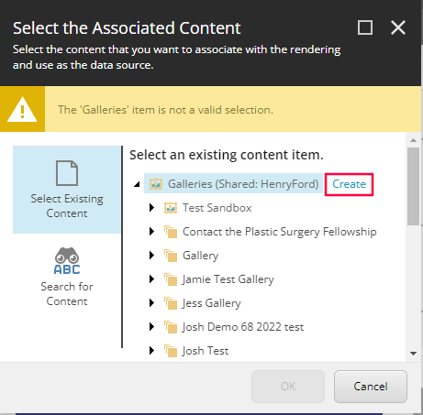
- In the Insert Item window, select the Gallery item (or the Gallery Folder item if you are creating a folder), name that item in the Name field below and select OK.
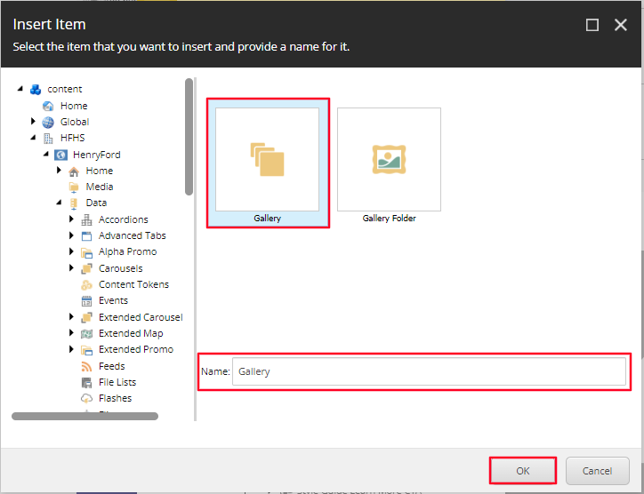
- After you wait a few seconds and the Gallery Placeholder will appear on the page. Select Save in the top left hand header banner. To add an image to the Gallery, click to the right of the word [Gallery] and select the plus icon that appears in the Gallery (empty) toolbar.
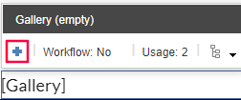
- An Insert Item, window will appear. Select the Gallery Image item and name that item in the Name field below (Note: you cannot have the same name under one Gallery Folder) and select OK.
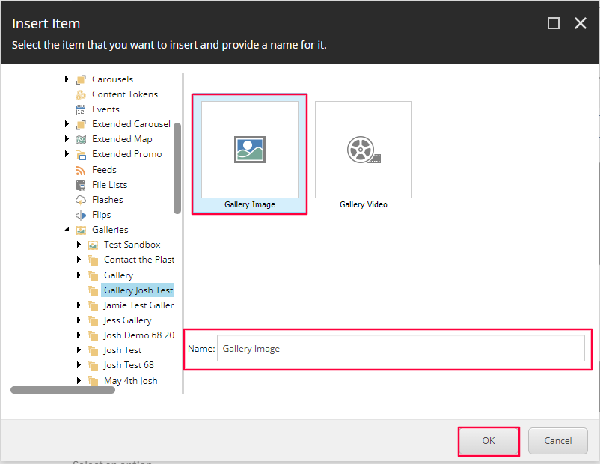
- An image placeholder will appear. To edit this gallery Image, select the placeholder Image, and then select the Choose an Image Icon in the Image from media library Toolbar.
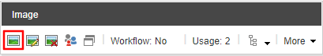
  - Select OR upload the media file that you wish to display and then click Select.
- To edit the Title or Content Copy associated with the image, select to the right of that specific image and select the Edit gallery image properties icon.
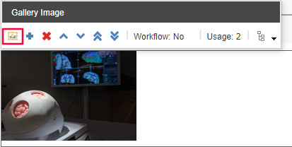
- A window will appear. Update the Title or Description text fields and then select OK.
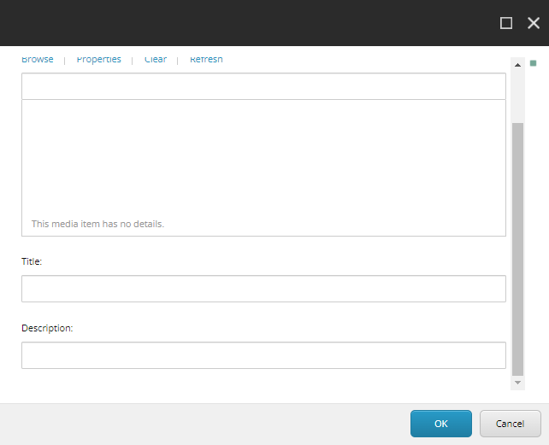
- To Add an additional image to the Gallery, follow steps 5 – 9 but instead just select to the right of an existing image.
- To Delete an existing Image, select to the right of the image you wish to delete and then select the X icon (red).
To Move and reorder the images of your Gallery use the move icons highlighted in yellow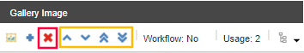
- To edit the Gallery in the Content Editor, go to the following path.
  - /sitecore/content/HFHS/HenryFord/Data/Galleries
  - Once here, right click the parent Galleries item to insert a new Gallery/Gallery Folder OR right click the Gallery item to insert a Gallery Image.
  - Once the Gallery Image is created, you can add the Image, Title and Description as needed.
- You have now created an Image Gallery. When Publishing, it is recommended to have Smart publish and Publish related items both checked.

