

INLINE DROPDOWN COMPONENT
SITECORE SXA | HENRY FORD HEALTH

Inline Dropdown Component: Adding through the Experience Editor

To add a Inline Dropdown Component:
- Select the Add component icon in the top left corner and select the +Add here button where you would like to add the Inline Dropdown Component.
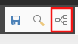
- Select the Extended Navigation tab from the Select a Rendering window, then select Inline Dropdown and Select.
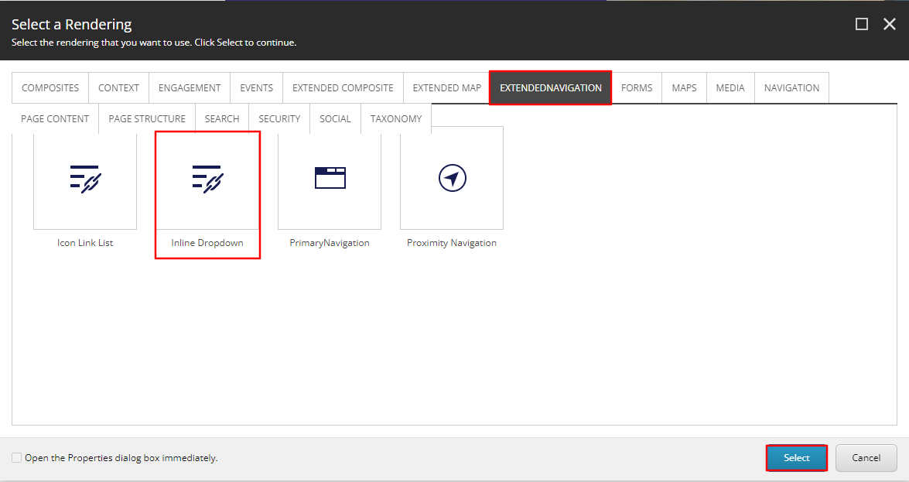
- Select the Inline Dropdown Folder (or the folder you wish to have this inline dropdown stored under) and then select Create.
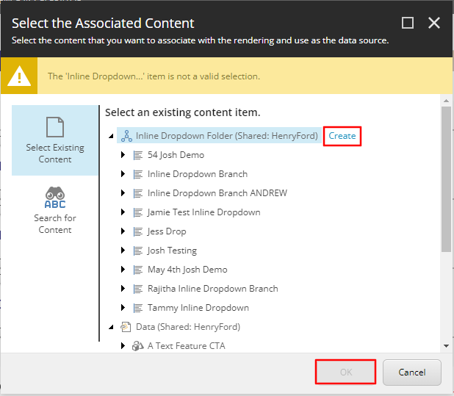
- In the Insert Item window, either create an Inline Dropdown Branch or an Inline Dropdown Folder and assign a Name to it in the bottom field. Then select Okay.
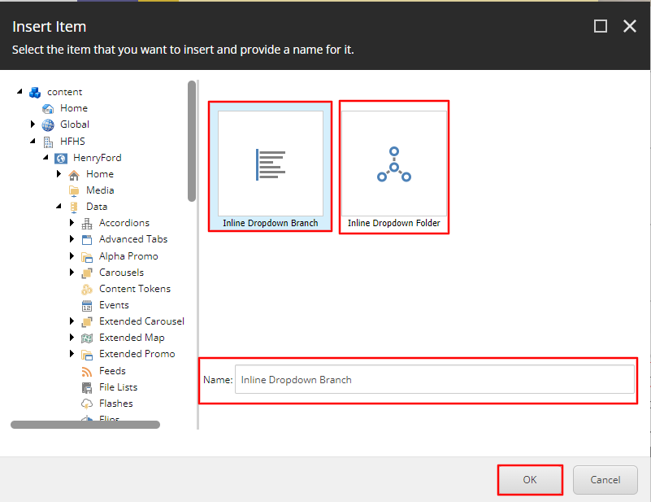
- The Inline Dropdown will load on the page after a few seconds.
- To edit the first value in the inline dropdown, select the [No text in field] text, then select the Edit the links destination and appearance icon in the Link toolbar.
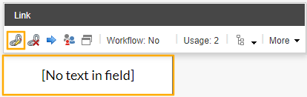
- Once selected, an Insert a Link window will appear. From here you can either:
  - Set the value to an internal link, by selecting the page from the Tree node and setting the value text through the Link Description field.
  - Set the value to an external link by entering the external URL into the URL field and then setting the value text through the Link Description field.
  - Set the value to a Mailto: link by entering the email address into the Mailto field and then setting the value text through the Link Description field.
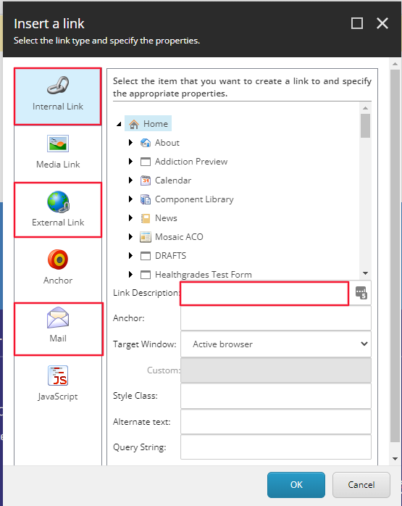
  - Note: If a text field is not edited, it will not appear on the front end.
- Select Okay. That value will now be added to the dropdown.
- To add/delete or move dropdown value items to the dropdown component click to the right of the values in the dropdown.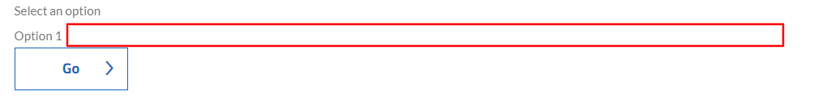
- Once you select that area, a Section Toolbar will appear. 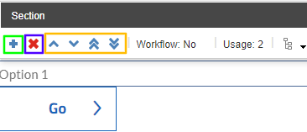
- To add a new dropdown value, select the plus icon (green).
- An Insert Item window will appear. Select the Link, provide a name in the field below and then select Okay. A dropdown value item will now appear below the other dropdown value items.
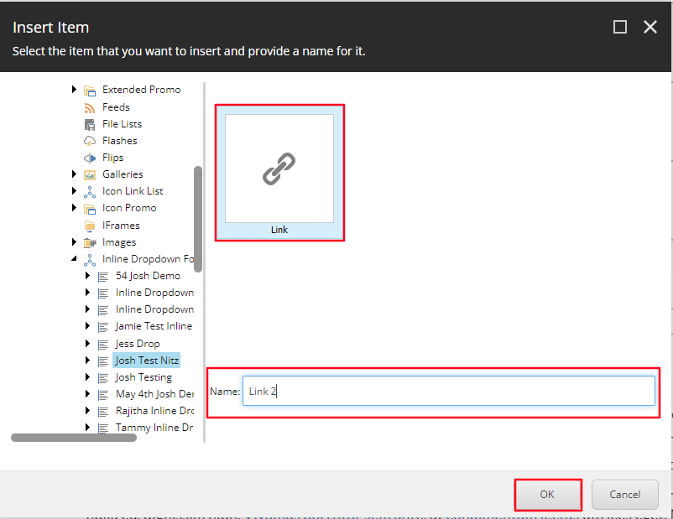
- To edit that value’s text and destination, follow the steps mentioned in steps 6 and 7.
- To delete a value, follow the steps mentioned in step 9 and select to the right of the value you wish to delete. When the Section Toolbar appears, select the X icon. A dialogue box will appear asking you if you are sure you want to delete that dropdown value item. Select Okay.
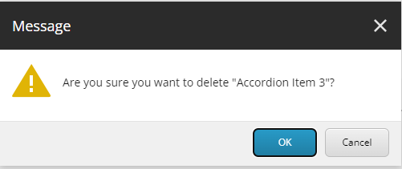
- To Reorder the dropdown value items, select the area that was mentioned in step 9. In the Section toolbar that appears, select the corresponding icon that meets your needs (Yellow).
  - Up caret = moves the value up one spot.
  - Down caret = moves the value down one spot.
  - Double Up caret = moves value item to the top of the dropdown list.
  - Double Down caret = moves value item to the bottom of the dropdown list.

- To edit the Button Text, select the Go text and edit the text to your desired state.
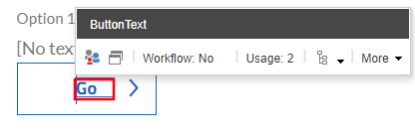
- To Edit the Hint text that appears in the dropdown by default, select the Select an option text and select the Edit the links destination and appearance icon in the Link toolbar. Once the Insert a link window appears, only change the Link Description.
  - Note: Do not change the anchor.
