

LOCATIONS CONFIGURATION
SITECORE SXA | HENRY FORD HEALTH

Logging into Sitecore
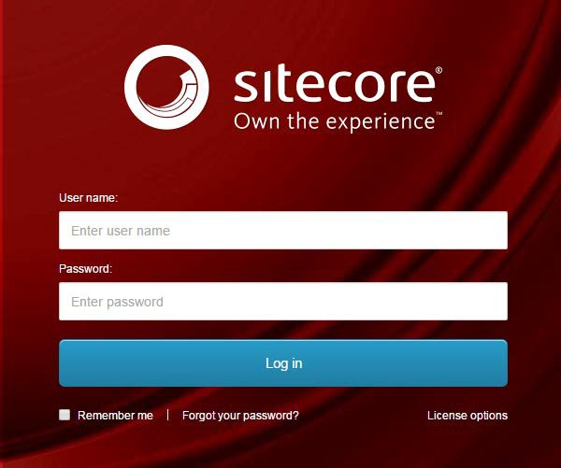
- Enter your User Name, Password, and then click Login to log into Sitecore

- Forgot Your Password – enter in your User Name to have Sitecore email you a newly generated password (this may go to your junk email folder – sender: donotreply@website.net)

- It is recommended that you use either Chrome, Mozilla or Edge.

The Launchpad – The Experience Platform

Note: Based on the access rights of your account and role, your launchpad may look different.

- The Sitecore Launchpad is well organized in the following categories:
  - Green – marketing and analytics tools
  - Red – content editing tools
  - Orange – tools to organize your digital assets and page workflows
  - Black – recycle bin to retrieve your deleted items
  - Blue – account configuration, system steup and app installations
  - Purple – user account settings

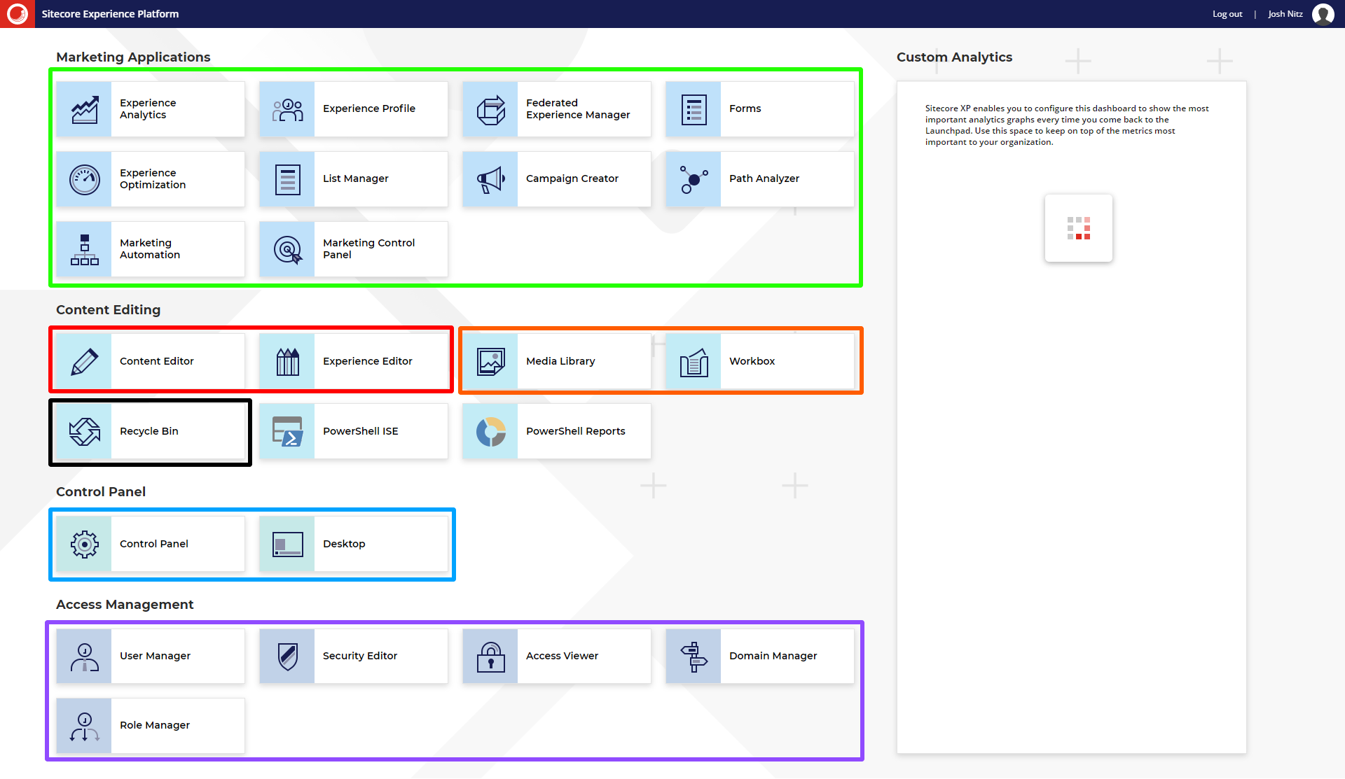

- The contents of this document will focus on:
  - How to change your password
  - How to navigate the SXA framework and edit your page’s front-end and backend content through the Experience Editor.

Navigating Around Your Content Tree
To Start Editing your Locationsy
- Select the Content Editor button.
  - To start editing from the backend select the Content Editor button
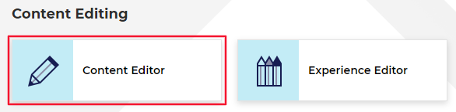
- The Content Tree contains all your website’s pages, items, and modules (including Locations).
  - Note: The Location items are found under the HFHS > HenryFord > Home > Locations node.
    - You will need to scroll down to find the Locations node.
  - Setup your Content Editor with the appropriate settings and menus by opening the View ribbon and having the following checkboxes checked:
    - Content Tree (checked by default)
    - Entire Tree
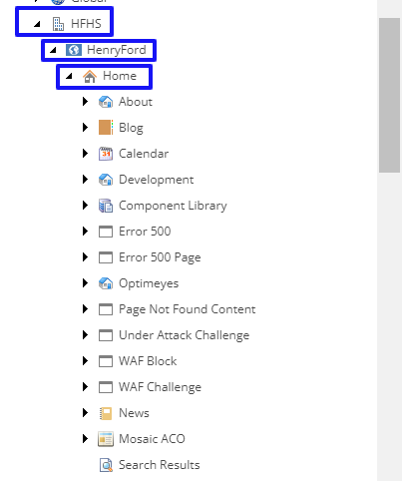
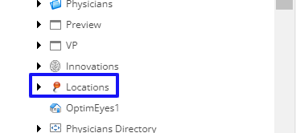

Adding a New Location Profile
- Determine which type of location page you need
  - Building page represents a specific location and all the services and amenities available.
    - Use: For all physical building where HFHS services are offered (Hospital, Medical/Health Center). Find a doctor location links and directory management will link to these pages
    - Example: Henry Ford Allegiance Health Center – Mason
    - Rules:
      - List all HFHS owned and leased buildings
      - Main building page will include links to the Service-Location pages associated with that building
      - Large sites with centralized scheduling will only have a building page
      - 3 or more practices in a building - create building page
      - If HF occupies a majority of the building with 2 or more practices - then create a building page
      - If only primary care and diagnostic center occupy the building then build two pages (primary care page contains the LocID and appears in appt form, no Service-Location page)
  - Service-Location page is a page that represents a specific service line or system clinical department within a larger building.
    - Use: When services and/or system clinical departments, located within a larger building, have unique contact info, operating hours and scheduling procedures.
    - Example: Henry Ford Allegiance Family Medicine – Mason
    - Rules:
      - For large sites with decentralized scheduling the individual, employed practices will be listed separately as Location-Service pages under the Building page
      - Ancillary Services at each building will have Service-Location page if their contact information and hours differ from Building.
  - Custom Location Landing Pages (Hospitals)
- To add a new location profile, do one of the following:
  - Right-click the Locations item, select Insert, and then Location (red).
  - Go to the Home ribbon and then select Location from the Insert section (orange).
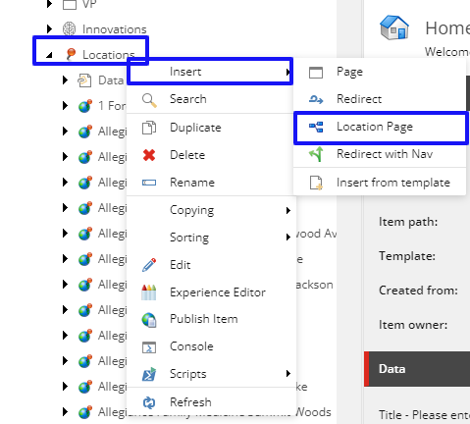
- Name your locations profile item when prompted and then click OK.
Note: the name added here will become this location profile page’s URL.
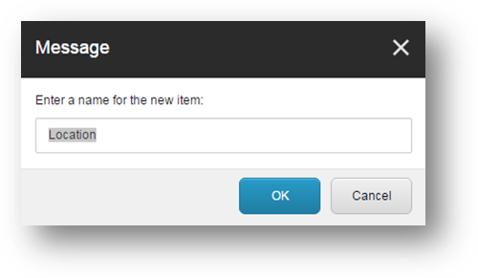

Location Profile Data
- Page Data fields:
  - Headline (Red) – this is the main header <h1> or title of your page; click inside the field to start editing.
  - Introduction (Orange) – this is a teaser or snippet of your copy for your website’s Site Search only and it will not display on the web page; click Show Editor on top of the field to open up the Rich Text Editor to edit or enter text.
Note: if this field is left empty, the system will automatically use the first 150 characters of your content copy
  - Content Copy (Green) – this is the copy/location information of your page; click Show Editor on top of the field to open up the Rich Text Editor to edit or enter text.
Note: for more information on how to use the Rich Text Editor, please refer to your
101: Beginning Basics and Fundamentals of Sitecore 8 document.

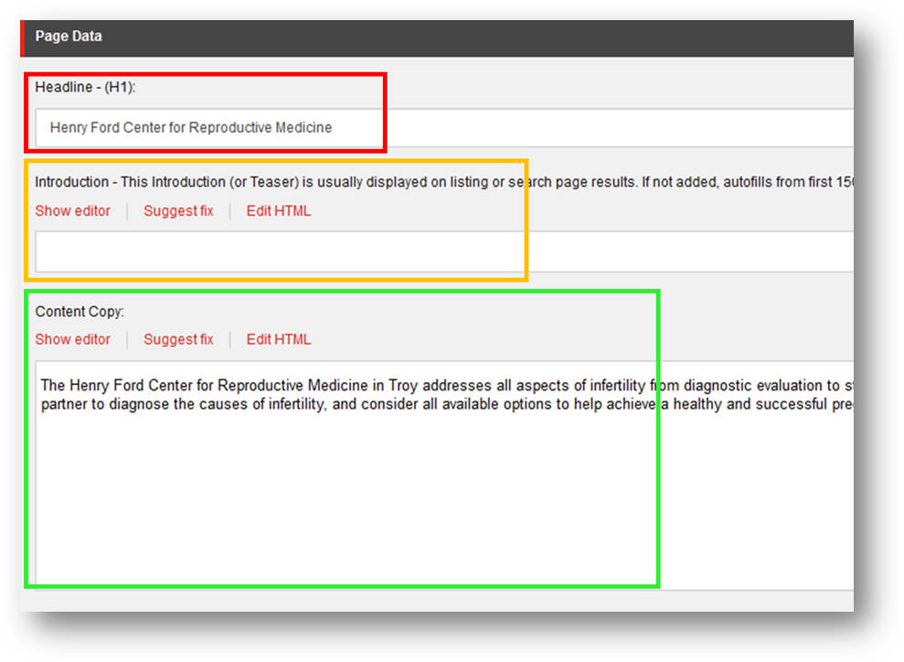

- From the Tagging section, select the taxonomy terms to associated with this location from the All field (left box) and move it over to the Selected field (right box) by using the blue arrows.
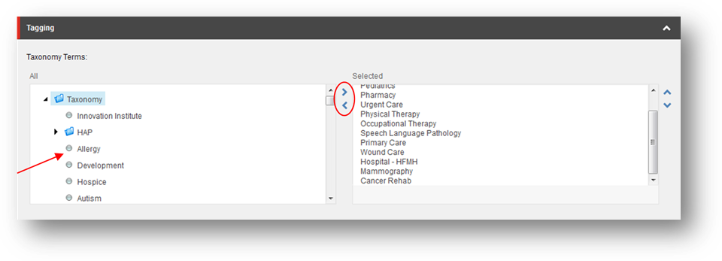
- Select the medical services offered at this location from the All field (left box) and move it over to the Selected field (right box) by using the blue arrows. The selected services will display on the profile page.

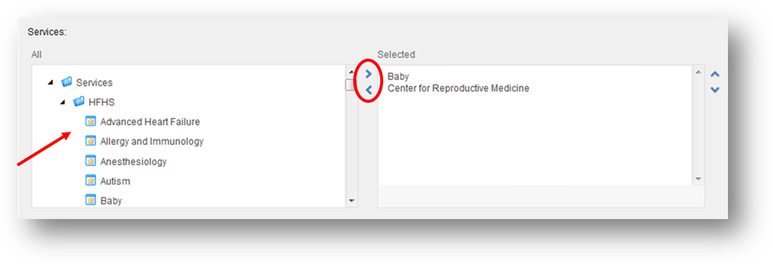
- Location Properties section fields:
  - The Location ID (Red) enter location id matching Find a Doctor import file ID, if applicable.
  - Enter the Location Name (Orange) and the correct address to the Address 1, Address 2, City, State, and Zip fields (Green). The address fields are connected to Google API and will automatically generate a Maps & Directions link that provides directions to the address via Google Maps.
  - The Main Phone (Blue) is for the main location contact number.
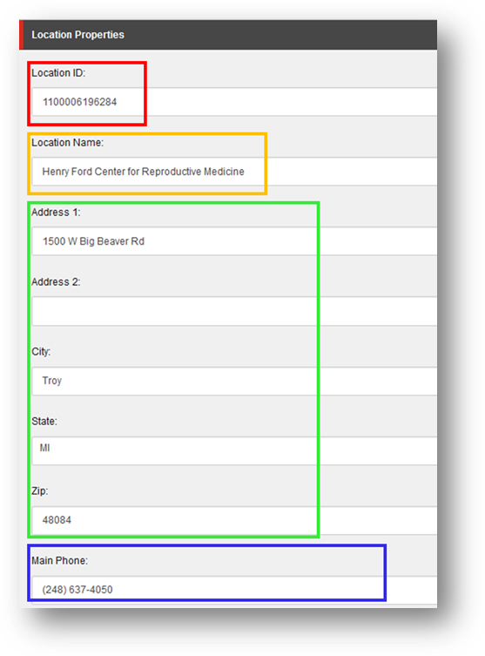
- Upon Save, the Latitude field and Longitude field under the Data section will be automatically filled with the appropriate latitude and longitude of your location based on the data of the address entered.

- Additional location profile information:
  - Check the Accepting New Patients checkbox if accepting new patients at this location (Red)
    - Not active currently.
  - Enter any additional contact phone numbers to the phone number fields Alternate Phone and Appointment Phone (Orange).
  - Departments field (Not shown):
    - Not in use at this time.
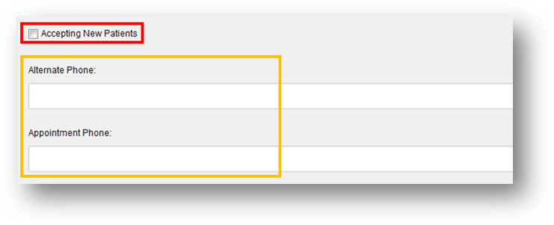

  - Check the Display Physicians At this Location (Red) to include a link to the physician list associated with this location.
    - Not in use at this time.
  - Enter the Email Address for the main point of contact for the location (Orange).

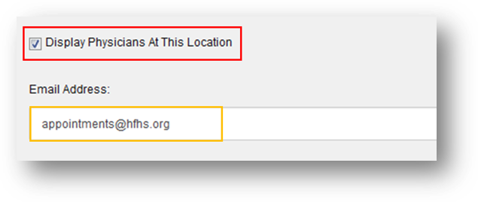
  - Select the location type(s) for this location from the All field (left box) and move it over to the Selected field (right box) by using the blue arrows. The location will display in search results for the type(s) selected.
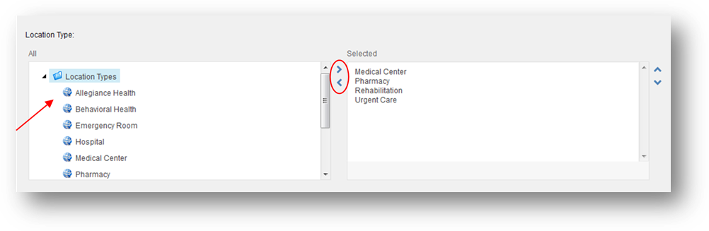

- Enter the Main Fax number for the location (Red).
Enter the location’s Office Hours by clicking the Show Editor to open up the text editor (Orange)
Add a location profile image in the Photo field by clicking the Browse button. Find and select an image to add using the media browser (Green).
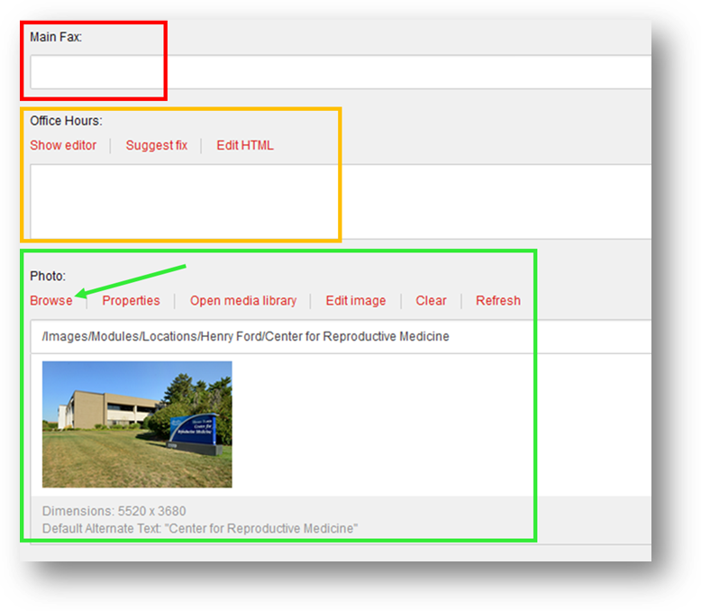
- Location Data section fields:
  - Location Landing checkbox field is no longer in use. Will be removed.
    - Note: If you need a Location Landing template, go to the Designing section and select Location Landing Page value from the Page design dropdown.
  - Check the Display in Appointment Form List (Red) checkbox to include this location in the Appointment form location dropdown.
    - Include email addresses in the Appointment Email Notification (Orange) field to receive notifications when the location is selected from the Appointment form.
  - Click Show Editor to edit the Office Hours Notification (Green) text.
  - Show Service Tab (Blue) will be checked by default to display a tab listing the related services at this location.

Editing Location Tabs
- To edit Location Tabs, go to your Location in the site tree and then select Data > Location Tabs > Tab Items.
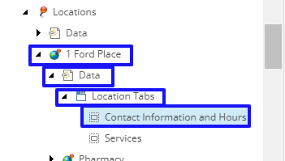
- Once selected you can edit each Tab item individually fields:
Tab Title (Blue): Enter text that will display as the title of the tab.
  - Tab Content (Red): Click Show editor to edit the content of the tab.
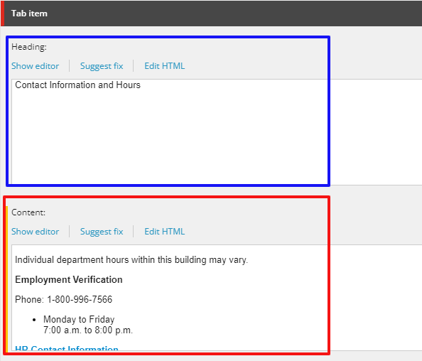
  - If you need to add more Tabs, right click the Locations Tabs item, and then insert Tab Item.
  - 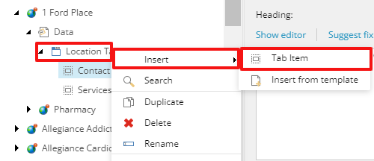

Location Landing Fields
- If you need a Location to display as a Location Landing template, go to the Designing section and select Special Location Landing Page value from the Page design dropdown.
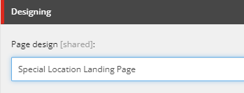
- Select Hero Banners from the All field (left box) and move it over to the Selected field (right box) by using the blue arrows. Additional banners can be created here: /sitecore/content/Global/Hero Banner/Henry Ford
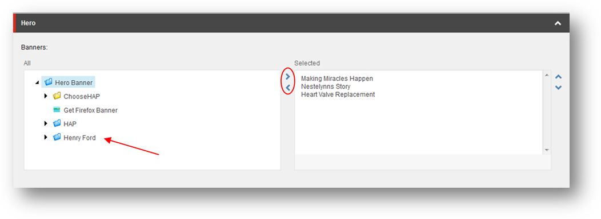
- Locations Call to Action Buttons:
  - Edit these through the Experience Editor by using the Horizontal Call to Action Training Guide.
- Text Features Blue:
  - Edit these through the Experience Editor by using the Text Feature Blue Training Guide.
- Text Image Features
  - Edit these through the Experience Editor by using the Text Image Features Training Guide.
- Two Column CTA Buttons Properties:
  - Edit these through the Experience Editor by using the Two Column CTA Buttons Properties Training Guide.
- Slider CTA:

Adding Child Pages
- To add a child page to the location profile, do one of the following:
  - Right-click the location item, select Insert, and then 2 Column Wide Right or Location.
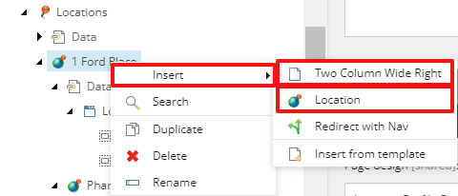
- Name your page when prompted and then click OK.
Note: the name added here will become this news page’s URL.
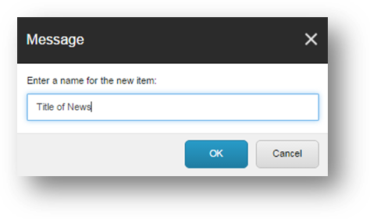
- The hierarchy of the child pages in the Content Tree will determine the order displayed in the proximity menu of the location profile.

Submitting Your Item through the Workflow
- When you are done with your edits and have saved your work, from the Review tab you can:
  - Check In: “unlock” the page from your account and make it available for other users to “lock” the page to their account; this action will keep the current version as Draft and therefore will not be published.
  - Submit: sends the most recent version to the staging area for an approval to be published by a publisher or an administrator.
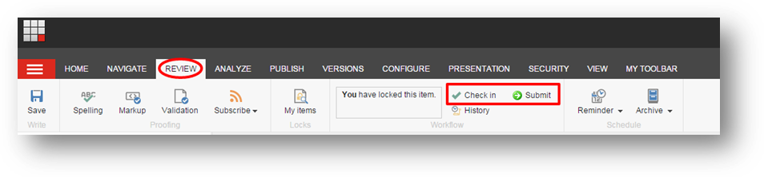
- If you have Publishing rights or are an Administrator, then you will see the Approve and Reject buttons immediately appear after Submitting your page.
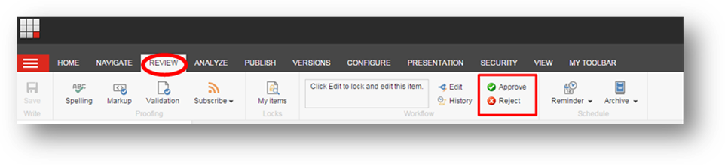
- When you click Approve, the page will be staged for Publishing and when you click Reject, it will send the page back to the workflow as a Draft and will not be published.

How to Publish Your Item
- Select the item or page that you want Publish, open the Publish ribbon and then click the Publish button (Red) or click the down arrow. Then select Publish Item from its drop down menu (Orange).
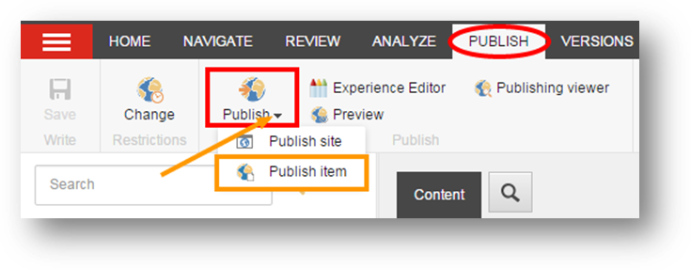
- Click Publish to publish the item, its sub-items, and related items.
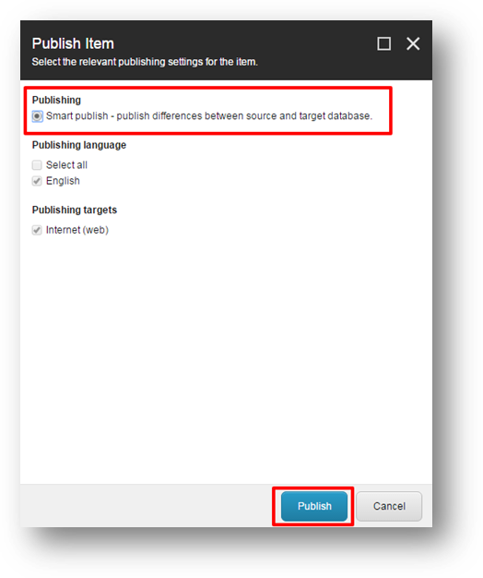

Appendix 1: Page Type Rules Grid
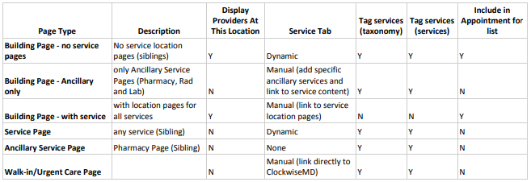
- Building Page - No service pages https://www.henryford.com/locations/fairlane
- Building Page - Ancillary only https://www.henryford.com/locations/hfml-wyandotte
- Building Page - with service https://www.henryford.com/locations/allegiance-health-professional-building
- Service Page https://www.henryford.com/locations/allegiance-health-professional-building/cardiac-rehabilitation
- Ancillary Service Page https://www.henryford.com/locations/allegiance-health/pharmacy https://www.henryford.com/locations/allegiance-health-center-cascade-ridge/diagnostic-center

Appendix 2: Location Name Rules
Location names, IDs and services should be verified using the EPIC Location file (S:\OFP\PLAN_MKT\Web\HF.com\Locations Directory\Locations-Data-Extract)
- Discrepancies in names should be forwarded to Ara Telbelian and Market marketing manager
- Discrepancies in service listings should be discussed with the location manager
Branded Location Name Standards
- All HFMG outpatient facilities are branded Henry Ford Medical Center – name of city
- All multispecialty Henry Ford Macomb or Henry Ford Wyandotte facilities are branded Henry Ford Health Center – name of city
- All HF Macomb owned practices with 1-2 services are branded Henry Ford Macomb (noun of service) …i.e. Henry Ford Macomb OBGYN)
- All HF Wyandotte owned practices with 1-2 services are branded Henry Ford Wyandotte (noun of service) …i.e. Henry Ford Wyandotte OBGYN
- Single specialty locations HFMG: Henry Ford [specialty/service name] - name of city

