

Maintaining Your Physician Directory
SITECORE SXA | Henry Ford Health

Logging into Sitecore
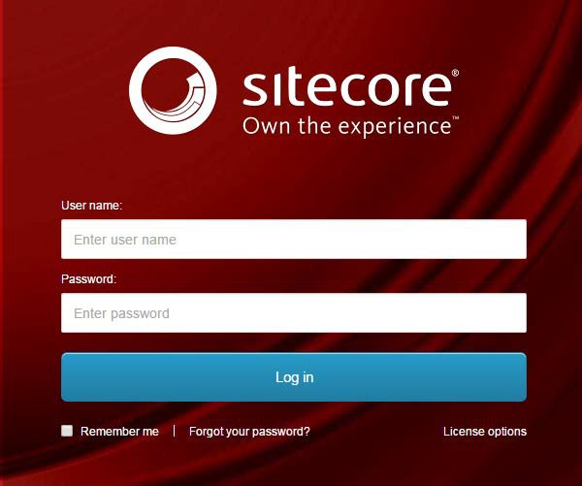
- Enter your User Name, Password, and then click Login to log into Sitecore

- Forgot Your Password – enter in your User Name to have Sitecore email you a newly generated password (this may go to your junk email folder – sender: donotreply@website.net)

- It is recommended that you use either Chrome, Mozilla or Edge.

The Launchpad – The Experience Platform

Note: Based on the access rights of your account and role, your launchpad may look different.

- The Sitecore Launchpad is well organized in the following categories:
  - Green – marketing and analytics tools
  - Red – content editing tools
  - Orange – tools to organize your digital assets and page workflows
  - Black – recycle bin to retrieve your deleted items
  - Blue – account configuration, system steup and app installations
  - Purple – user account settings

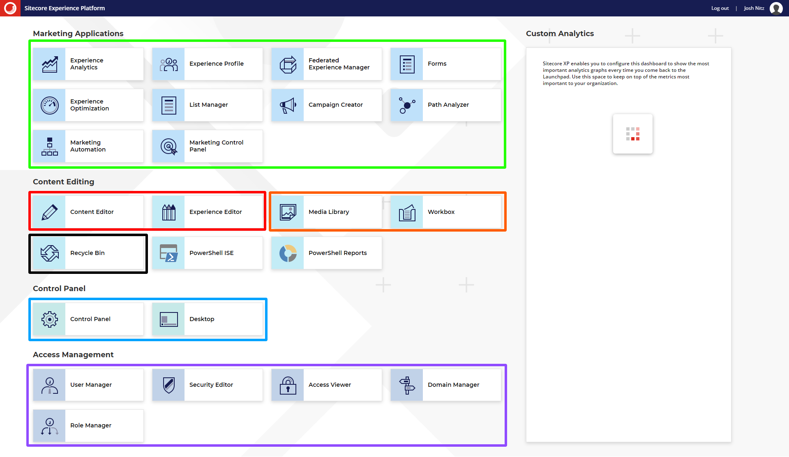

- The contents of this document will focus on:
  - How to change your password
  - How to navigate the SXA framework and edit your page’s front-end and backend content through the Experience Editor.

Navigating to your Physician Directory Physicians

To Start Editing your Physician Directory
- Select the Content Editor button.
  - To start editing from the backend select the Content Editor button
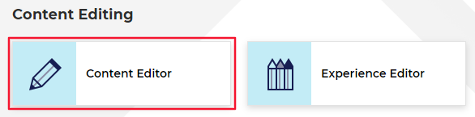
- The Content Tree contains all your website’s pages, items, and modules (including Physician Directory).
  - Note: The HF Physician Directory item that’s found in live will be found under the HFHS > HenryFord > Home > Physician Directory node.
  - Setup your Content Editor with the appropriate settings and menus by opening the View ribbon and having the following checkboxes checked:
    - Content Tree (checked by default)
    - Entire Tree

Accessing Your Physician Directory
Note: OptimEyes physicians are added within the microsite.
Note: Open Scheduling will be covered in a different training module.

Add a physician to the main physician directory
- Click the triangle in front of the HFHS item, then HenryFord item. Expand the Home item and then navigate down to Physician Directory.
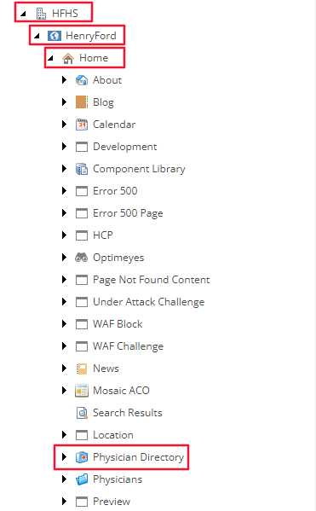

- The folder structure of your Physician Directory module is organized alphabetically with the starting letter of the physician’s last name.
Click the triangle in front of the letter folder to view all physician profiles in that folder.
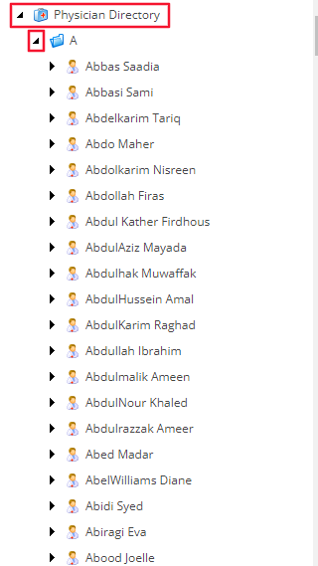

Adding a New Physician Profile
- Navigate to Physician Directory and expand the item. Select the appropriate letter folder that you want to add the profile to and then do one of the following:
  - Right-click on the letter folder, select Insert, and then Physician (Red).
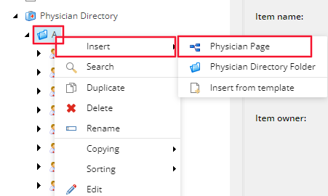
- Enter the name of the physician in Lastname Firstname format (i.e. Smith Joan) when prompted and then click OK.
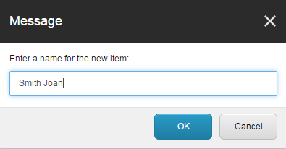

How to Use the Multisite
- Select the Microsite(s) where the new entry should be copied to from the All field (left box) and move it to the Selected field (right box) by using the blue arrows.
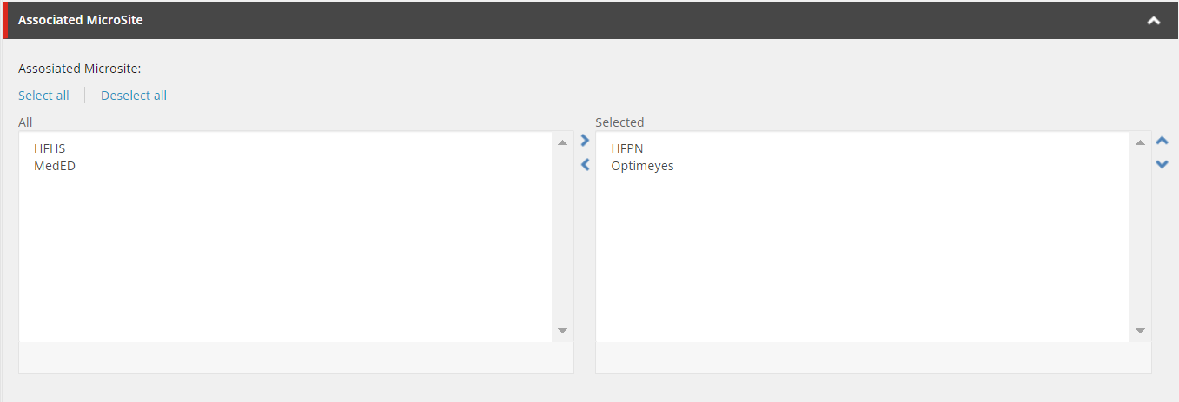
- Go to the Home ribbon and click Save to save the change to the microsite in the Content Tree.
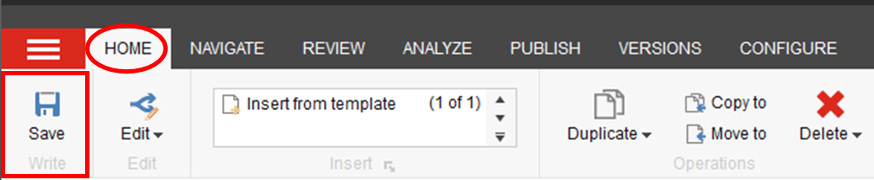
- Items cannot be previewed in the microsite’s modules. To preview the physician directory in the main site, go to the Home tab and then click Preview.

The Physician Data
- Enter the physician’s name in the First Name, Middle Initial, Last Name, and Suffix fields (in red). 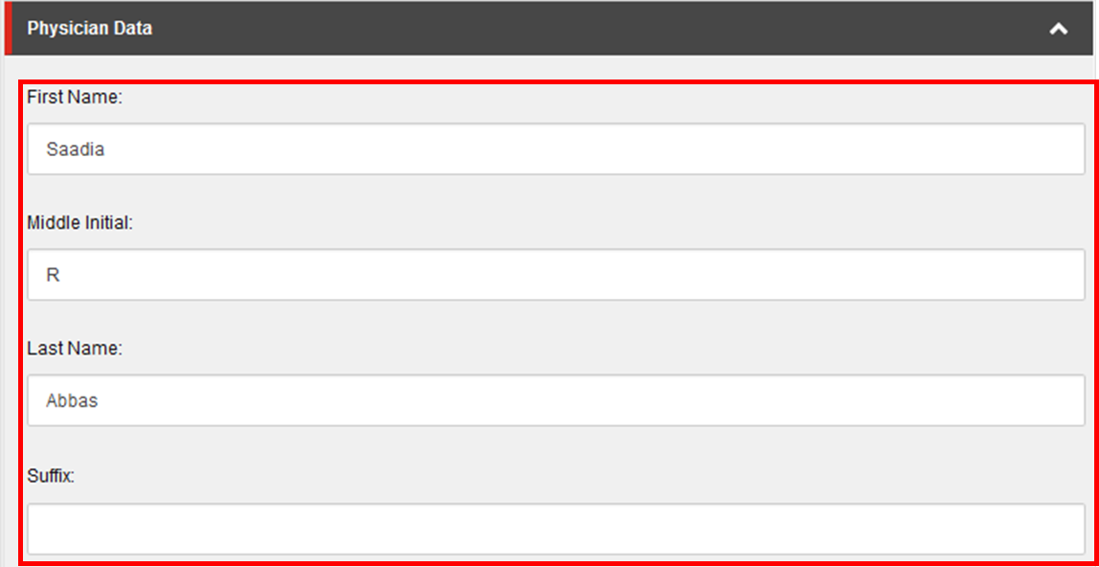
- Click the Gender field to select the appropriate gender from the dropdown.
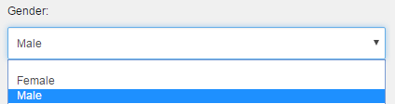
- Photo field: Click Browse and select an image from the media browser to add a profile image.
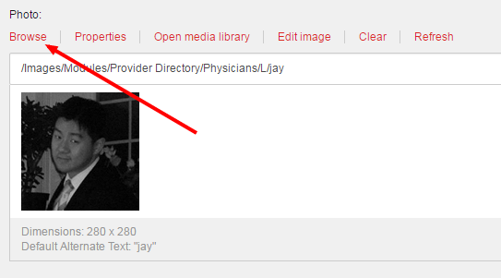
  - To upload a new physician photo from the photo field, select the Upload media button.
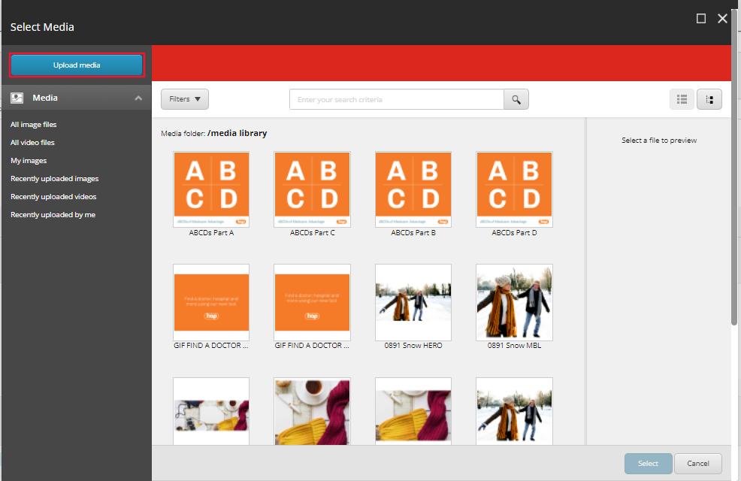
  - Click Change Destination and select the folder path that the image you upload should reside and select Confirm. The image will automatically be added here once uploaded.
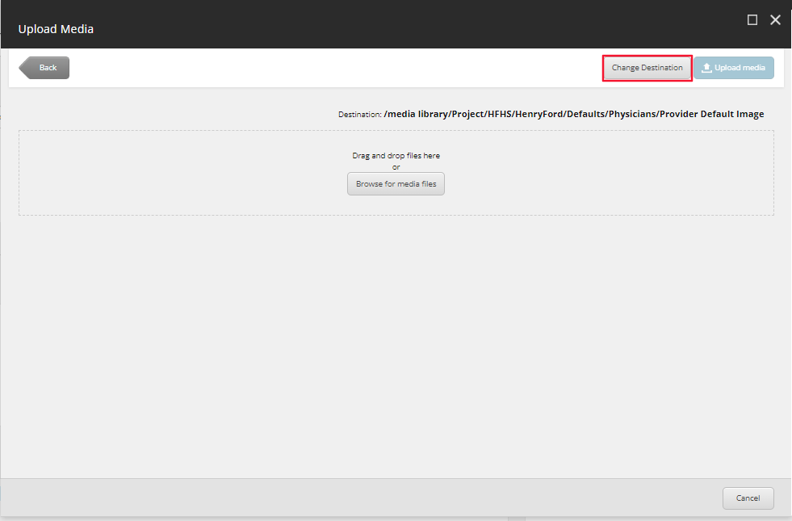
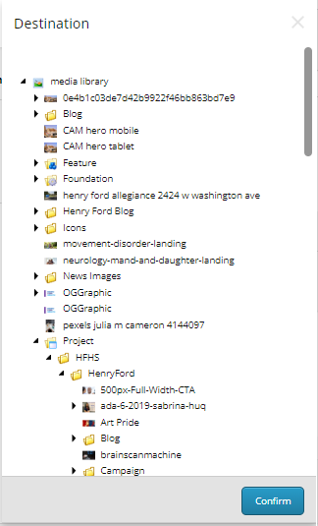
  - To upload an image file, either drag and drop the image file from your File Explorer into the dotted line area (blue) or select the Browse for media files button (red), and then select the image field.
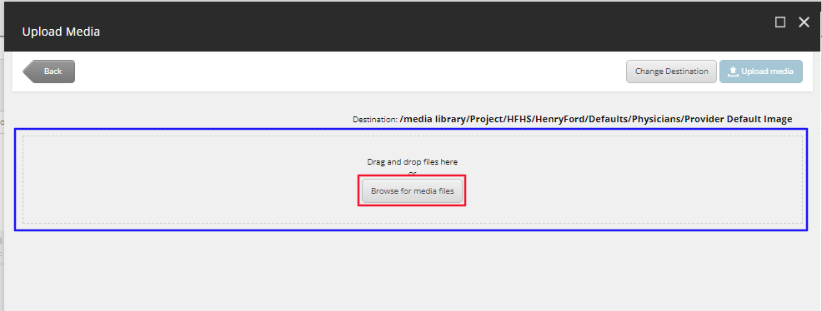
  - Once the image is added, it will appear below the drag and drop area. Populate the Alternate Text and select Upload media in the top right corner.
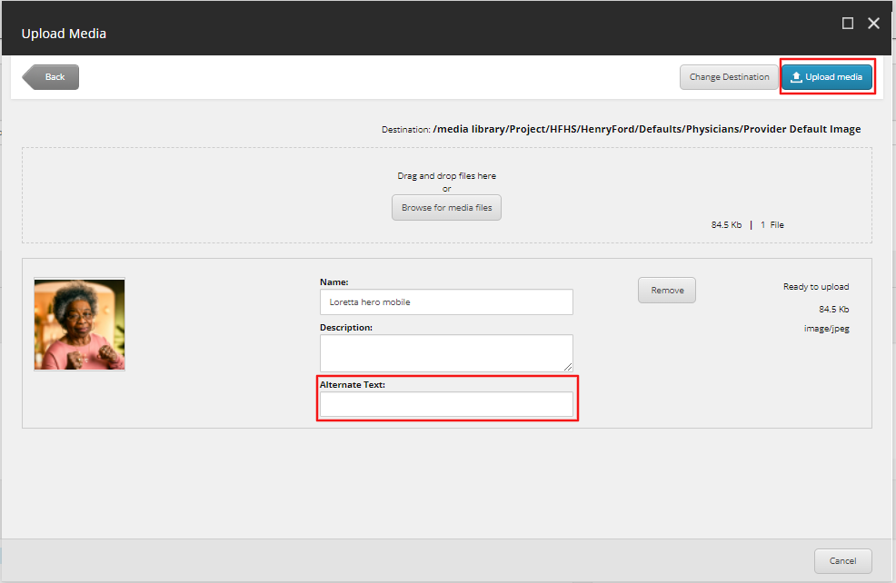
  - The system will navigate you to the Select media window. Select the Recently uploaded by me link on the left-hand side, select the image recently uploaded and click Select.
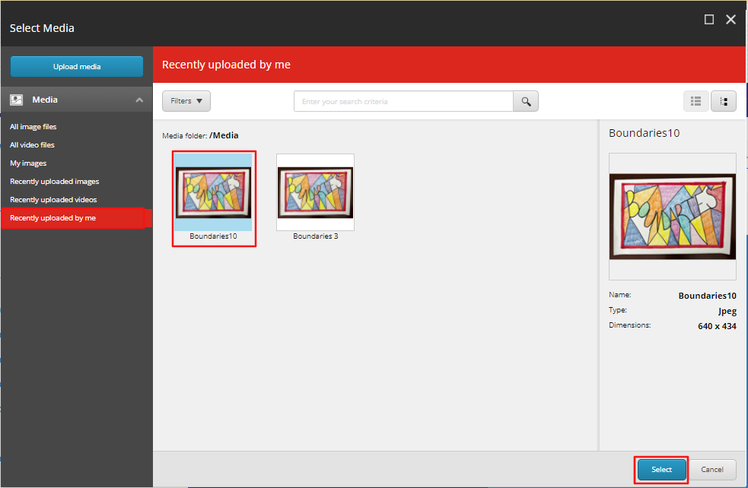
  - For the image to appear on the front-end, navigate to the image in the Media Library and Publish the item. Do this by navigating to the item, opening the Publish tab in the ribbon and then clicking the Publish button (Red) or click the down arrow. Then select Publish Item from its drop down menu (Orange).
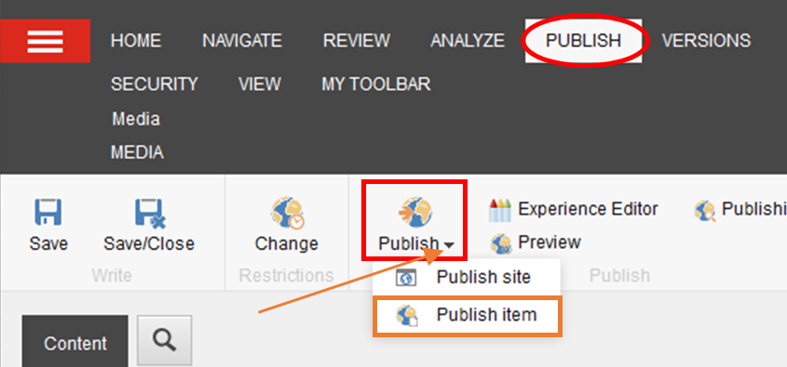
  - Click Publish to publish the image. 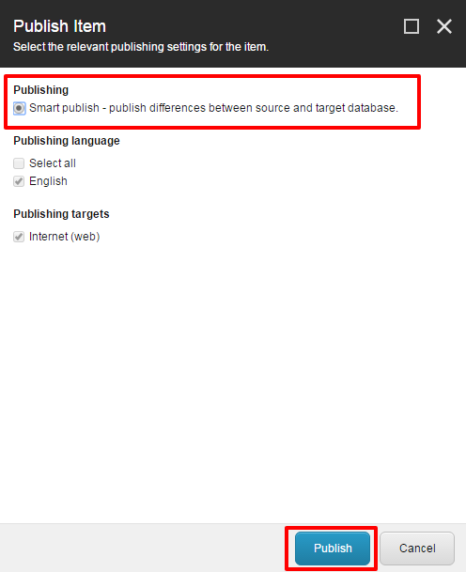
- Select the appropriate Degree Titles and Languages Spoken by selecting the item(s), click on blue arrow to move to the Selected section.
Note: Upon saving the item, Degree Titles will be added to the physician’s name in the Headline field.
Note: Degree Titles are populated by the import file, but can be manually supplemented if the import will not include the item and it is not a duplicate. To manually add a degree title, navigate to /sitecore/content/Global/Physician Directory/Degree Titles.
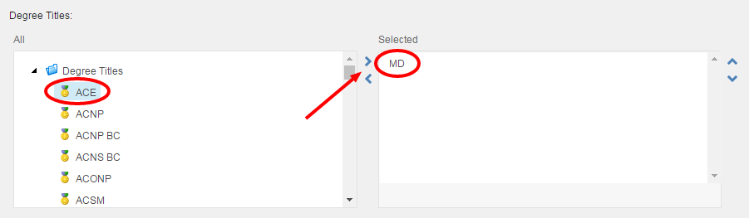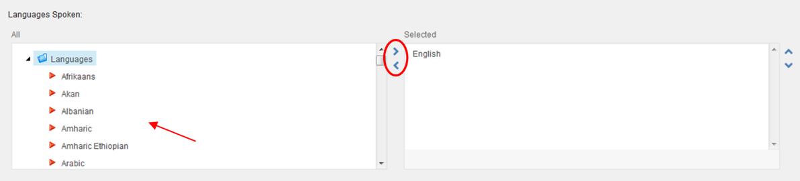
- Website (Red): If the physician has a separate webpage, click Insert Link to add the URL if the page is in the same content tree as the module or use Insert External Link for an external webpage.
Internal Hospital ID (Orange): Click inside the field to enter an internal code associated with the physician (can be used for physician data import).
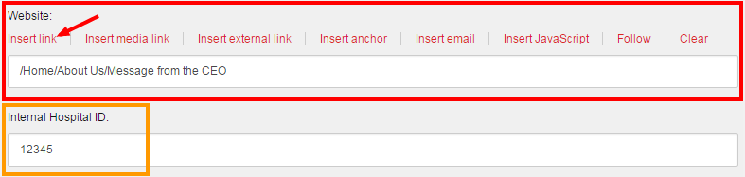
- Select the Hospital Affiliations by selecting the item, and clicking on the blue arrow to move to the Selected section.
Note: Hospital Affiliations are populated by the import file, but can be manually supplemented if the import will not include the item and it is not a duplicate. To manually add a hospital, navigate to /sitecore/content/Global/List Manager/Hospital Affiliations.
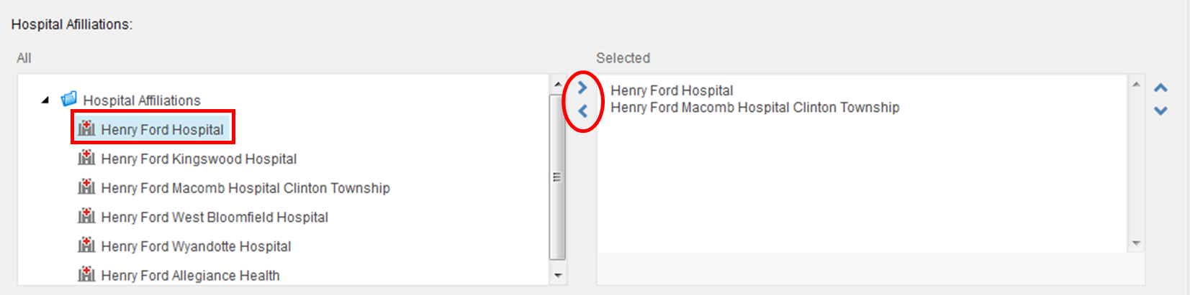
- Medical Group (Red): If the physician is associated with the Henry Ford Medical Group, select this checkbox. The physician will display in the Henry Ford Medical Group physician search results and the medical group logo will display on the profile.
Physician Network (Orange): If the physician is associated with the Henry Ford Physician Network, select this checkbox. To include this physician in the physician network search, add HFPN in the clone destinations section.
Appointments (Green): If this physician is currently accepting appointments, use this checkbox. The Request and Appointment option will display on their profile and will use the Appointment Form Link.
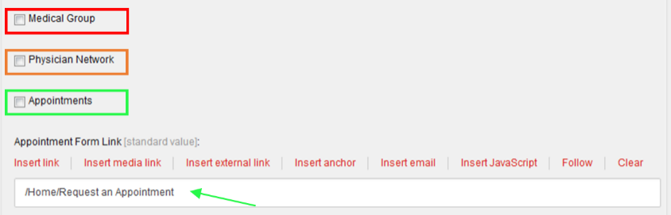
- Appointment Form Link – This is the location the user will be sent to if they select Request an Appointment button on the front-end.
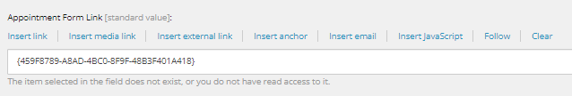
- Enter the NPI Number (Red) associated with the physician.
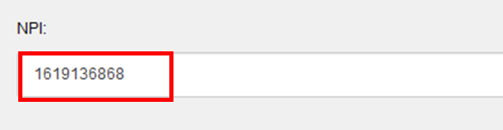
- Additional Degree Title: Add Additional Degree Titles by selecting the item(s) in the All Field (left-hand field) and clicking on the blue arrow to move to the Selected section.
Note: Add Additional Degree Titles manually, they are not populated by the import file. To manually add a degree title, navigate to /sitecore/content/Global/Physician Directory/Degree Titles
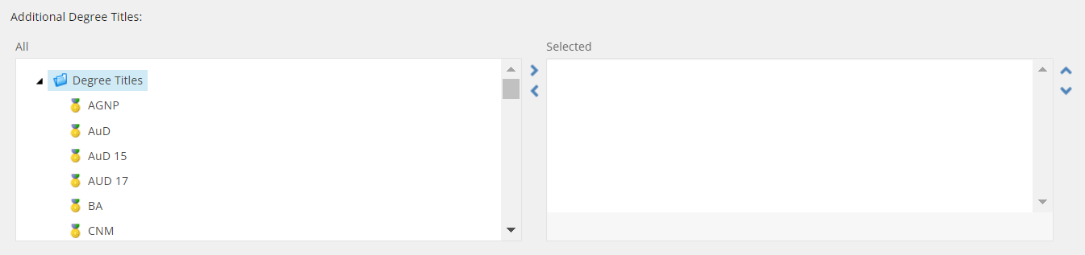
- Faculty checkbox – check this box if the Faculty Dynamic Doctors control will be used to display this physician as a faculty.
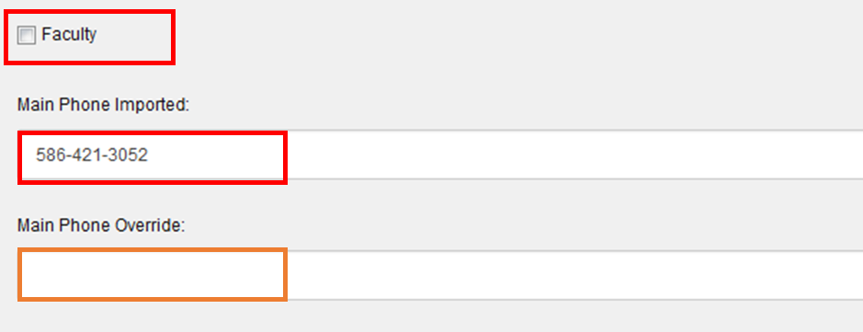
- Main Phone fields:
  - Main Phone Imported (Red): populated by the physician import.
  - Main Phone Override (Orange): Phone number to display on the provider search results and profile. Overrides the Main Phone Imported for display.
- Biography fields:
  - Biography Import (Red): populated by the physician import.
  - Biography Override (Orange): overrides the Biography Import field for display on the provider profile. Click Show Editor to edit this field.
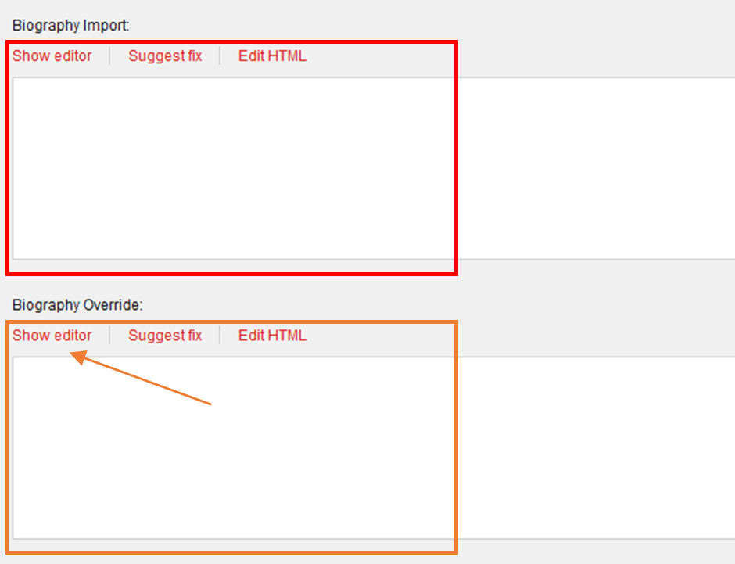
- Accept New Patient: This checkbox field will determine if this physician is available for Open Scheduling or Request an Appointment online button. This field is updated through the import and should very rarely be altered manually.

- Page Data fields:
  - Headline (Red) – this is the main header <h1> or display title of the profile (physicians’ name); this field will be automatically filled upon saving if the name fields were entered and degree titles selected.
Note: this field is not visible in the front end, but is important for SEO (search engine optimization).
  - Introduction (Orange) – this is a teaser or snippet of your copy for your website’s Site Search only and it will not display on the profile; this field will be automatically filled upon saving if the departments field was selected.
  - Content Copy (Green) – this is your physicians’ Biography; click Show Editor on top of the field to open up the Rich Text Editor to edit or enter text.

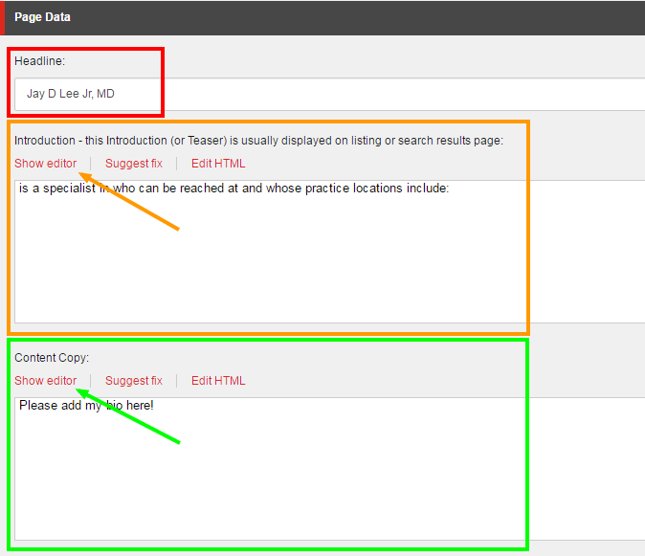

- Credentials fields:
Content entered in Certifications RTE fields in the Credentials section and Publications in the Achievements section will be displayed under the Biography section in the frontend of the profile.
Note: these fields function like the content copy field – click Show Editor to start entering content.
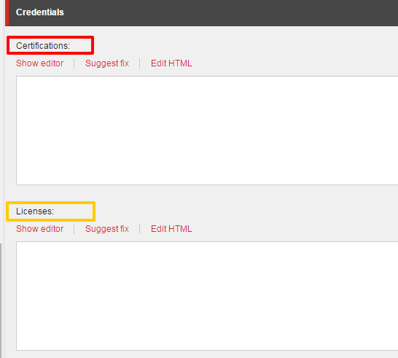
- Tagging fields:
To associate the physician with Specialties or Services select the item from All and use the blue arrows to move to Selected.
Note: Specialties are populated by the import file, but can be manually supplemented if the import will not include the item and it is not a duplicate. To manually add a specialty, navigate to /sitecore/content/Global/List Manager/Specialties.
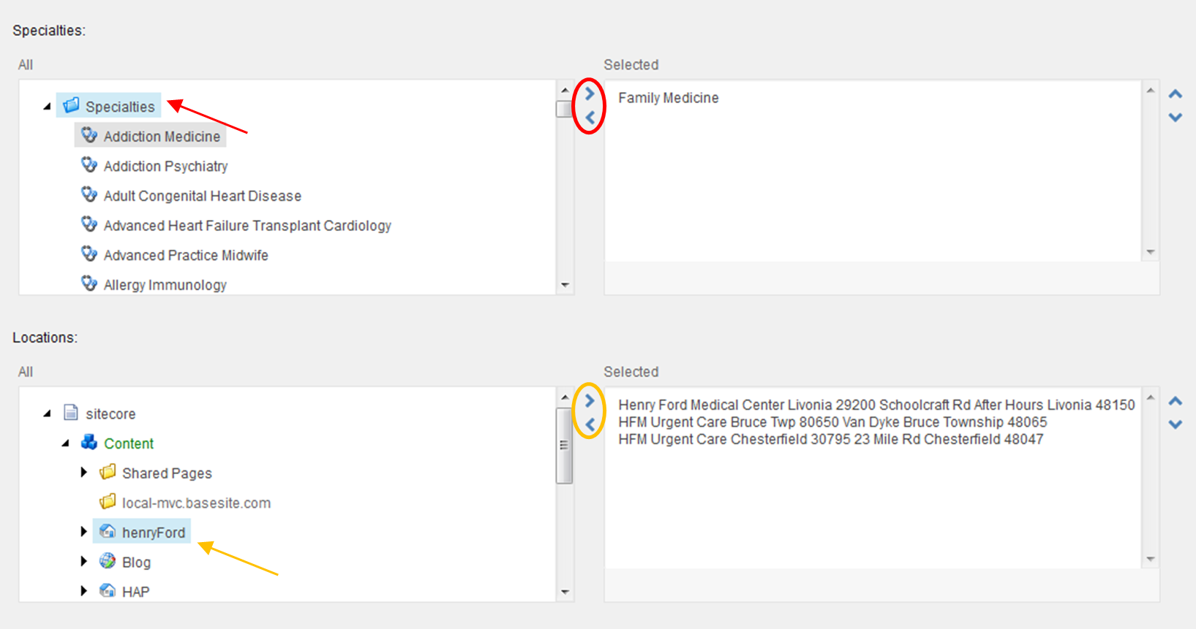
- The Locations field is automatically populated by the physician offices within the child elements. After adding physician offices, return to the physician profile and save to update this field.

- Henry Ford YouTube Properties fields – fields repeated for four videos.
  - Caption (Red): Caption to display beneath video.
  - YouTube Image (Orange): Optional image to display. If no image is provided, the YouTube video image will display.
Click Browse to select an image from the Media Library.
  - YouTube ID (Green): enter YouTube ID only from YouTube embed snippet.
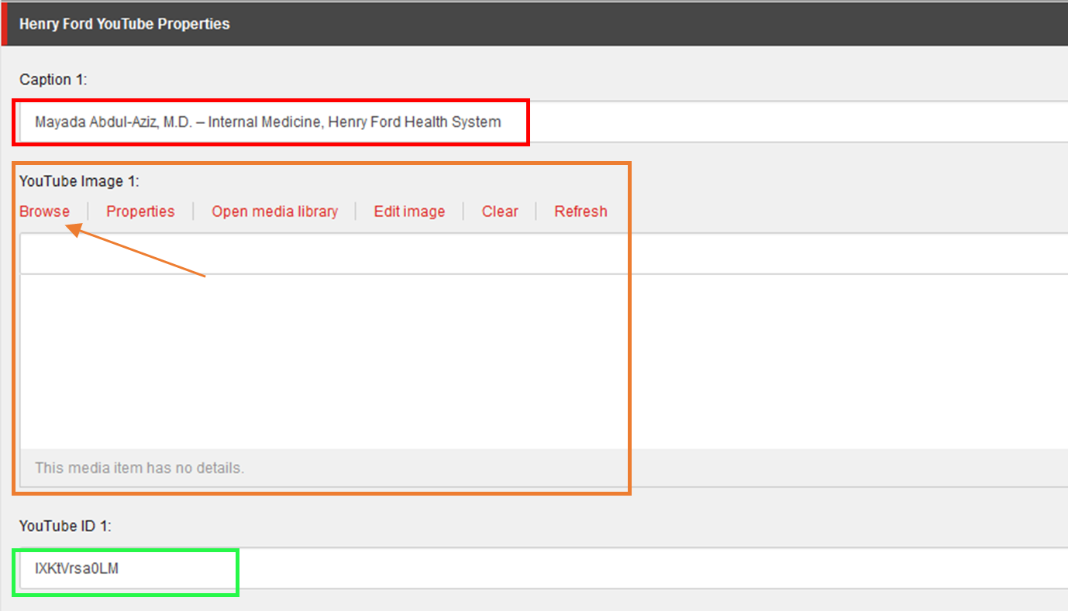

Child Elements
These items can be added to the folder beneath the physician item in the Shared Pages folder and will display in the Board Certification and Education section on the physician profile page.
- Navigate to the Physician profile and expand the item. Select the appropriate item folder that you want to add the item to and then do one of the following:
  - Right-click on the letter folder, select Insert, and then Education (Red).
  - Open the Home ribbon and then click Education from the Insert section (Orange).
Note: Insert options for the other folders include: Residency, Fellowship, and Physician Office.
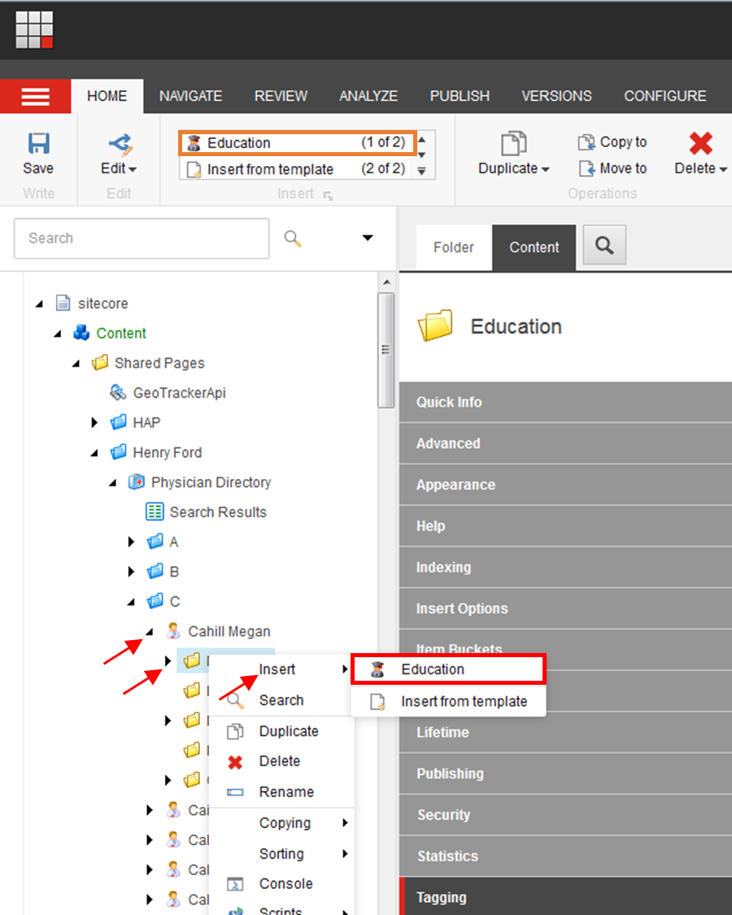

Education
Education Data – The Institution Name and Year fields will display on the physician profile page.
- Education Type (Red): Use the dropdown arrow to select from the dropdown options.
Note: Education types are populated by the import file, but can be manually supplemented if the import will not include the item and it is not a duplicate. To manually add an education type, navigate to /sitecore/content/Global/Physician Directory/Education Types.
- Enter the Institution Name (Orange), and Year (Green) of degree completion.
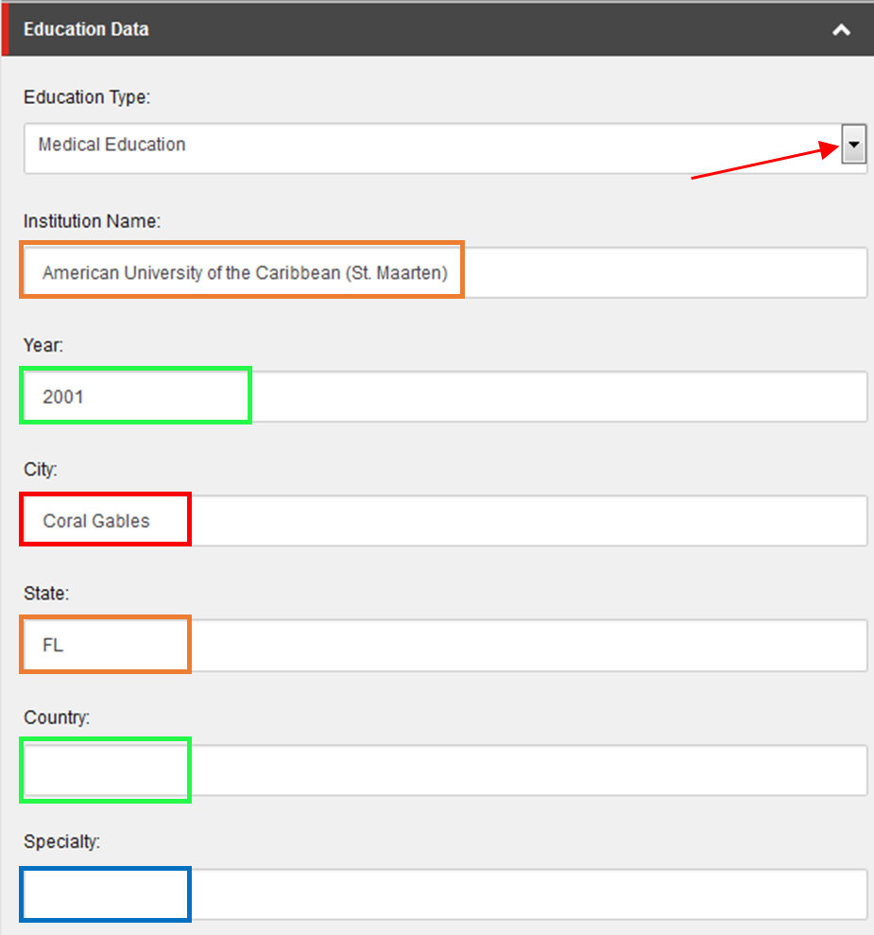
- Enter content for the City (Red), State (Orange), and Country (Green) where the institution is located and include a Specialty (Blue) if applicable.

Residency
Residency Data – The Institution Name, Specialty, State, and Year will display on the physician profile.
Note: Internship information is also included in this folder.
- Add content for the City (Red), Institution Name (Orange), and State (Green).
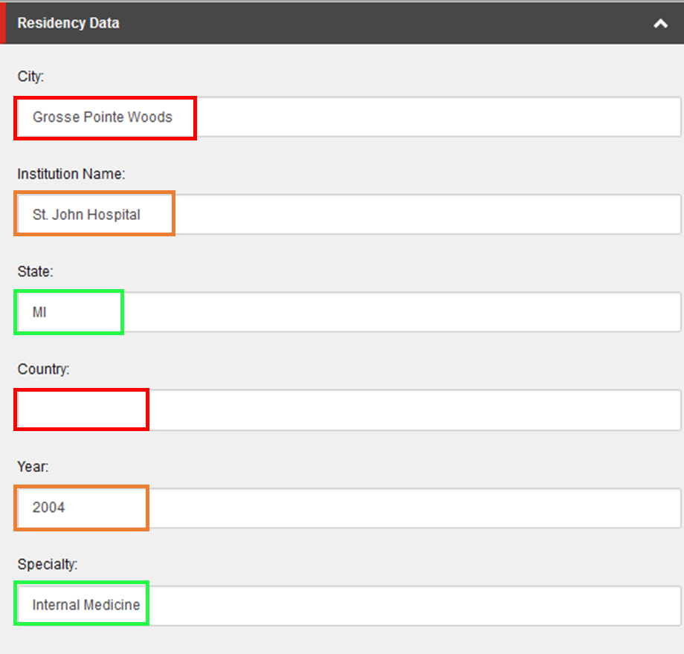
- Enter content for Country (Red), Year (Orange), and Specialty (Green).

Fellowship
Fellowship Data – The Institution Name, Specialty, State, and Year will display on the physician profile.
- Enter content for the City (Red), Institution Name (Orange), and State (Green).
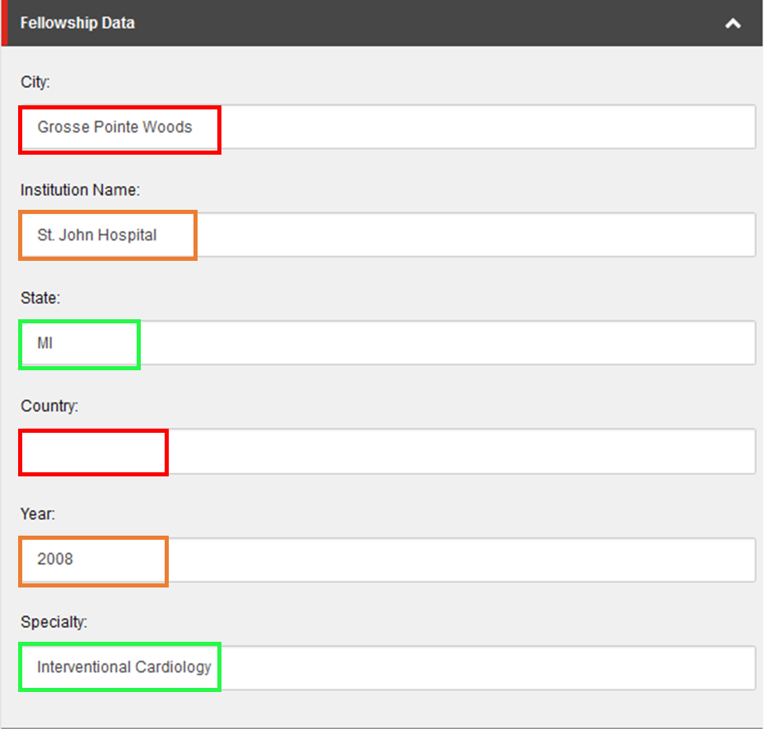
- Add content for Country (Red), Year (Orange), and Specialty (Green).

Offices
Physician Office Data
- Add content for the Office ID (Red) if applicable and enter the Office Name – Manual (Orange).
- If you are editing an imported physician profile, do not edit the Location – Imported (Green) field. If this is a manually create physician profile, select the location using the dropdown.
Note: To manually create an office location navigate to /sitecore/content/Global/Locations.
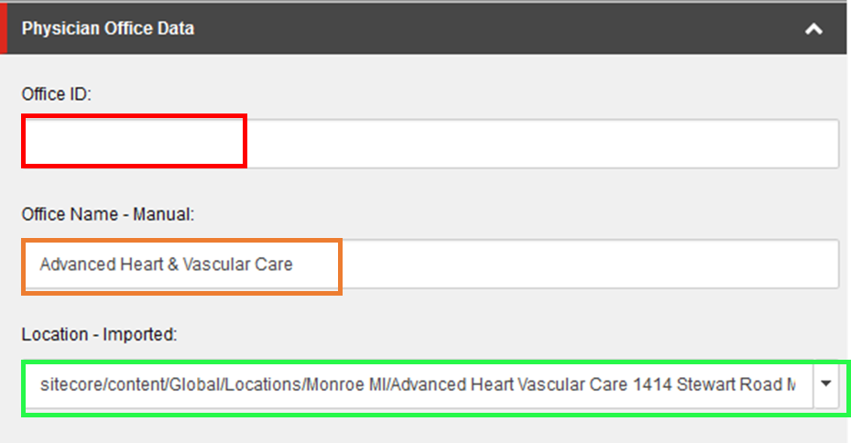
Contact Information
- Enter office contact information in the following fields:
  - Office Phone – Manual (Red)
  - Office Fax – Manual (Orange)
  - Office Hours – Manual (Green): Click Show editor to add content to this field.
  - Email Address – Manual (Blue)
  - Office Address 2 – Manual (Purple)
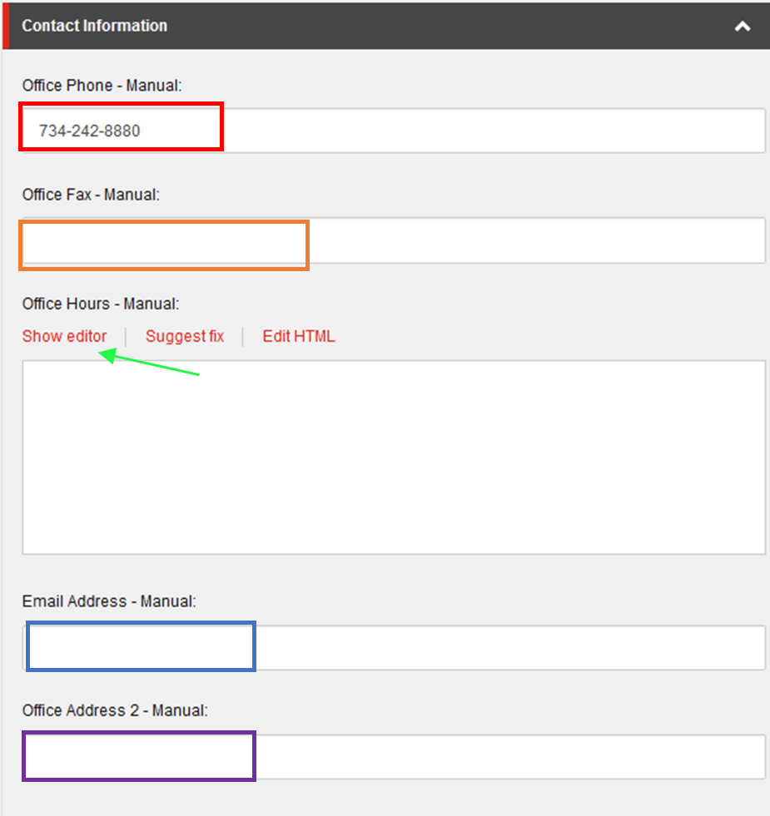
Office Details
- Accepting New Patients – Manual (Red): Check this box if the physician is accepting new patients at this office.
- Primary Office – Manual (Orange): Check this box to indicate that this is the primary office for this physician.
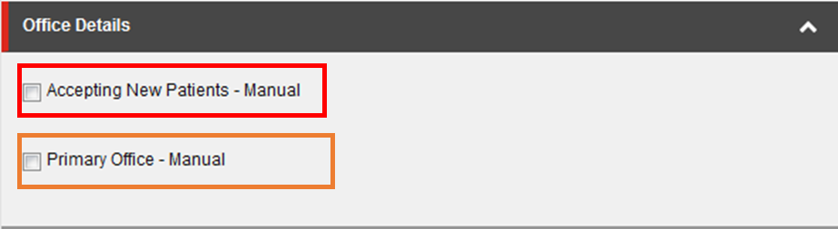

Preview Changes

- You can preview your updated page at any time by selecting the page at the cloned location, going to the Publish ribbon and clicking on the Preview button (the system may prompt you to Save the page – if the preview window does not open, then click the Preview button again, or check to see if your browser’s pop-up blocker blocked it)

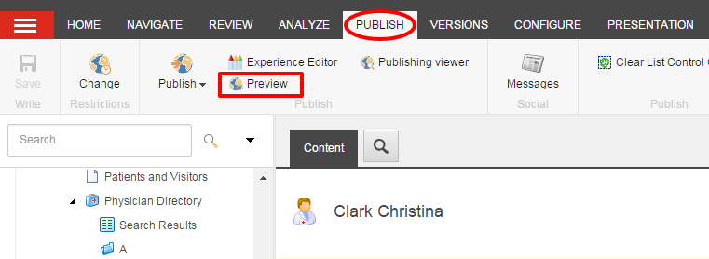

Submitting Your Profile through the Workflow
- When you are done with your edits and have saved your work, from the Review tab you can:
  - Check In: “unlock” the page from your account and make it available for other users to “lock” the page to their account; this action will keep the current version as Draft and therefore will not be published.
  - Submit: sends the most recent version to the staging area for an approval to be published by a publisher or an administrator.

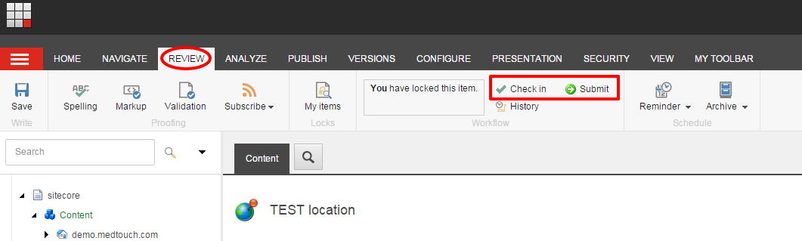
- If you have Publishing rights or are an Administrator, then you will see the disabled Approve and Reject
buttons immediately appear after Submitting your page. To enable the buttons, select Edit.
Note: You can ignore the Approve with Test for the purpose of this section.
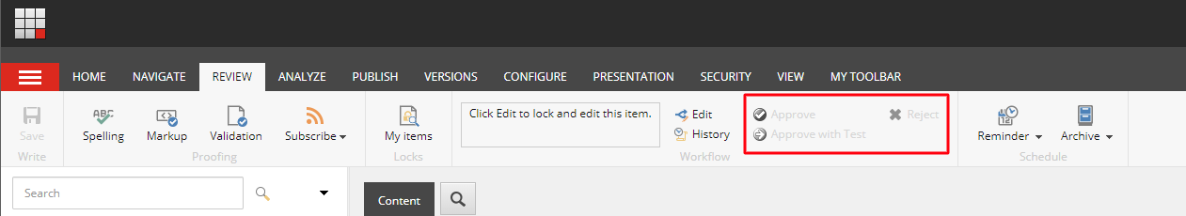

- When you click Approve, the page will be staged for Publishing and when you click Reject, it will send the page back to the workflow as a Draft and will not be published.

How to Publish Your Profile
- Select the item or page that you want Publish, open the Publish ribbon and then click the Publish button (Red) or click the down arrow. Then select Publish Item from its drop down menu (Orange).
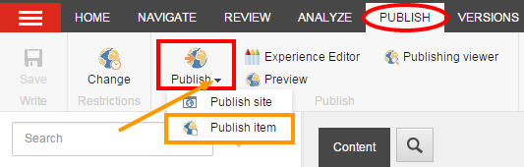
- Click Publish to publish the item, its sub-items, and related items.

