

NEWS CREATION BASICS
SITECORE SXA | HENRY FORD HEALTH

Logging into Sitecore
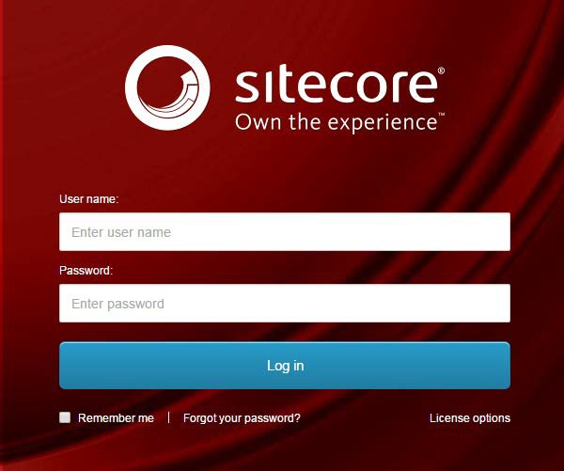
- Enter your User Name, Password, and then click Login to log into Sitecore

- Forgot Your Password – enter in your User Name to have Sitecore email you a newly generated password (this may go to your junk email folder – sender: donotreply@website.net)

- It is recommended that you use either Chrome, Mozilla or Edge.

The Launchpad – The Experience Platform

Note: Based on the access rights of your account and role, your launchpad may look different.

- The Sitecore Launchpad is well organized in the following categories:
  - Green – marketing and analytics tools
  - Red – content editing tools
  - Orange – tools to organize your digital assets and page workflows
  - Black – recycle bin to retrieve your deleted items
  - Blue – account configuration, system steup and app installations
  - Purple – user account settings

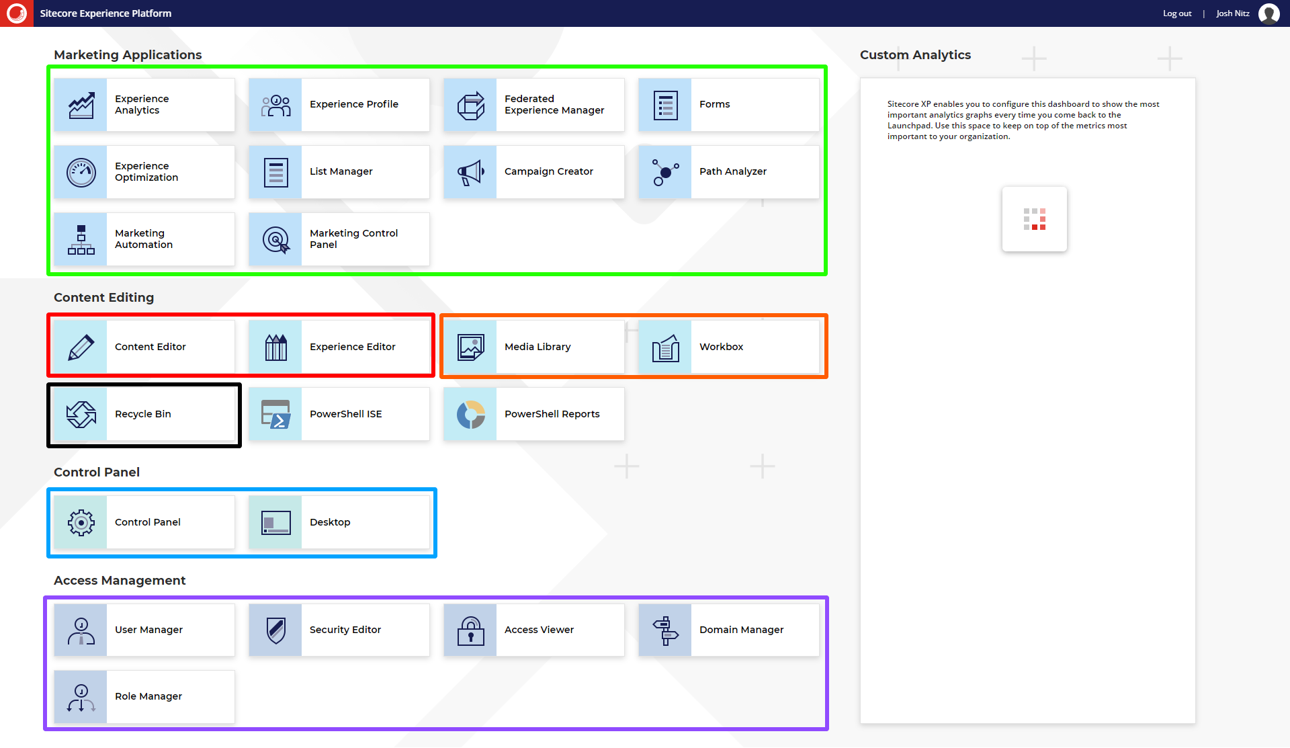

- The contents of this document will focus on:
  - How to change your password
  - How to navigate the SXA framework and edit your page’s front-end and backend content through the Experience Editor.

Navigating to your News Item

To Start Editing your News Posts
- Select the Content Editor button.
  - To start editing from the backend select the Content Editor button
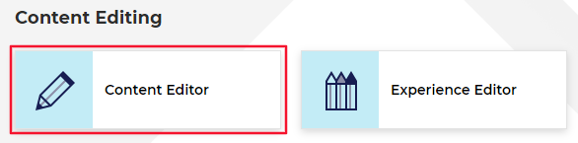
- The Content Tree contains all your website’s pages, items, and modules (including News).
  - Note: The HF News items that are found in live will be found under the HFHS > HenryFord > Home > News node.
  - Setup your Content Editor with the appropriate settings and menus by opening the View ribbon and having the following checkboxes checked:
    - Content Tree (checked by default)
    - Entire Tree

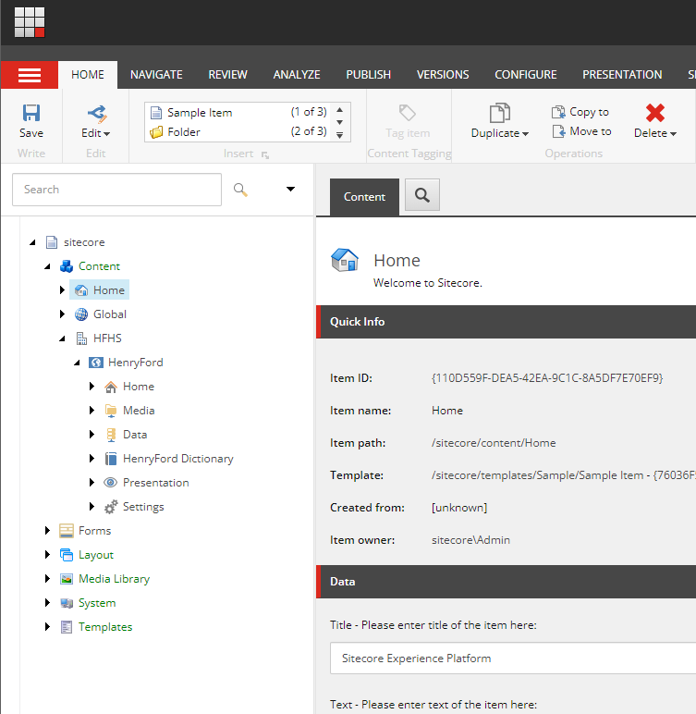

- Click the black arrow in front of the item that you want to expand and branch out.

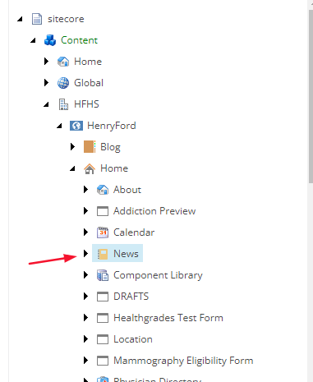

Adding a New Post

- Expand the year folder within your News module that you want to add the News Post to and then select the month folder. To add a News Post item:
  - Right-click on the month folder, select Insert, and then select News Detail
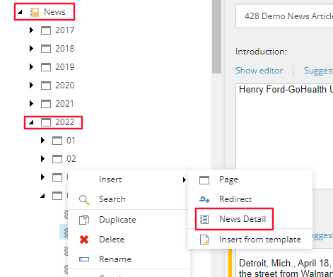
- Name your News Post when prompted and then click OK.

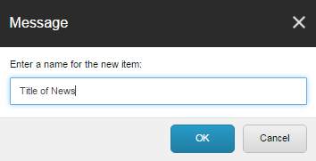
Note: the name added here will become this news page’s URL.

How to Edit the News Post Details Data

- Page Data fields:
  - Headline (Red) – this is the main header <h1> or title of your page; click inside the field to start editing
  - Introduction (Orange) – this is a teaser or snippet of your copy for your website’s Site Search only and it will not display on the web page; click Show Editor on top of the field to open up the Rich Text Editor to edit or enter text
Note: if this field is left empty, the system will automatically use the first 150 characters of your content copy
  - Content Copy (Green) – this is the copy of your page; click Show Editor on top of the field to open up the Rich Text Editor to edit or enter text
Note: for more information on how to use the Rich Text Editor, please refer to your

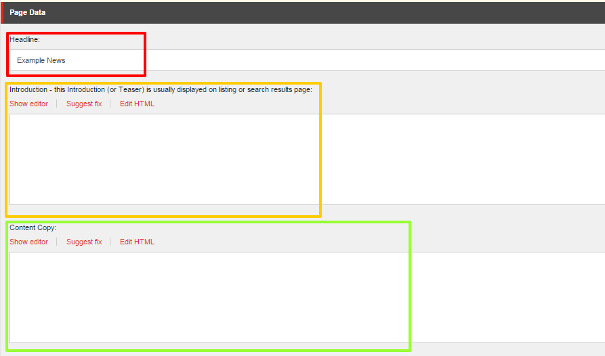
Training Documentation Basics and Fundamentals of SXA document.

- News Date:
  - Select the News Date by clicking on the dropdown to access the date picker.
Note: this date does not define when the news item will be published
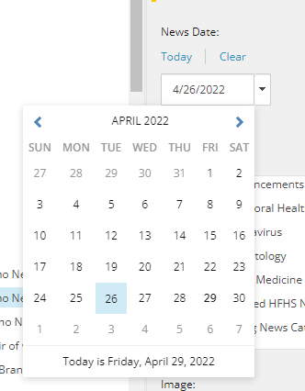
- News Categories field:
  - To associate News Categories to a News Post double click the News Category value in the left-hand side of the selector field.
    - This will add the News Category to the right-hand column of the selector field, which means it is associated with the News Post.
  - To remove an News Category from the right hand side of the selector field, double click the News Category value.
  - Note: You can associate as many News Categories to a News Post as needed.
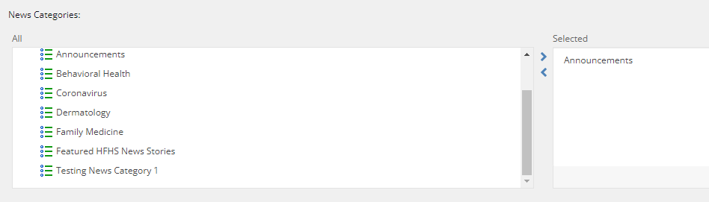
- Create a News Category value:
  - If the News Category that you wish to associate with your News Post does not exist, go to Global.
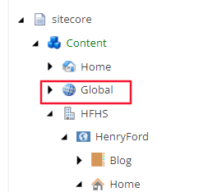
- Under the following path in Global (/sitecore/content/Global/News Category)
    - Right click the News Category folder, select Insert and then select News Category value.
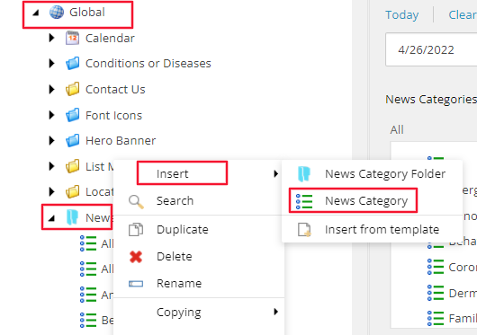
  - Name your News Category when prompted and select Okay.
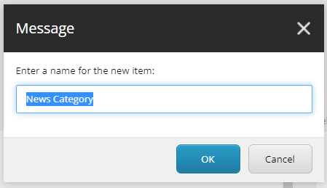

- Image field:
  - To add a thumbnail image to your News Post, click Browse to access the Media Browser to insert the image of your choice.
    - Note: Utilizing the Media Library is covered in the Media Library Training Documentation.
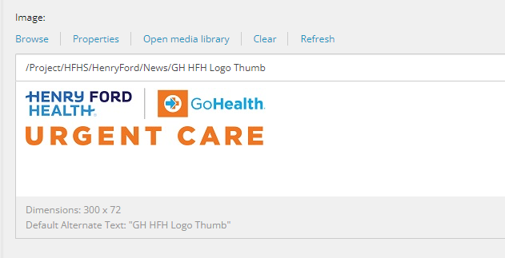

- Tagging fields:
  - To associate the proper Tags to a News Post, navigate to the Tagging Section of the News Post

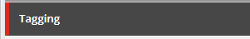
  - And using the same methods outlined in the News Categories section, associate the Taxonomy Terms, Services or Specialties to the News Post.
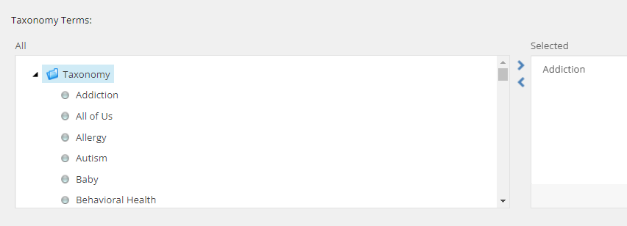

Submitting Your News through the Workflow

- When you are done with your edits and have saved your work, from the Review tab you can:
  - Check In: “unlock” the page from your account and make it available for other users to “lock” the page to their account; this action will keep the current version as Draft and therefore will not be published.
  - Submit: sends the most recent version to the staging area for an approval to be published by a publisher or an administrator.

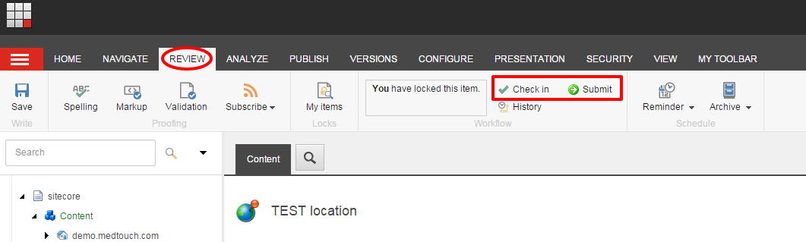
- If you have Publishing rights or are an Administrator, then you will see the disabled Approve and Reject
buttons immediately appear after Submitting your page. To enable the buttons, select Edit.
Note: You can ignore the Approve with Test for the purpose of this section.
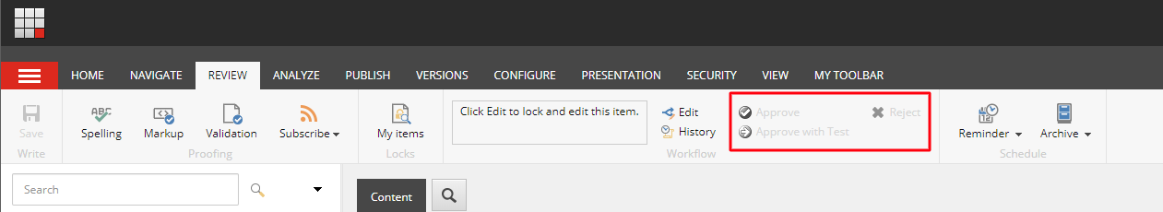

- When you click Approve, the page will be staged for Publishing and when you click Reject, it will send the page back to the workflow as a Draft and will not be published.

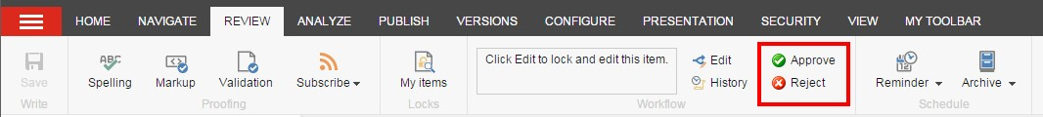

How to Publish Your News Item

- Select the item or page that you want Publish, open the Publish ribbon and then click the Publish button (Red) or click the down arrow. Then select Publish Item from its drop down menu (Orange).

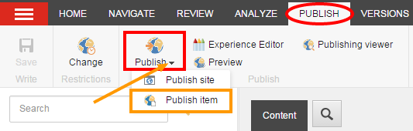
- Click Publish to publish the item, its sub-items, and related items.

