

SITECORE FORMS & FORMS MANAGMENT
HENRY FORD HEALTH

Table of Contents
The Launchpad – The Experience Platform 3
Sitecore Forms: Forms Dashboard Page 4
Forms Dashboard Page 4
Create a New Form 5
Editing an Existing Form 5
Delete an Existing Form 5
Adding & Editing a Form Field 6
ReCAPTCHA & Submit Button (Save Actions) 8
Saving a Form 8
Publishing a Form 9
Adding a Form to Your Page 10
Adding a Form to Your Campaign page 13
How to Publish Your Page 15

Logging into Sitecore
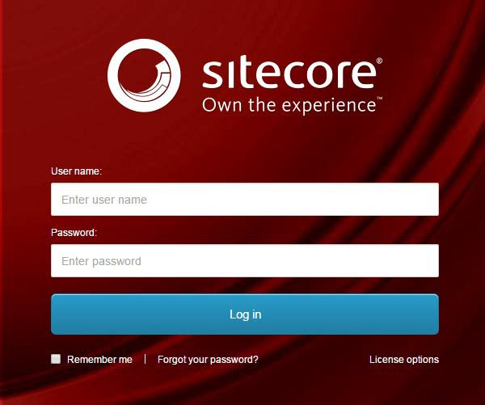
- Enter your User Name, Password, and then click Login to log into Sitecore

- Forgot Your Password – enter in your User Name to have Sitecore email you a newly generated password (this may go to your junk email folder – sender: donotreply@website.net)

- It is recommended that you use either Chrome or Mozilla.

The Launchpad – The Experience Platform

Note: Based on the access rights of your account and role, your launchpad may look different.

- The Sitecore Launchpad is well organized in the following categories:
  - Green – marketing and analytics tools and Sitecore forms
  - Red – content editing tools
  - Orange – tools to organize your digital assets and page workflows
  - Black – recycle bin to retrieve your deleted items
  - Blue – account configuration, system steup and app installations
  - Purple – user account settings

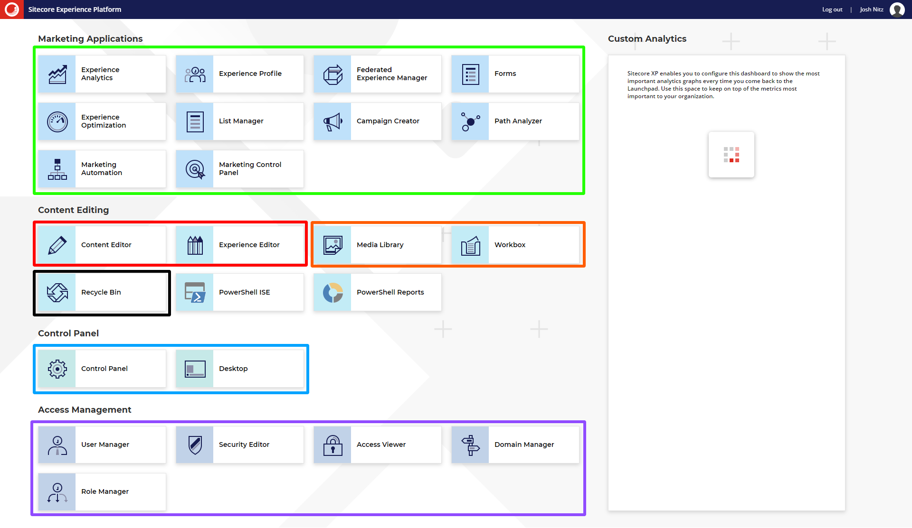

- The contents of this document will focus on:
  - How to change your password
  - How to navigate the SXA framework and edit your page’s front-end and backend content through the Experience Editor.

Sitecore Forms: Forms Dashboard Page

Forms Dashboard Page
- Select the Forms Tile on the Launch Pad page to navigate to the Sitecore Forms Dashboard page.
  - Found under the Marketing Applications section.
- On the Forms Dashboard Page:
  - Blue: You can create a new form by selecting Create.
    - More Information found under Sitecore Forms: Creating a New Form
  - Purple: Filter forms displayed in the Form Results area by selecting All Forms, My forms (Forms that were created by you) or All Templates (Base from templates)
  - Orange: Filter the forms that are displayed in the Form Results area through a Search Field or a sorting dropdown.
  - Red: After checking the checkbox of a form in the Form Results area, you can choose from the many options in the Form Actions Dropdown.
    - Edit the Form – Upon selection you can edit the form that had it’s checkbox checked.
    - Rename the Form - Upon selection you can edit the form that was checked.
    - Export the Data – Upon selection, the system will export the form submission data of that form to a CSV file and download the file on your computer
      - Note: This will only occur for Forms that have the “Save Data” save action selected.
    - Delete – Delete the Form.
    - Set as Form Template – Will make that Form as a form template which can be used as a base template when creating new forms.
    - Publish – Publishes the Form
    - Tools Panel – Displays or hides the Tools Panel which provide a brief overview of that form.
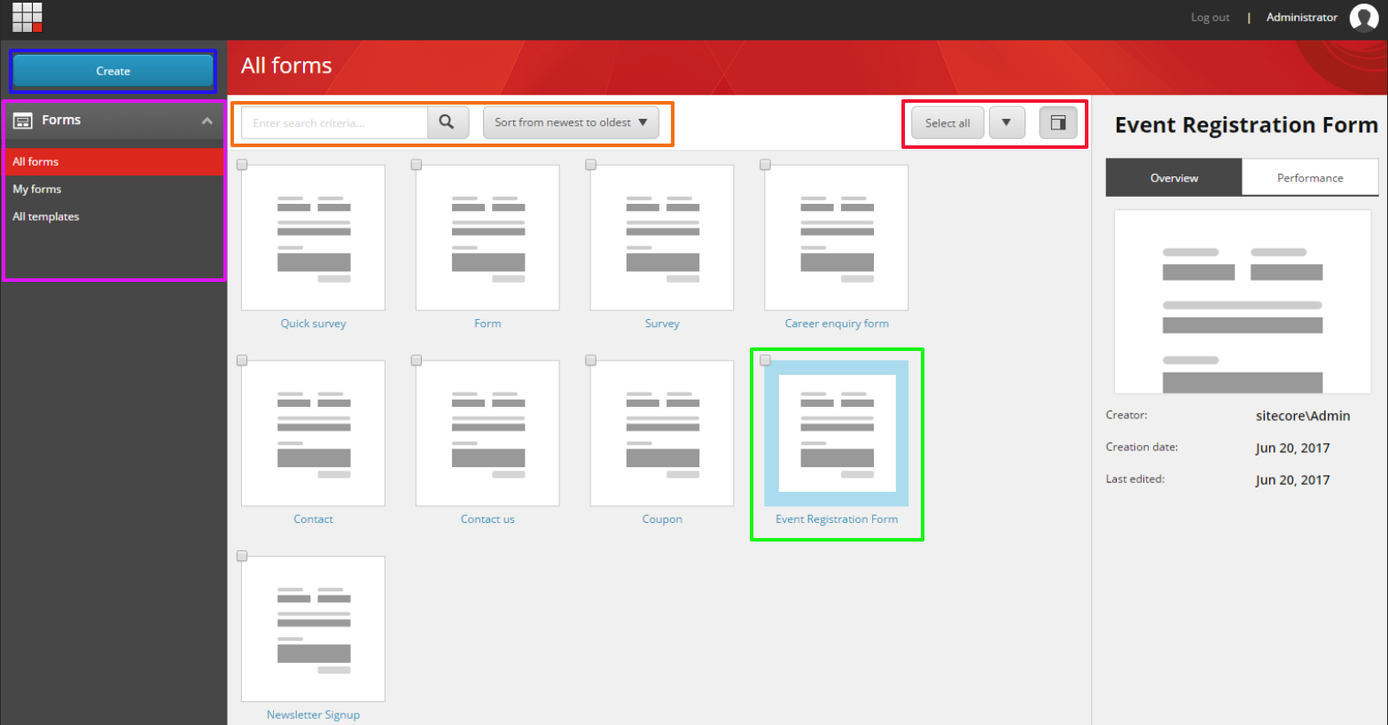

Create a New Form
Create a New Form
- On the Forms dashboard, click Create.
- To create a new form from scratch, click Blank form, or select a template to base your form on.
  - You can start with a blank form or build your form using a template. Sitecore Forms does not include pre-defined templates by default but you can set these up yourself by selecting the “Save as template” action to create your own base templates.
- Upon selection, the Form Designer page will be displayed.
  - If a form template was selected, those base fields and actions will be prefilled in the Form Designer Area.

Editing an Existing Form
Edit an existing form
- On the Forms dashboard, check the checkbox of the form you want to edit.
  - 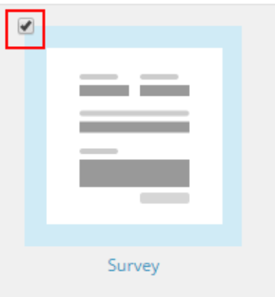
- Then Select the Edit Button.
  - The Form Designer Page will load with the selected form’s fields displayed int eh Form Canvas area.

Delete an Existing Form
Delete an existing Form
- On the Forms dashboard, check the checkbox of the form you want to delete.
- Then Select the Delete Button.
  - Select OK in the Confirmation Dialog box.

Adding & Editing a Form Field
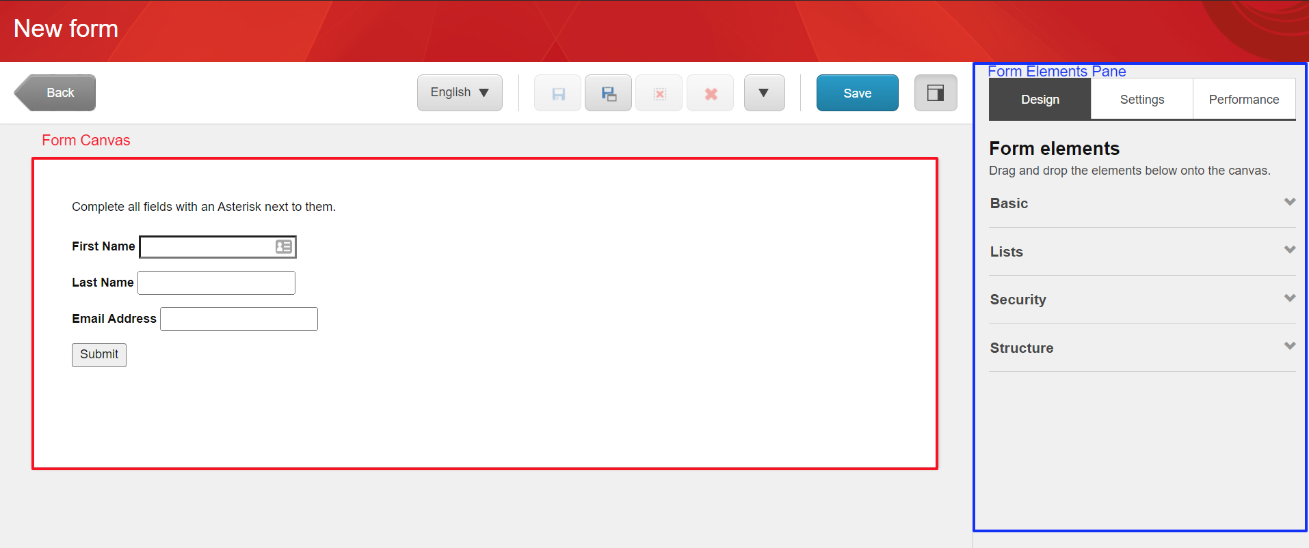
To Add/Edit a Form Field:
- You can add a field to a form by dragging a form element from the Form elements pane onto the form canvas.
  - Select from the Basic Form Elements, Lists Elements, Security Elements or Structure Elements.
    - Basic Form Elements include:
      - Text
      - Single-line text
      - Multiple-line text
      - Number field
        - Only allows for numeric values to be entered.
      - Email
        - Allows for Email Validation to ensure proper email format is entered by users.
      - Telephone
        - Allows for Telephone Validation to ensure proper phone format is entered by users.
      - Checkbox
      - Date
    - Lists Elements:
      - Dropdown List
      - Checkbox List
      - Radio Button List
    - Security Elements
      - Recaptcha
    - Structure Elements
      - Submit Button
- Once you have placed an element as a form field on your form in its desired location, you can change its settings and properties on the General tab by selecting the field and updating the form fields details in the Form elements pane.
- In the General Tab of the Form, you can edit it’s:
  - Details (Note: this will vary based on the field selected):
    - Label – label that displays on front-end
    - Field Name – item name on the backend
    - Default value – initial value assigned to field be default
    - Placeholder text – text that is displayed as light gray that prompts the user to understand the type of value that should be filled (aka hint text)
    - Minimum text length: Minimum number of characters allowed to be entered into the field and be submitted.
    - Maximum text length: Maximum number of characters allowed to be entered into the field and be submitted.
  - Validation:
    - Field Validation: Check the validation checkbox if applicable to ensure the correct format is entered by users on the front end.
    - Field Importance: Make a field required by selecting the Mandatory radio button.
      - Optional is selected by default.
  - Styling:
    - Correct CSS Class and styling will be applied by default. There is no need to engage with this section based on current site functionality.
  - Advanced Settings:
    - Performance Tracking: Enables this field to be involved in the Permformance tracking of this field.
    - Allow Save: Enables the information that pertains to this field to be saved.
  - Additional information about Basic Element form field can be found here:
    - https://doc.sitecore.com/xp/en/users/93/sitecore-experience-platform/the-basic-elements.html)
  - Additional information about List Element form field can be found here:
    - https://doc.sitecore.com/xp/en/users/93/sitecore-experience-platform/the-list-elements.html
- In the Performance Tab, admins can:
  - Select the date range that the admin wants to view Form performance.
  - View Abandonment Rate, Error Rate (incorrect information applied to this field that caused a validation error) and the average time spent on each component of the form.
- Once you have applied all the correct settings to the Form field select “Apply”.

ReCAPTCHA & Submit Button (Save Actions)
Add ReCAPTCHA to a form:
- Once you have completed all fields and edited the form field settings and properties, add a ReCAPTCHA to your form by going to the Security Elements section and dragging and dropping the ReCAPTCHA element to the bottom of your form.
Add a Submit Button to a form:
- Once you have completed all fields and the reCAPTCHA item to your form add a Submit Button, and by proxy, Save Actions to your form by going to the Structure Elements section and dragging and dropping the Submit button element to the bottom of your form.
- Select the item in the Form Canvas area and update the Button’s label under the Details section of the Form Elements Pane.
- Then, under the Submit Actions section:
  - Add a Save Action to the form by selecting the Save actions from the dropdown list that apply to this form.
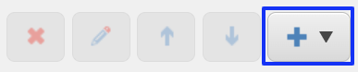
  - Delete a Save Action by selecting a Save Action and selecting the x icon.
  - Edit a Save Action by selecting a Save Action and selecting the pencil icon.
  - Reorder a Save Action by selecting a Save Action and selecting the arrow icons.
- NOTE: If you are adding a Redirect Save Action to a Form, please ensure this is the last Save Action applied to the Form. Otherwise, it will not perform the other save Actions:

Saving a Form
From the Form Designer Page
- Once you have completed all the edits to your form that you wish, select the Save button.
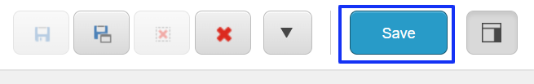
- A Save As window will appear, enter the name of the form, and select Save.
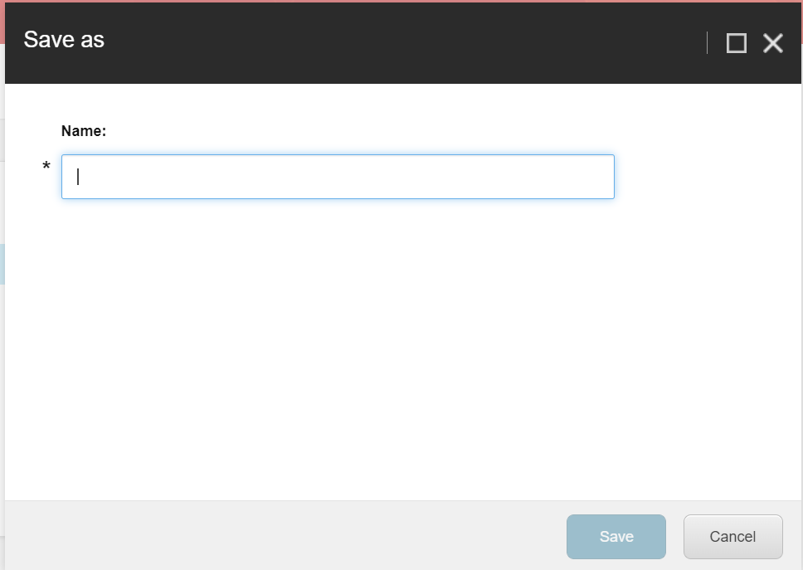

Publishing a Form

From the Form Dashboard Page
- Select the Form you wish to Publish and be available on the front-end of the site..

- Select the Publish button from the Form Actions Dropdown.
- Insert Image here when QA is available.

- Select the publishing targets and then click Publish to publish the item, its sub-items, and related items such as media items uploaded directly to the page.
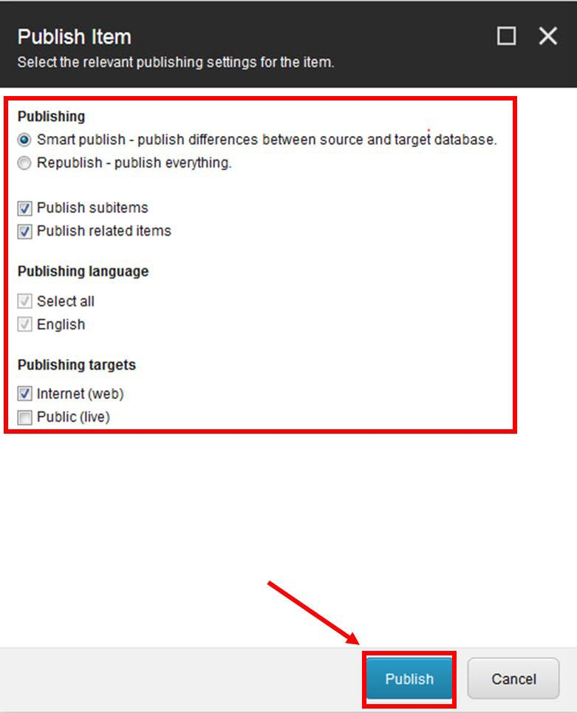

Adding a Form to Your Page

From the Experience Editor
Note: the same method does not apply for the Campaign Page forms. Please refer to the following section for assistance around Campaign Forms.
- Open the Home ribbon and then select Component. Gray + Add here buttons will show on the page to show you where you can add new components.
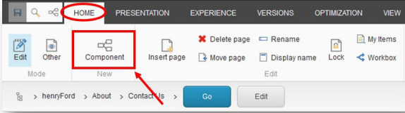
- Click one of the + Add here buttons in the Content Panel area (body of the page where the copy is placed) in the location you want to add the form to.
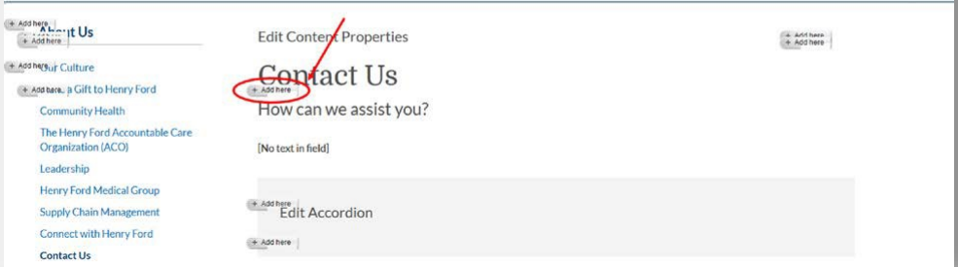
- On the Select a Rendering window, select the Forms tab and select the Sitecore Form Wrapper rendering and click Select.
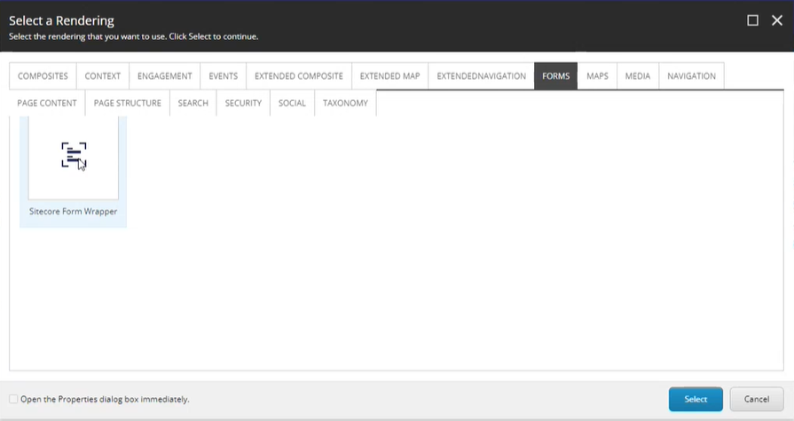
- Select the container where that Sitecore Form Wrapper appeared and select the +Add here button.
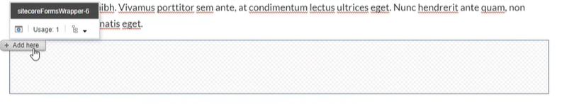
- A select a Rendering window will appear again with the following two options:
  - Form with Validation Summary and MVC Form.
- Select the Form with Validation Summary option and click Select.
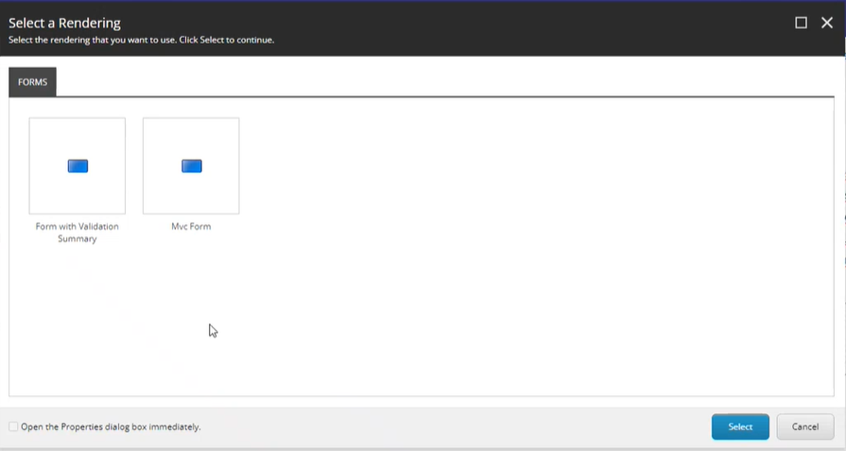
- A Select the Associated Content window will appear. Select the Form that applies to this page and click OK.
  - 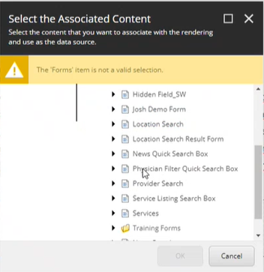
- The form will be added to the page. To have this form appear on the front-end publish the page as outlined in the Basics and Fundamentals Training Document.

Adding a Form to a Campaign Landing page
From the Experience Editor
Adding Campaign Forms follows a slightly different experience than “normal forms”. Please refer to the following section for assistance around Campaign Forms.
- On a Campaign Landing page design, open the Home ribbon and then select Component. Gray + Add here buttons will show on the page to show you where you can add new components.
- Click one of the + Add here buttons in the Right Side Rail Panel area, the area of the page where the campaign forms are placed.
- In the Select a Rendering window, select Page Structure then select Container.
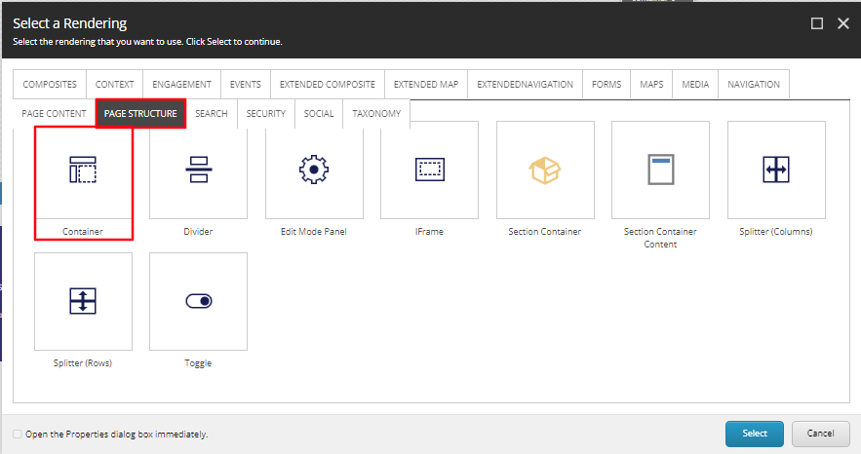
- On load of the Container, select the Paint bucket icon. In the window that appears, scroll down to the Styling section and under Background color, select Blue Background. Select OK.
- Select the Blue Container that was just created and select + Add here.
- In the Select a Rending window, select the Page Content tab, then select Icon Promo and Select.
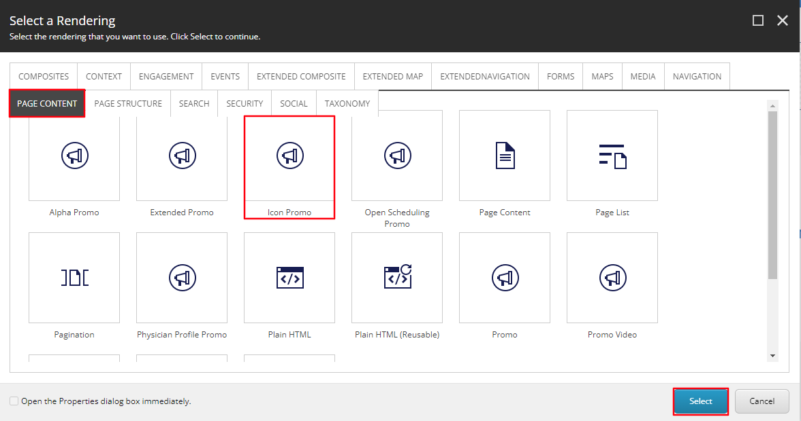
- Navigate to the Campaign Forms folder and then select Create.
- In the Insert Item window, either create an Icon Promo folder or an Icon Promo and assign a Name to it in the bottom field and select OK.
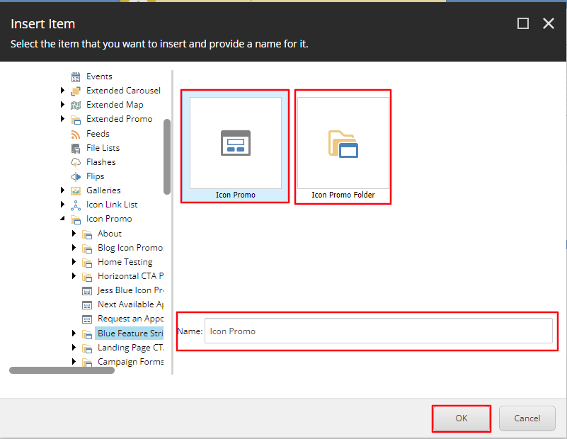
- The CTA will load on the page after a few seconds. Once it does, wait a few more seconds for the Variant Dropdown to appear under the Icon Promo Toolbar, then select the Form Icon option from the Variant Dropdown.
- To edit the Icon displayed, select the Icon button from the Icon Promo toolbar.
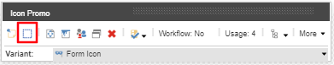
- Select the Icon you want displayed from the Icon Dropdown and select OK.
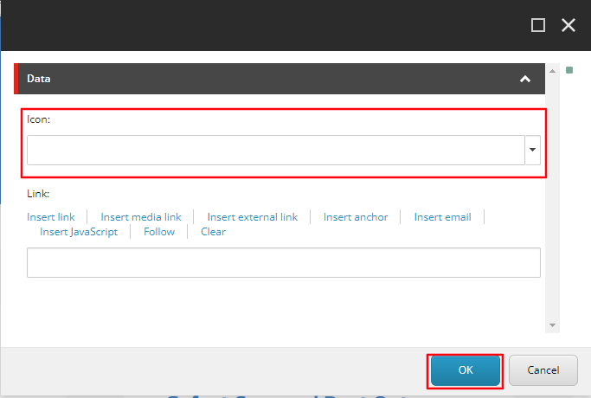
- Select Save in the top right corner for the Icon to display.
- To edit the Heading (Red) and Content Copy (Blue) select the [No text in field] for each field respectively and typing the text you want to display.
- Next, open the Home ribbon and then select Component. Gray + Add here buttons will show on the page to show you where you can add new components. Click the + Add here buttons in the Right Side Rail Panel area below the Icon promo you just created. Select the Forms tab and select the Sitecore Form Wrapper rendering and click Select.
- Then select the container where that Sitecore Form Wrapper appeared and select the +Add here button.

- A select a Rendering window will appear again with the following two options:
  - Form with Validation Summary and MVC Form.
- Select the Form with Validation Summary option and click Select.
- A Select the Associated Content window will appear. Select the Form that applies to this page and click OK.
The form will be added to the page with the correct white text styling. To have this form appear on the front-end publish the page as outlined in the following step.

How to Publish Your Page

From the Experience Editor
- 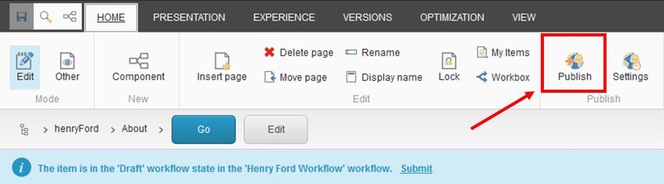Open the Home ribbon and then click the Publish button.

- Select the publishing targets and then click Publish to publish the item, its sub-items, and related items such as media items uploaded directly to the page.

