

SLIDER CTA
SITECORE SXA | HENRY FORD HEALTH

Slider CTA: Adding through the Experience Editor

To add a Slider CTA:
- Select the Add component icon in the top left corner and select the +Add here button where you would like to add the Slider CTA.
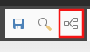
- Select the Extended Composite tab from the Select a Rendering window, then select Carousel Slide and Select.
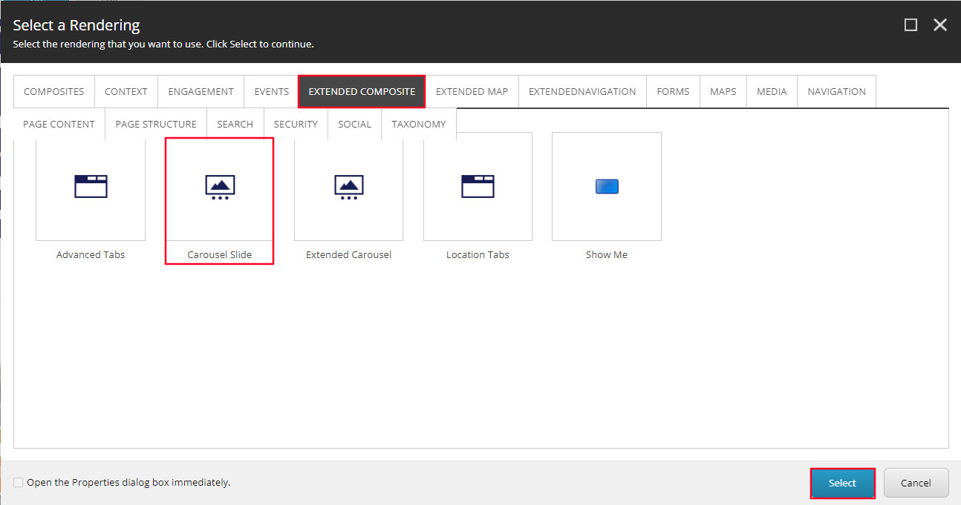
- In the Select the Associated Content window, select the Extended Carousel item (or the folder you wish to have this promo stored under) and then select Create.
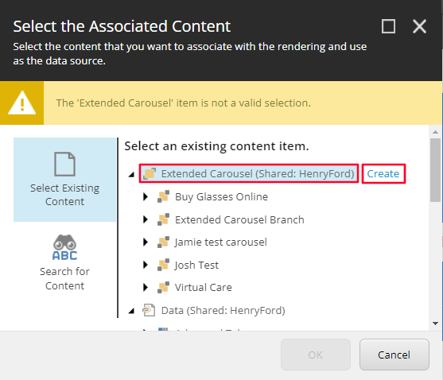
- In the Insert Item window, select the Extended Carousel Branch tile (or Extended Carousel Folder), assign a name to this Slider CTA in the Name field, and then select OK.
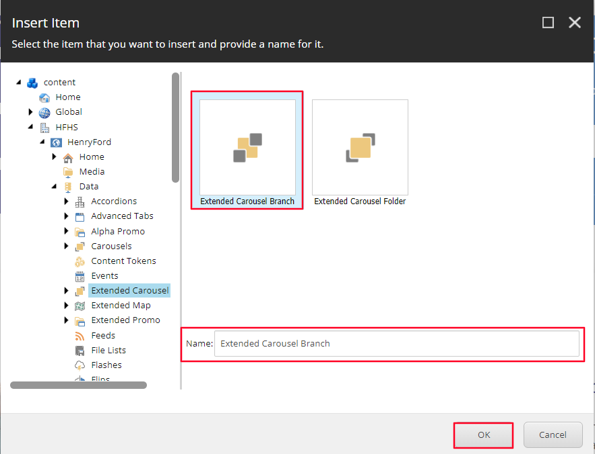
- The CTA will load on the page after a few seconds. Once it does, select the paint bucket icon in the Carousel Slide Toolbar.
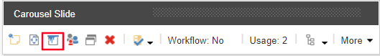
- A window will appear, in the Tablets dropdown select 6 as the value and select OK.
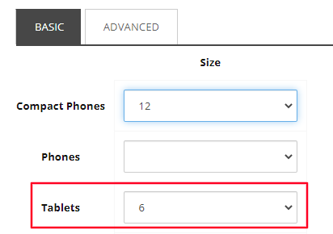
- Select the Slider CTA, once selected you can edit the Heading (Red) and Content Copy (Blue) by selecting the [No text in field] for each field respectively and typing the text you want to display.

  - Note: If a text field is not edited, it will not appear on the front end.
  - Note: To edit the other sliders, select the slide you are editing by selecting the circles at the bottom (yellow). From here, you can follow the same steps in steps 8 and 9 for each slide.
- To edit the Link text (Green) and link destination, select the text area and select the “Edit the link destination and appearance” icon.
- Once selected, an Insert a Link window will appear. From here you can either:
  - Set the button to an internal link, by selecting the page from the Tree node and setting the Button Text through the Link Description field.
  - Set the button to an External Link by entering the external URL into the URL field and then setting the Button Text through the Link Description field.
  - Set the button to a Mailto: link by entering the email address into the Mailto field and then setting the Button Text through the Link Description field.
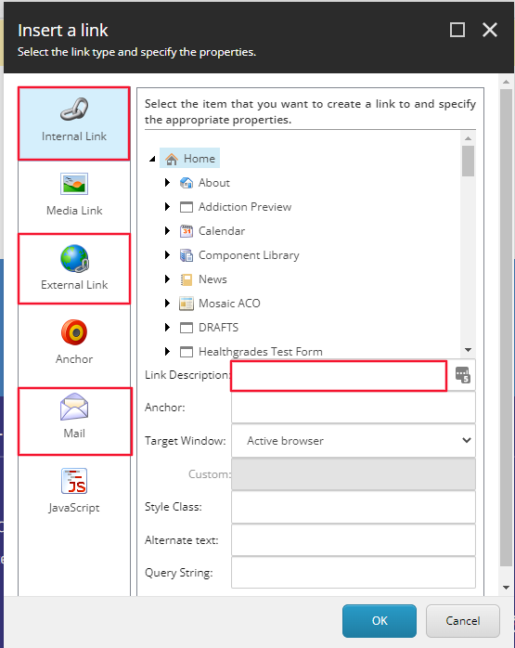
  - Note: If a text field is not edited, it will not appear on the front end.

- You have now created a Slider CTA.
- When Publishing, it is recommended to have Smart publish and Publish related items both checked.

