

CREATING TABS
SITECORE SXA | HENRY FORD HEALTH

Tab: Adding through the Experience Editor

To add a Tab component:
- Select the Add component icon in the top left corner and select the +Add here button where you would like to add the Tab.
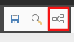
- In the select a Rendering window, select Extended Composite and then Advanced Tabs and Select.
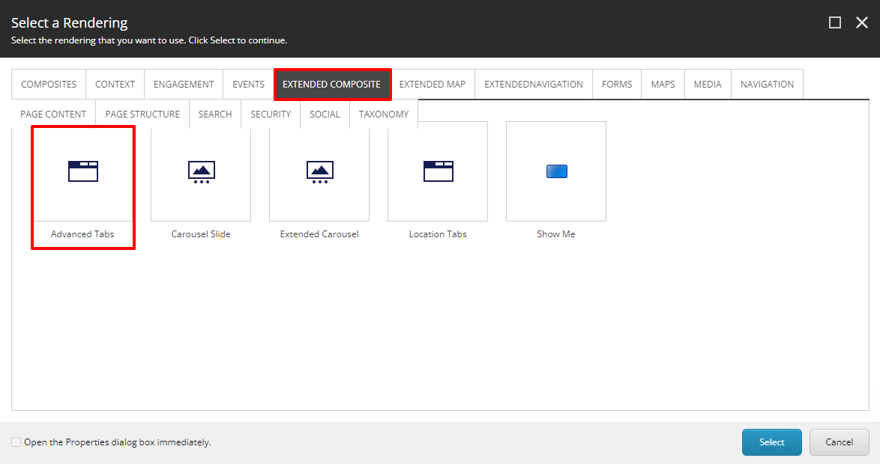
- A Select the Associated Content window will appear, from here select Create or the folder you wish to have this Tab Component be stored under and then select Create.
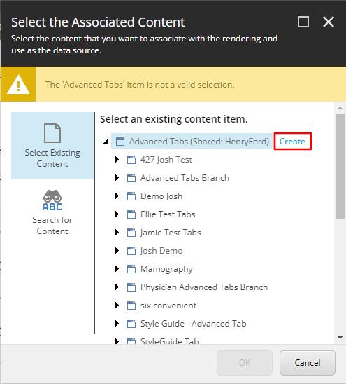
- In the Insert Item window, either create an Advanced Tabs folder or an Advanced Tab Branch and assign a Name to it in the bottom field. Then select Okay.
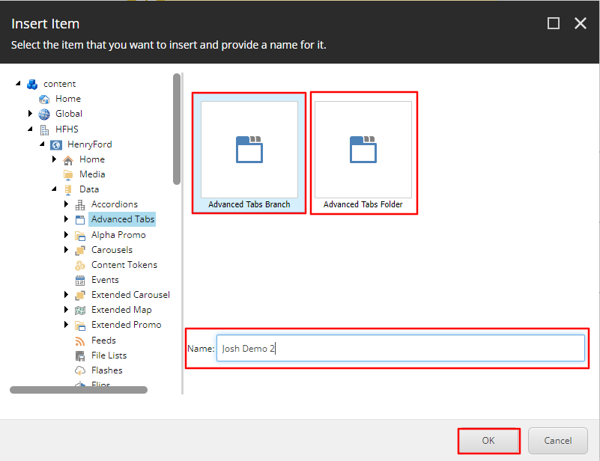
- The Tabs component will load on the page after a few seconds. To edit the Tabs Headline, select the [No text in field] item at the top of the component and add the text you want to have displayed.
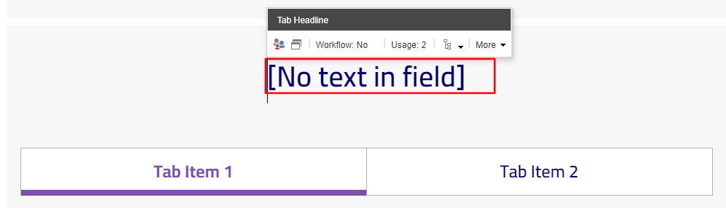
  - Note: If you do not edit anything in this field, it will not display any text and the area where that text appears will be hidden
- To edit Tab Titles, select Tab Item 1 or Tab Item 2 text and type in the text you wish to display as the Title.
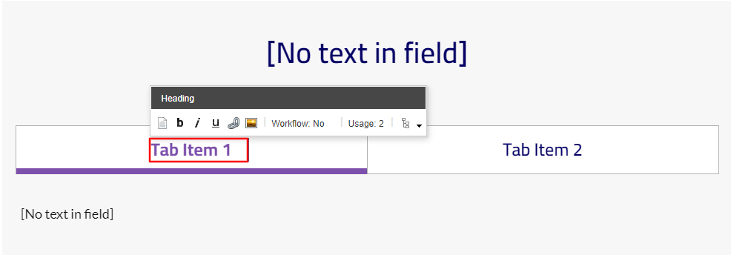
- To edit the content copy in the Tab content area, select the Tab of the item you wish to edit. This will display the Content Copy of the Tab you selected. To edit the Content Copy, select the [No text in field] area and either enter the text you want displayed or select the RTE icon in the Content tool bar and then enter the text into the RTE window and then select Okay.
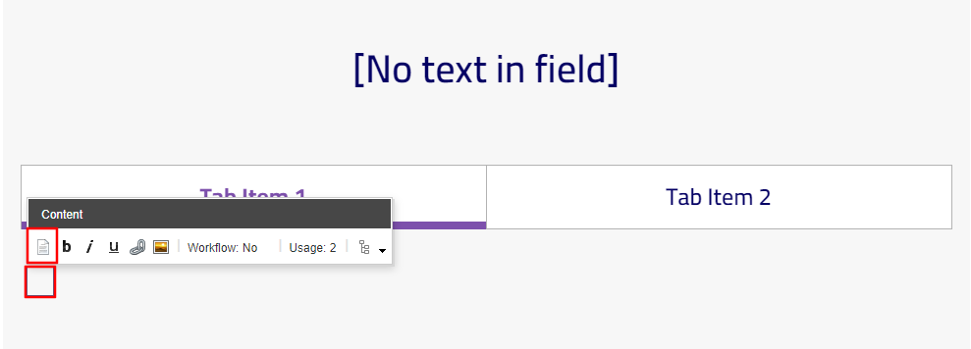
- To add/delete or move more Tab items to the Tab component select a Tab Title after which a Heading Toolbar will appear. From here select the arrow to the right of the Go to Parent Component icon in the tool bar and select Tab from that dropdown. A Tab toolbar will appear.
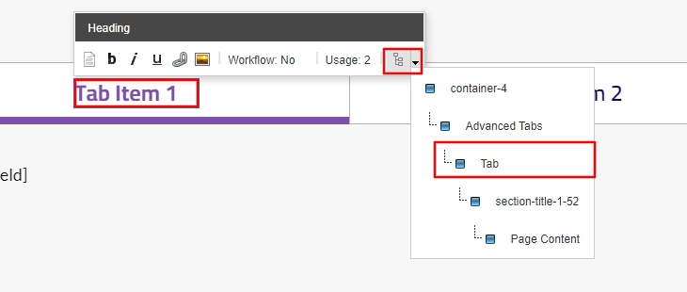
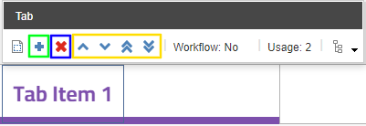
- To add a new Tab Item, select the plus icon (green). An Insert Item window will appear. Select the Tab Item, provide a name in the field below and then select Okay. A Tab item will now appear to the right of all other tab items.
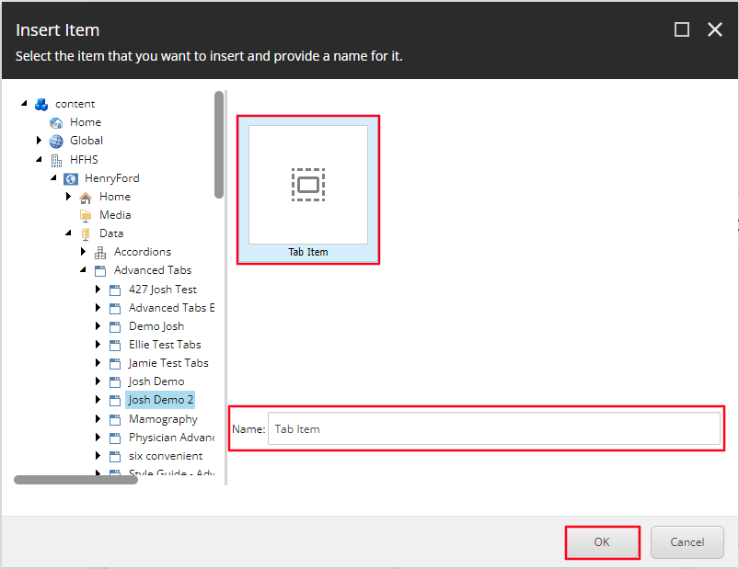
- To Delete a Tab item follow the steps mentioned in step 8. In the Tab toolbar that appears, select the X icon (blue). A dialogue box will appear asking you if you are sure you want to delete that Tab item. Select Okay.
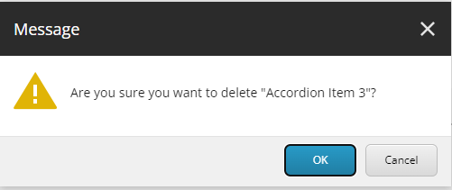
- To Reorder an Tab item, follow the steps mentioned in step 8. In the Tabs toolbar that appears, select the corresponding icon that meets your needs (Yellow).
  - Up caret = move Tab item to the left one spot.
  - Down caret = move Tab item to the right one spot.
  - Double Up caret = moves Tab item all the way to the left.
  - Double Down caret = moves Tab item all the way to the right.

