

TEXT FEATURE STRIP CTA
SITECORE SXA | HENRY FORD HEALTH

Text Feature Strip CTA: Adding through the Experience Editor

To add a Text Feature Strip CTA:
- Select the Add component icon in the top left corner and select the +Add here button from an area all the way on the left-hand side of the page. You must select from the side to add the Text Feature Strip CTA with proper formatting.
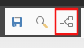
- Select the Page Structure tab, Section Container and then Select.
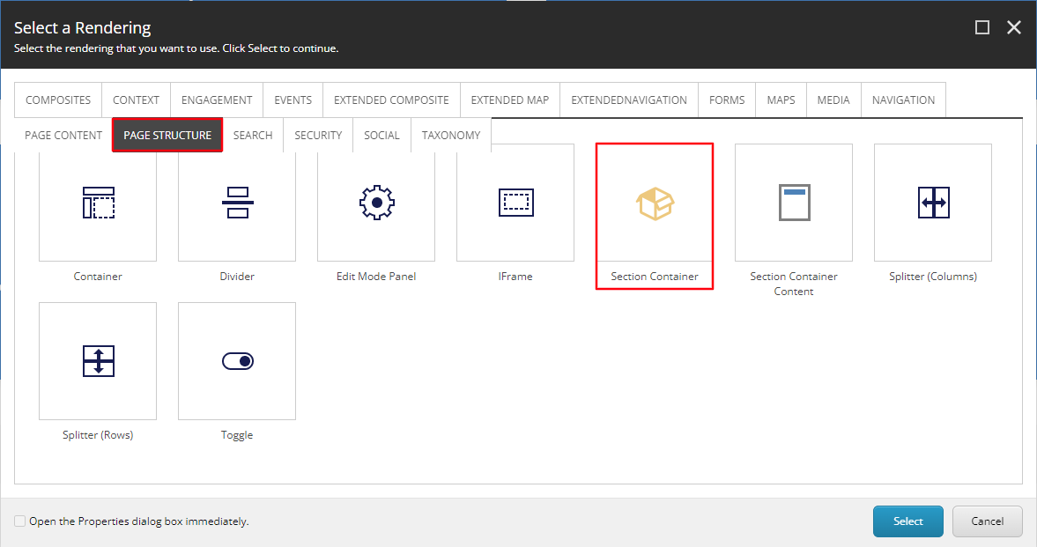
- Once the Section Container appears, select the checkered area, then select the Go to Parent component icon in the container toolbar and select Section Container at the bottom of that dropdown.
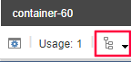
- A Section Container toolbar will appear, select the Edit style and behavior of the component (aka. Paint bucket styling) icon.
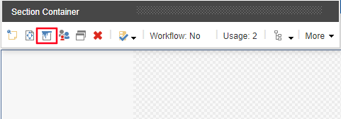
  - Navigate down to the background color section and select the Gray Background checkbox and select OK.
  - Select Save in the top left-hand ribbon to see the updates.
- Select the checkered area, select the + Add here button. In the Select a Rending window, select Snippet (under the default composites tab) and Select.
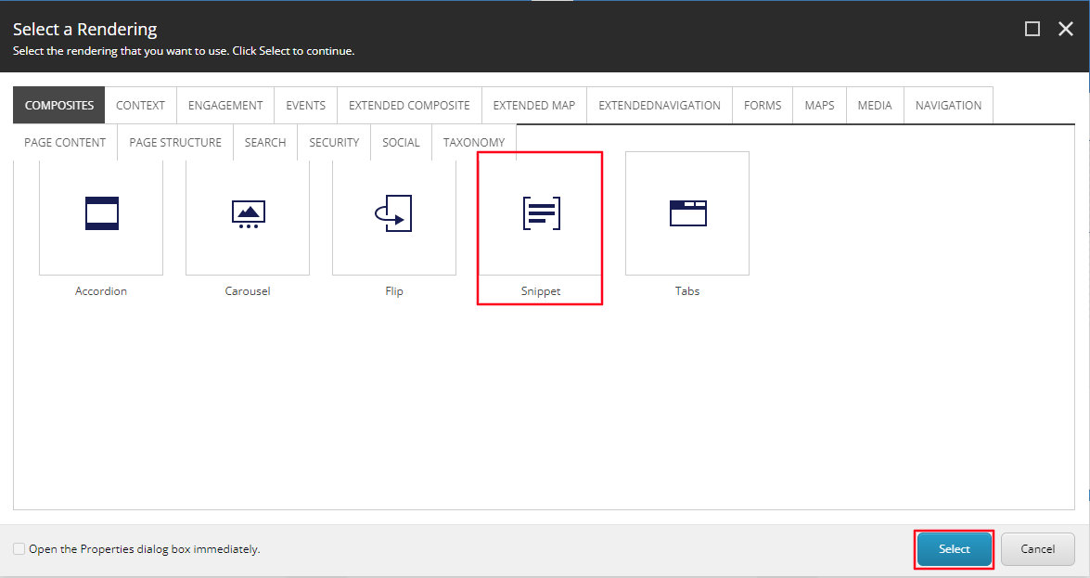
- Open the Text Feature CTA folder and select the top option under that folder called A Text Feature CTA. Select OK, an information window will appear, from here, select the Yes button. Note: This will create a copy of the data source and make for very easy editing.
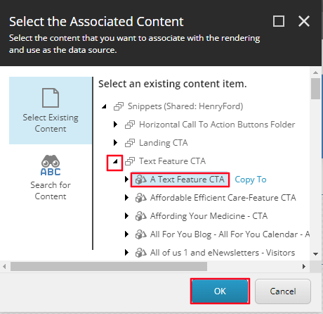
- All three CTAs will load on the page after a few seconds. Once it does, select the CTA that you want to edit.
- If you want to edit the Headline found above all three Text Feature CTA’s, select the [No text in field] text field and enter the text you wish to display.
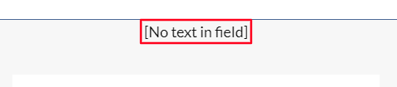
- If you wish to edit the icon or the link destination of the Text Feature CTA on an individual CTA, select the CTA then select the Icon button from the Icon Promo toolbar.
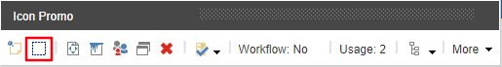
- Select the Icon you want displayed from the Icon Dropdown (Red) and set the Link destination (Blue), select OK.
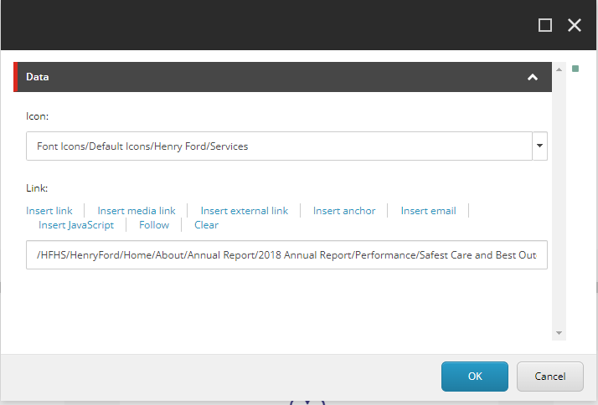
  - Note: Select Save in the top right corner for the Icon to display.
- To edit the Heading (Red) and Content Copy (Blue) select the Text areas found below to edit each field respectively and typing the text you want to display.
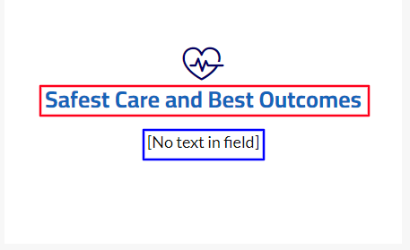
  - Note: If a text field is not edited, it will not appear on the front end (except the heading).
- When Publishing, it is recommended to have Smart publish and Publish related items both checked.

