

TEXT VIDEO FEATURE CTA
SITECORE SXA | HENRY FORD HEALTH

Text Video Feature CTA: Adding through the Experience Editor

To add a Text Video Feature CTA:
- Select the Add component icon in the top left corner and select the +Add here button where you would like to add the Text Video Feature CTA.
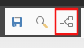
- Select the Page Content tab from the Select a Rendering window, then select Promo Video and Select.
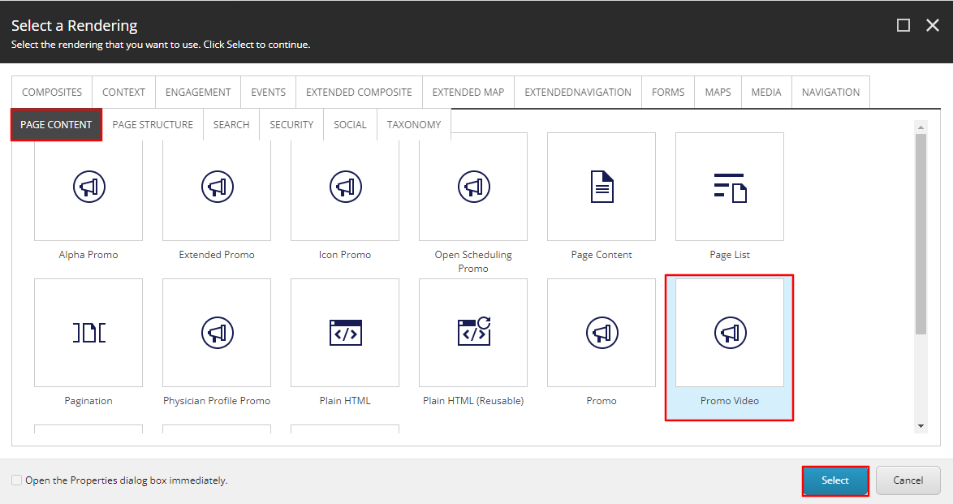
- Select the Text Image Feature Folder (or the folder you wish to have this promo stored under) and then select Create.
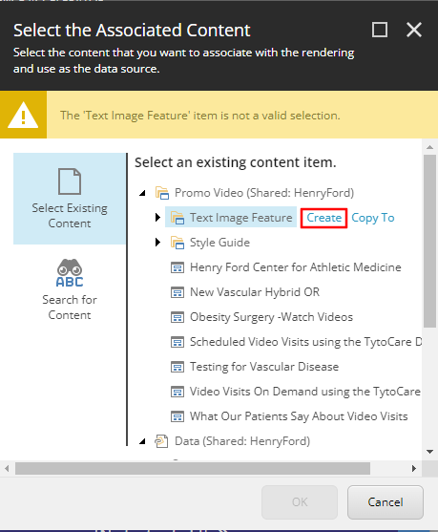
- In the Insert Item window, either create a Promo Video folder or a Promo Video, and assign a Name to it in the bottom field and select Okay.
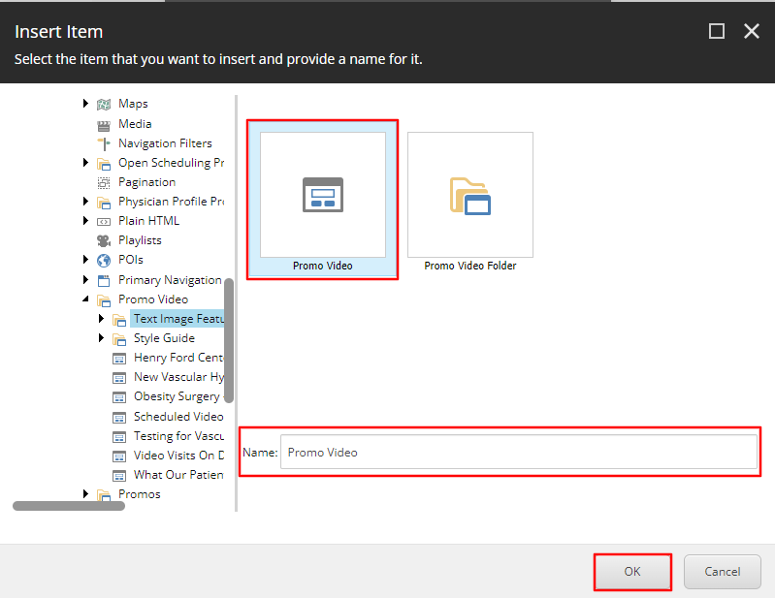
- The CTA will load on the page after a few seconds. Once it does, select the Variant dropdown (green) and then select the Left Text Feature Video Callout Width CTA or the Right Text Feature Video Callout from the dropdown based on your preference.
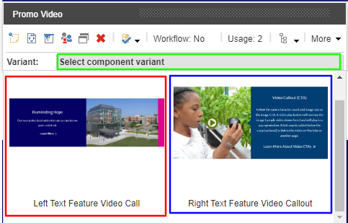
- Once selected, the proper formatting of the CTA will load, from here you can edit the Heading (Red) and Content Copy (Blue) by selecting the [No text in field] for each field respectively and typing the text you want to display.
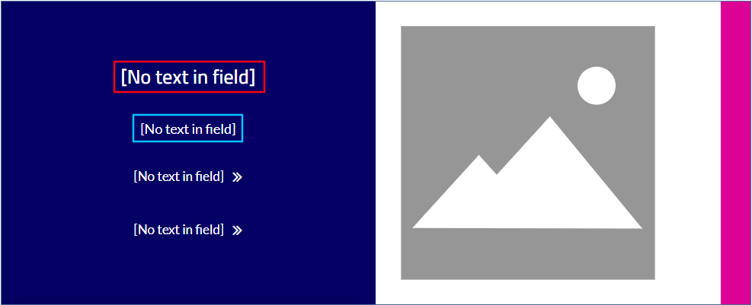
  - Note: If a text field is not edited, it will not appear on the front end.
- To edit the Image of this component, select the placeholder Image, and then select the Choose an Image Icon in the Image Toolbar.
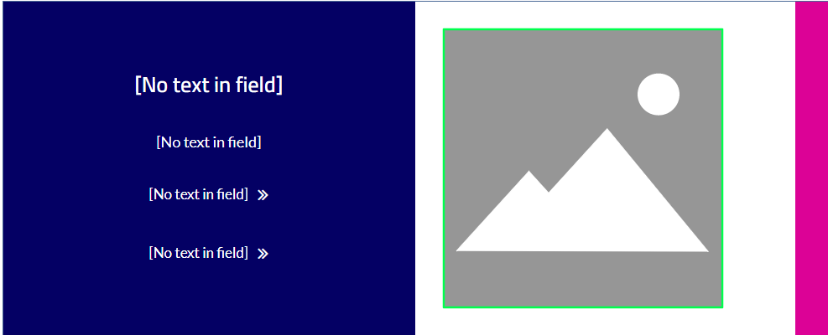
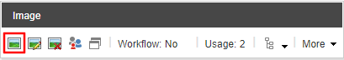
  - Select OR upload the media file that you wish to display and then click Select.
  - If no image is provided it will inherit the YouTube video image.
- To edit the Link text (Orange) and link destination, select the text area and select the “Edit the link destination and appearance” button.
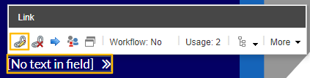
  - Note: This is the second to bottom link.
- Once selected, an Insert a Link window will appear. From here you can either:
  - Set the button to an internal link, by selecting the page from the Tree node and setting the Button Text through the Link Description field.
  - Set the button to an External Link by entering the external URL into the URL field and then setting the Button Text through the Link Description field.
  - Set the button to a Mailto: link by entering the email address into the Mailto field and then setting the Button Text through the Link Description field.
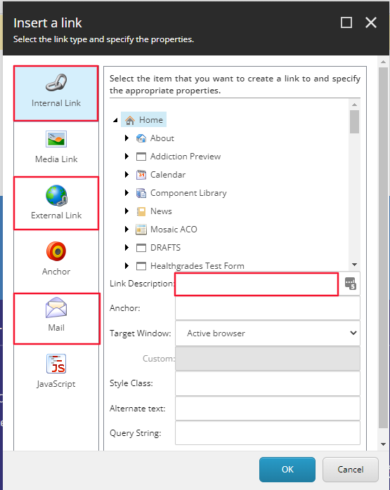
  - Note: If a text field is not edited, it will not appear on the front end.
  - Select Okay.
- To edit the YouTube video that is displayed in the CTA select the link area at the very bottom. Once selected, a Video Link toolbar will appear, select the “Edit the link destination and appearance” icon. Select External Link on the left-hand side and insert the full YouTube URL into the URL field and select OK.
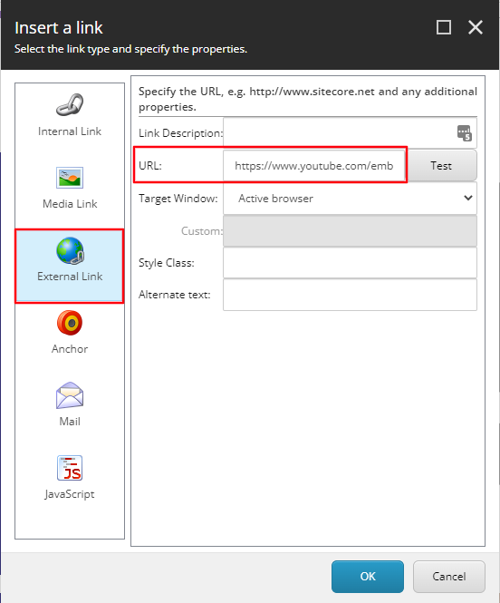
  - Note: The link text will appear at the bottom of the Text area, that said, it will not be there on the front-end.
- If there is not appropriate padding for your CTA, select the Video Promo area, a Promo Video Toolbar should appear, from here select the Edit style and behavior of the component ( aka. Paint bucket styling) icon.
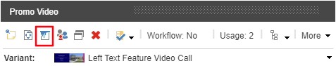
  - A window will appear. From here, scroll down until you see the Spacing checkbox section. Select the checkbox for the spacing you want added to the top or bottom of the component and select Okay.
- Select save in the Heading banner. You have now completed the adding a Text Video Feature CTA.
- When Publishing, it is recommended to have Smart publish and Publish related items both checked.

