To include an Additional Form on a calendar class or event, do the following:
- Navigate to the Forms module in Sitecore.
- Create a new form in the Calendar Additional Forms folder and add all necessary fields that registrants need to fill out before registering for a class. For this step follow instructions in the Forms Training Guide.
- On the editing toolbar under the Settings, enter “additional-form” in the CSS class field.
NOTE: This ensures the form will be appear as expected on the class or event page after an end-user clicks “I want to attend” next to a specific session.
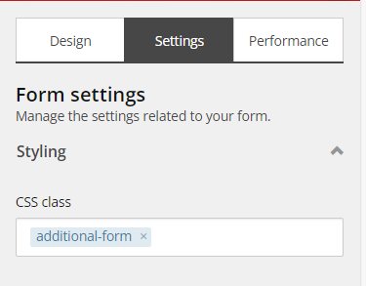

- Edit all fields as desired.
IMPORTANT NOTE: Only up to 10 fields can be added to a Calendar Additional Form. The Hidden fields that must be added to these forms (see step 5 below) do not count as part of the 10 fields.
- Add two hidden fields that will ensure the topic and the form are linked by doing the following:
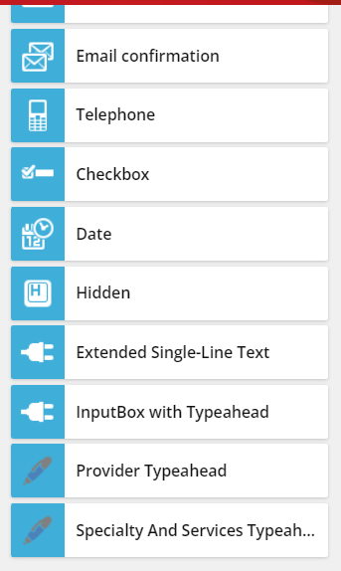
  - Drag and drop a Hidden field onto the form from field type options under the Design tab on the form editing toolbar.

NOTE: These fields will NOT appear on the Additional Form once added to a class or event on the site.
  - In the Field name field, enter ‘Topic-session-id’ on the editing toolbar.
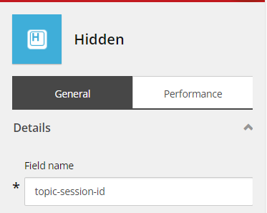

  - Click Apply to save the changes to the field.
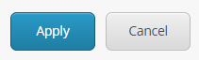

  - Drag and drop another Hidden field onto the form.
  - In the Field name field, enter ‘Form_name’ on the editing toolbar.
  - Click Apply to save the changes to the field.
- Add a submit button to the form by dragging and dropping the Submit Button option from the list of field types in the form editing toolbar. This is where you will navigate users to their Calendar Shopping Cart.
TIP: Submit Button is under Structure in the field types list.
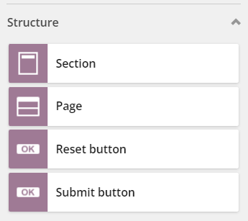

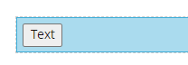
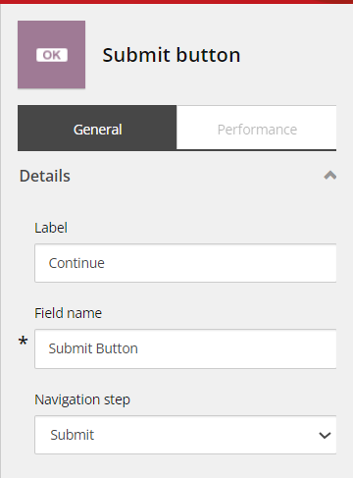
- Click on the button and enter a Label for the button on the editing toolbar. This text will appear on the button.

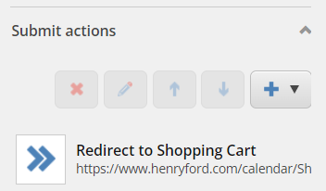
- On the editing toolbar, scroll down the Submit actions and click on the ‘+’ icon.

- Select Redirect to Shopping Cart from the dropdown of options that appears.
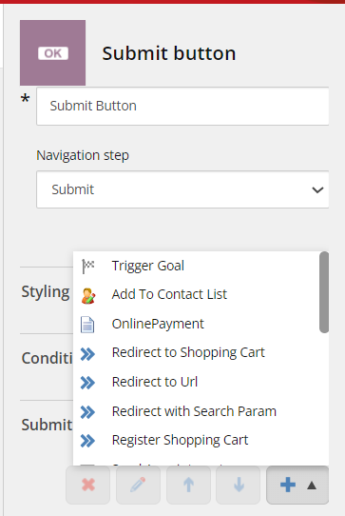

- A window will open to set up the redirect parameters. Fill out the fields on this window following these very specific instructions:
  - Url: Enter ‘https://www.henryford.com/calendar/Shopping Cart Checkout’ in this field to indicate that the target upon clicking this button is the registrant’s current Shopping Cart.
    - The Url Preview field will automatically populate based on the URL entered into the Url field.
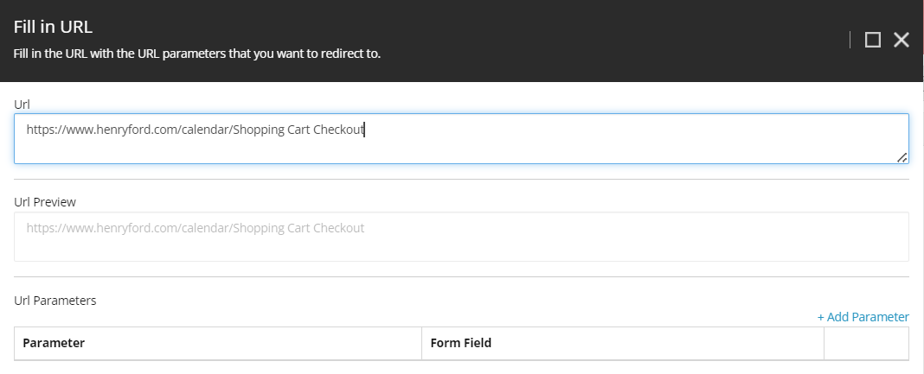

  - Url Parameters: Click +Add Parameters.

    - A row of fields will appear. For all the fields that will APPEAR on the form (not the Hidden fields) for registrants, populate these fields by doing the following:
      - Parameter: For any of the fields that will appear on the form, enter ‘Field[Number]’ (e.g., Field1, Field2, up to Field10).
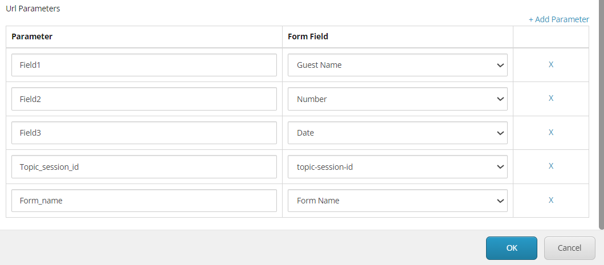

      - Form Field: Select the field from the dropdown that corresponds to each field.

IMPORTANT NOTE: The order in which the parameters are entered does not matter, however, it will dictate the order in which the fields appear in the Registrations view for Class Admins.
    - For the Hidden Topic-session-id and Form-name fields, fill out the Parameter fields by doing the following:
      - Parameter for ‘Topic-session-id’: Enter ‘Topic_session_id’.
      - Parameter for ‘Form_name’: Enter ‘Form_name’.
      - Form Field: Select the field from the dropdown that corresponds with the parameter (e.g., select ‘Topic-session-id’ for the Topic-session-id Hidden field).
  - Click OK to save the Parameter changes for the Submit Action.

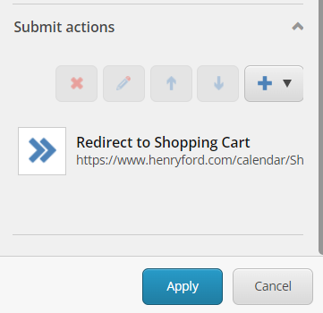
  - Click Apply on the editing toolbar to save the changes to the submit button.

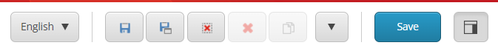
- Click Save at the top of the form to save all changes to the form.

To link the Additional Form to a class or event, do the following:
- Navigate to the calendar event or class topic in the Sitecore Content Editor tree.
TIP: This must be a topic with active (upcoming) sessions.
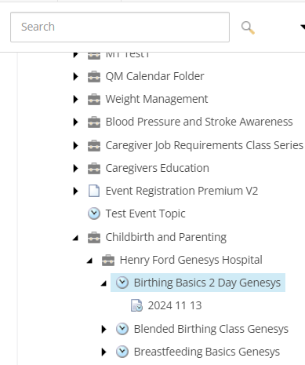

- Scroll down in the content section for this topic to the Additional Form field in the Premium Registration Data section.
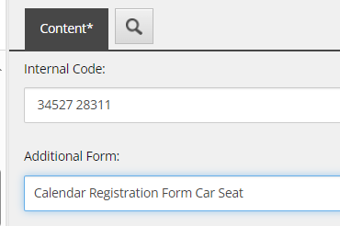

- Select the desired Calendar Additional Form from the dropdown.
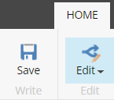
- Click Save from the main Sitecore toolbar to save the change to the topic.

- Right-click on the topic in the Sitecore content tree and click Publish Item.
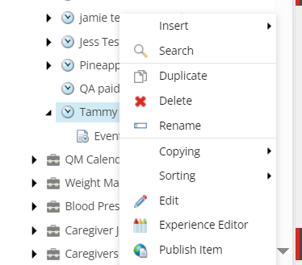

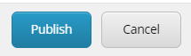
- Make the necessary selections on the Publish Item window and click Publish.

