

Accepting New Patients (Closed Panels) in Sitecore

Find a Doctor Import

Accepts New Patients
- Find a Doctor file contains a Y or N to indicate if a provider is accepting new patients. Column JK (272)
- In Sitecore’s provider detail, if Y the checkbox AcceptsNewPatients is checked within the Physician Data section:

  - Import process checks provider Accepts Open Scheduling checkbox if ALLW_OPEN_SCH_YN Column JJ (23) is Y
  - Import process checks provider Appointments if PAT_SCHEDULE_YN Column FS (175) is Y
- If N the AcceptsNewPatients is unchecked
  - Import process unchecks provider Accepts Open Scheduling Checkbox
  - Import process unchecks provider Appointments

Find a Doctor Website Search

Activating Find a Doctor Search checkbox Accepts New Patients
- For the applicable Find a Doctor settings navigate to
  - HFHS - /sitecore/content/Global/Settings/Henry Ford/Provider Directory Module Settings
  - Med Ed - /sitecore/content/Global/Settings/Henry Ford/Med Ed Provider Directory Module Settings
  - HFPN - /sitecore/content/Global/Settings/Henry Ford/HFPN Provider Directory Module Settings
- To display on the Find a Doctor landing page search check Accepts New Patients FAD Landing in the Open Scheduling section
- To display on the Find a Doctor search results search again check Accepts New Patients Search Results in the Open Scheduling section

Labels

To alter the Accepts New Patients checkbox label and tooltip on the Find a Doctor Landing Page:
- Navigate to sitecore/content/Global/Labels/Henry Ford/Modules/Physician Directory/Controls/Landing/Physician Search
- Update the text in the Accepting New Patients Label field and publish.
- Update the text in the Accepting New Patients Tooltip Label field and publish.
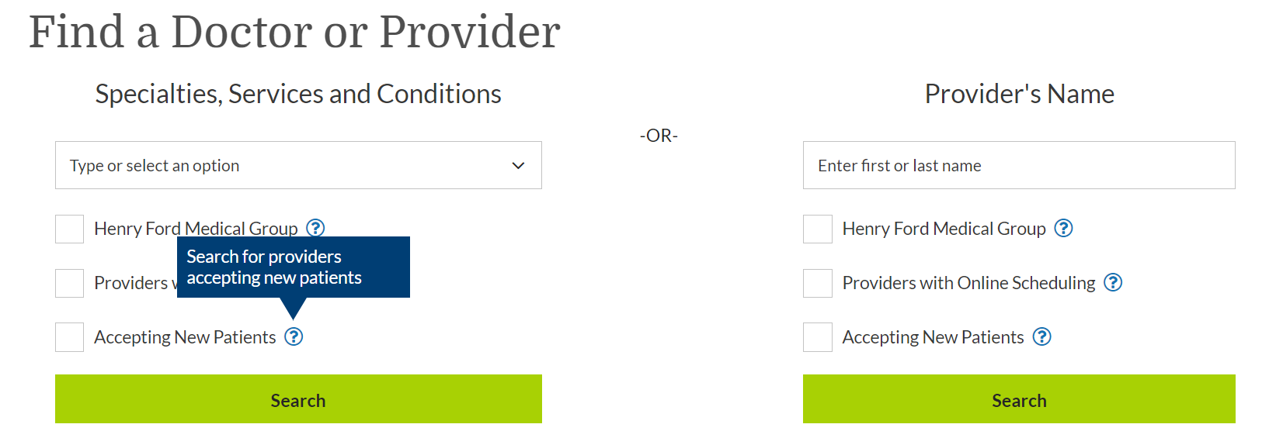

To alter the Accepts New Patients checkbox and tooltip on the Search results/Search again Navigate to sitecore/content/Global/Labels/Henry Ford/Modules/Physician Directory/Controls/Search Results/Physician Search Again OR /sitecore/content/Global/Labels/Henry Ford/Modules/Physician Directory/Controls/Search Results/Physician Search.
- Update the text in the Accepting New Patients Label field and publish.
- Update the text in the Accepting New Patients Tooltip Label field and publish. 

To update the Find a Doctor Search Results provider Not Accepting New Patients message:
- Navigate to /sitecore/content/Global/Labels/Henry Ford/Modules/Physician Directory/Controls/Search Results/Physician Listing
- Update the Not Accepting New Patient Label field and publish.
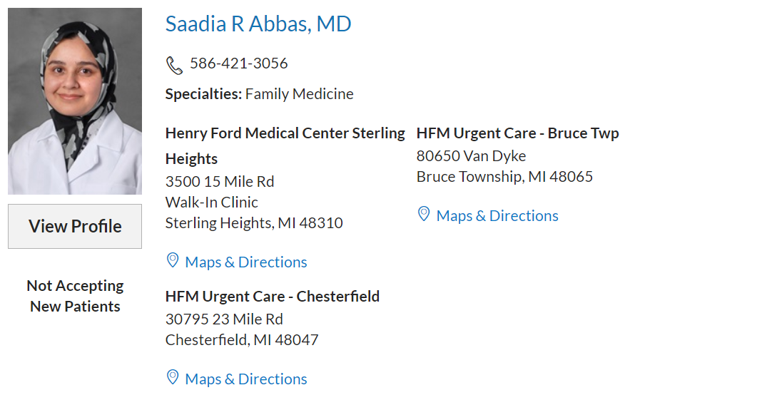

To update the Find a Doctor provider Detail page Not Accepting New Patients message
- Navigate to /sitecore/content/Global/Labels/Henry Ford/Modules/Physician Directory/Controls/Physician Detail/Physician Detail Labels
- Update the Not Accepting New Patient Label field and publish.


