Doctors Locations Services Triangle

Doctors to Locations
- Add Associated Location drop down field to Physician Office template, single selection

Source is the location directory /sitecore/content/Home/Locations
- If a physician office is linked to an associated location the office name should display as a link on the provider in the Locations map icon pop up office name and the office name listed to the right of the map.
- Selecting the link will go to the associated location page.
- If the physician office is not associated to a location, the office name should not appear as a link in the map or listing on the right.
- The map should use the Physician Office name field, instead of the location name from the location item.

FAD Import
- Set physician office's Associated Location field
- If a location id exist for each office, on the physician office set the associated location to the location module item with the matching id in the Location ID field

Doctors to Services
- Specialties map to services
- Add to global /sitecore/content/Global/List Manager/Specialties specialty template tree list to allow Sitecore user to associate specialty to items in the global services list /sitecore/content/Global/List Manager/Services/HFHS
- Reuses same services list used by the Services module
- New specialties and services will appear on import report created

Considerations

HFHS indicated we are not adding the ability to link specialties.

Modify FAD Import to automatically tag services on providers.
- Uses existing global services list /sitecore/content/Global/List Manager/Services
- Service items will contain a checkbox to Exclude from Services module. Default checked. If checked service and it's alternate terms will not appear in Service module keyword, alphabetical listing or service search result.
- Uses existing Tagging Services field for selections
- FAD Morrisey import file practice focus data is used to select applicable services in the provider Tagging section Services field.
- On providers services will not be manually tagged.
- Services will match to an existing item in the global services list. If no matching service is found, a new service will be created. New service will appear on the import change report under created.
- Services will not be deleted by the FAD import if they no longer exist in the file.
- Services display on FAD search result, Our Team listing, Our Faculty listing, links to applicable service page designated in global services list /sitecore/content/Global/List Manager/Services/HFHS.
- Services display on provider profile, links to applicable service page designated in global services list /sitecore/content/Global/List Manager/Services/HFHS.
- MedTouch will modify Our Team and Our Faculty to filter by services. Page selections for specialty or services is matched to providers where specialty or practice focus field matches selected specialties or services match selected services. If a provider matches any of these selections they appear in the listing

Considerations
- HFHS determined no manual service field is needed to overwrite the imported services.
- HFHS indicated specialties will be changing in Morrisey file. Import does not delete specialties. HFHS will manually remove specialties no longer needed or associated to providers and relink to new specialty to update existing tagging. Requires republish of impacted pages in addition to global specialty list.
- MedTouch will complete ContextSensitiveKey with service item name prior to import to allow the matching to occur. One time. Import will populate ContextSensitiveKey automatically going forward.
- MedTouch will unmark Exclude checkbox for all existing services, after the Exclude checkbox is deployed.

FAD Specialty Search
- Specialty drop down will include parent specialty, services shown as a sub item
- Specialty drop down only displays specialty and services that are associated to providers
- Specialty can be expanded/collapsed if it has associated services
- Default nothing in list is expanded
- Expand/Collapse is available in Featured and Other sections of the drop down.
- Website visitor may expand multiple items at one time. Website visitor selects collapse to close an item
- Specialties with no associated services do not contain expand/collapse
- Website visitor can search by a specialty or a sub item service. Single selection.
- Results displayed will match the selection. Providers matching the selected specialty or service. Does not match specialty and service.
- Same service may be listed under multiple specialties.
- User can select the label to select this as their search criteria or expand to show children items.
- Keyboard down arrow will move thru specialties and services. If I down arrow to a specialty with an expand, the next down arrow will expand the list and select it's first service
- Screen reader the full list is available. Everything is listed in the source for the screen reader to read. Visually we are just showing/hiding services using the expand/collapse
- Children items have a - marker, when I select these the - should not appear in the search box
Considerations
- HFHS to determine specialty to service mapping
- MedTouch to add services field, treelist multiple selection, to specialty item template
- HFHS to manually tag specialty with service(s)
- HFHS to forward MedTouch services list and specialty to services mappings when available. This is for informational purposes only.
- Services reuses global service list /sitecore/content/Global/List Manager/Services
- Alternate service names for a service will not be listed in the specialty search drop down, FAD search results, Our Team, Our Faculty or provider detail
- MedTouch design recommendation for drop down, once we understand what this will contain
- Featured specialties in drop down existing functionality
Optional Customization

Featured Specialties by grouping. Yes this can be customized to allow you to group specialties together. This was discussed during the strategy/design process, but our user studies show this did not perform well.

Locations to Doctors

Standard Location

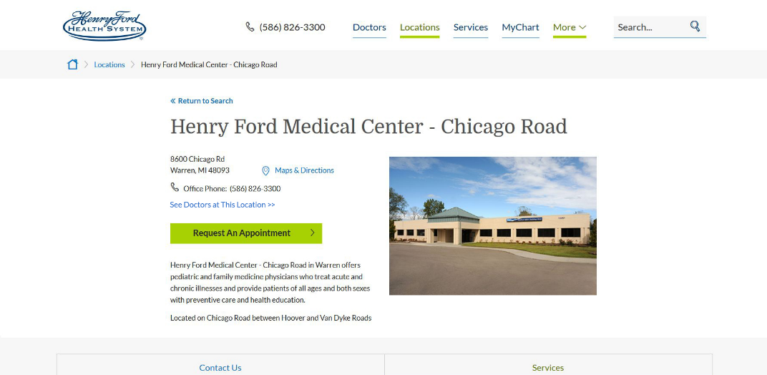
- Uses existing checkbox on location item Display Physicians At This Location. If this is checked See Doctors at This Location Link >> is displayed.
- HFHS will manually check for locations that will show the See Doctors at This Location >>
- Default is unchecked
- Automatic placement of See Doctors at This Location >> if checked displays above Content Copy field
- Links to Find a Doctor listing filtered to display providers associated to this location
- Add field to Location Module Settings template to enter the doctor search result page this links to. Field label is Doctors at This Location Link
- Returns all providers who have a Physician Office with the Associated Location selection matching this location.
- (Exist) Associated Location is set on Physician Office template. FAD import populates this field.
- Appends parameter to filter result. ?associated=Macomb+bruce+township
- associated = must use item name to work properly with special characters in location name
- MedTouch will create a custom doctor search result, is the same result as the FAD search, minus the search again. No development needed. Similar to Show Me News View All page

Location Landing
- Keep Find a Doctor button. Currently this is manually linked to the FAD results filtered by hospital
- If the Display Physicians at This Location is checked would show above the content copy field in the Campus Information tab. This is optional, it is there, but you do not need to use it.
- Same functionality as Standard Location

Locations to Services

Existing functionality services are manually tagged to locations. Display with links on the location detail pages.

Considerations

HFHS we will not automatically populate this from the FAD import file.

Appointment Form Location Drop Down
- All physician offices will have associated locations if accepting appointments. If an office does not have an associated location, that location will not appear in the appointment location drop down list. You indicated this should not be an issue.
- Appointment form Locations drop down will only show associated locations for the selected physician.
- The appointment locations drop down name is the Location Module name. This may not be an exact match to the physician office name.
- I don't know/Other is a selection.
- No location will be selected by default.

